3D Modelling with 3ds Max

**Table of Contents**

Introducing 3ds Max 2

Make yourself familiar with 3d Max 4

Creating the Coke can 3D model in 3ds Max 5

Setting up a Project Folder in 3ds Max 2019 (and Beyond) 6

Blueprint Setup 7

Building the Mesh 14

Pivot the Spline and Lathe 17

Smoothing the Mesh 24

Texture the Coke Can 33

The Textured Coke Can 45

Lights and Cameras 46

Lights 46

Cameras 48

Creating the Sprite bottle in 3ds Max 50

Creating your third model in 3ds Max 72

Appendices 74

Appendix A — 3ds Max Tutorials 74

3ds Max Interface Familiarisation 76

For the 3D modelling beginner 77

Appendix B — Download 3ds Max 82

Appendix C — Alternative Methods for Modelling a Coke Can 82

Coke can modelling 82

Sprite bottle modelling 83

Appendix D — Using Boolean Operations to insert Dimples 83

Appendix E — UVW Unwrap Modifier in 3ds Max 85

# **Introducing** 3ds Max

Welcome to Lab 2 for the Mobile Web 3D Applications module. In lab 1 you will recall that you developed a responsive and mobile first web page with a fluid grid-based layout using Bootstrap. You will adapt (or redesign) this web page into a 3D App template in lab 4. In lab 3 you will learn how to convert your lab 2 3D models into a format ready to integrate into your 3D App in lab 4. In labs 5, 6 and to 7 you will acquire further skills allowing you to refine your 3D App into a dynamic version built around an MVC design pattern using PHP to fetch data from an SQLite database at the backend. If you have not finished lab 1 yet, you will need to get a move on and finish it as soon as possible in your own time.

In Lab 2, this tutorial introduces [Autodesk 3ds Max](https://www.autodesk.com/education/free-software/3ds-max) and the basic principles of 3D modelling and texturing required for this particular 3D App module. This link takes you to the Autodesk Education site giving you access to download and install 3ds max as a Student, see Figure 1.

Go to the Get Started tab, at some point you will need to registers for an account, then follow the Get Product tab to the download and pick a version to install. In the University labs, as of January 2021 we had version 2019 and 2020 installed, I think? It doesn’t really matter as each new version published each year has very few changes and the interface is virtually the same. This year, 2022, we suggest that you install version 2022 on your Windows 10 platform.

|  |  |
| --- | --- |
|  |  |

Figure 1: Access 3ds Max on the Autodesk Education site for installation on your home Windows PC

In this tutorial we cover all the basic skills needed without any prior knowledge, but you must be prepared to investigate, read around the subject and engage with 3D modelling and 3ds max outside the labs. For example, there are many online tutorials available to learn 3D modelling using 3ds Max — some are linked in the Canvas site for this module. For this 3D App module, we will give you sufficient instructions in this tutorial to allow you to create (i.e. model, texture, illuminate and setup a camera studio) 3D models of objects with sufficient complexity to acquire the skills needed to complete the assignment for this module. The three models you should complete in Lab 2 are:

* A Coke can — Introduces modelling from splines, texture mapping, etc.
* A Sprite bottle — introduces modelling from standard primitive shapes and adapting these shapes to create more complex models
* A Dr Pepper cup — increases and refines your 3D modelling experience

You can see the theme for your initial basic responsive and mobile first 3D App developing now — a Coca Cola 3D App. This basic 3D App will be the foundation upon which to build your skills and complete the 3D App for your final assignment.

Some if you may already be familiar with other 3D content authoring packages, e.g. May, Blender, Cinema 4D or others. We cannot cover every package, but feel free to use those packages. However, there is a basic requirements. You need to be able to integrate your 3D models into your 3d App, and this is currently done using X3D. So, whatever package you choose to use you will need to be able to export your 3D models and convert them to X3D. We show you a workflow on how to do this with 3ds max to X3D in lab 3, this workflow will change if you use any other 3D content authoring package.

To reward success in using a 3D Authoring package and different workflow to that outlined in Lab 2 and lab 3 tutorials we allocate an automatic 5 marks (total 10) for 3D Content Authoring and the associated Workflow. These marks are also available if using a mix of 3ds Max and other packages, etc. This element of the marking scheme is designed to allow those without Windows PC at home to use 3D content authoring and other workflows because 3ds Max is not available on iOS platforms.

**Tip!**

**Read through this tutorial and get a basic idea of requirements first, irrespective of what 3d content authoring package you plan to use, check out the assignment requirements re. the 3D models, and consider meeting these requirements by following suitable third party YouTube tutorial, this is an acceptable approach.**

# Make yourself familiar with 3d Max

Before you start this tutorial — Creating the Coke can, Sprite bottle and Dr Pepper Cup — if you have no prior experience with 3ds Max you should have a play with the 3ds Max interface and familiarise yourself with generating some basic primitives, try some of the 3ds Max tutorials provided by Autodesk. To do this jump to Appendix A — 3ds Max Tutorials before starting the next section.

Also, don’t forget to download and install 3ds Max 2020 on your own computer, note it will only work on a Windows operating system, see the Canvas Laboratory 2 — Building 3D content for your 3D App with 3ds Max page for more details or jump to Appendix B — Download 3ds Max.

# Creating the Coke can 3D model in 3ds Max

To model the Coke, Sprite and Dr Pepper models it will, of course, take longer than the time allocated for Lab 2 unless you are super quick. So, you should put some other time in too — don’t forget a 15-credit module has some 10 hours of work per credit expected!

In Lab 2 you will create three, relatively straight forward, models that serve to get you into the modelling, texturing, illumination and camera setup skills needed to create reasonably realistic 3D objects for rendering in a mobile 3D App — your 3D App objects will be modelled, textured, and illuminated specifically for rendering in a WebGL context, which means relatively **low polygon count for the geometry, application of standard materials, cameras and illumination** suitable for scanline rendering — photorealistic materials and illumination will not work, but you can use these methods to create extra media content, e.g. 3D images. Please check out the lab notes for this lab session in Canvas for an overview and talk to the module convenor if you are not sure.

For the first part of this module (up to Lab 6), you will develop a basic 3D App that renders the three basic objects modelled in Lab 2, this lab. As mentioned above, these objects are the **Coke can**, **Sprite bottle**, and the **Dr Pepper cup**. This tutorial starts with detailed instructions to model the Coke can. Once you have finished the Coke can model, you will use a different method to create a Sprite bottle, followed again by using any of the two methods so far (or any other method that you might discover if you research deeper) to create a Dr Pepper paper cup, see Figure 2 for illustrations of potential blueprint images.

The main purpose behind Lab 2 is to familiarise yourself with some basic modelling, texturing, lighting and camera techniques through the creation of these 3 objects, while at the same time ensuring you are familiar with using the 3ds Max interface so that you can create appropriate 3D objects for your assignment, i.e. objects that can be modelled using similar techniques.

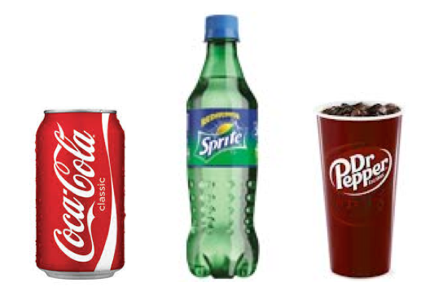

Figure 2: 3D object blueprints

For this lab, the first thing you need to do is download the blue prints for these objects, starting with the *can_blueprint.jpg* and *can_texture.jpg* from Canvas; these images are located in the Lab 2 section on Canvas for this Mobile Web 3D Applications module. The blueprint will be used to ensure that the can’s proportions are correct. The texture will provide colour and detail (rather than using complex geometry) once the model is finished.

Before we set up the Coke can blue print, if you did jump to Appendix A and started to have a play with 3ds Max you will need to get rid of the objects you created while becoming familiar with the 3ds Max interface. To do this you could simply delete all the objects in the perspective viewpoint by selecting and deleting them (Tip! Ctrl+A selects all objects in the viewports, then Edit => Delete) or you could just close or reset the file without saving and open a new file.

## Setting up a Project Folder in 3ds Max

Launch 3ds Max if you don’t currently have it open. Now set up a project in 3ds Max:

1. First go to Customize > Preferences to open the Preference Settings tab, then select the files tab and check the Convert local file paths to relative and click ok. This ensures that when you move your 3ds Max files from your laptop to the lab pc and back your files are all relative to your project folder and not your hard drive.
   * Note, if you only intend to use your home PC to create 3D models this does not matter.
2. Next select File > Project > Create Default … on the flyout and then navigate to your root project folder, see Figure 3 and select ok.
   * I have already created three folders for lab 2: lab2/coke; lab2/sprite and lab2/pepper
3. 3ds Max will then create a whole bunch of folders under your Coke folder along with a path configuration file.
   * If you do not configure your files relatively, you will need to update the paths if you bring files back and forth from home; most likely.
   * You will save your 3ds Max file (e.g. Coke_can_blueprint.3ds) in the scenes folder, and any assets, e.g. the Coke can texture and blue print in the sceneassets/images folder. Don’t forget to download these from Canvas Laboratory 2 — Building 3D content for your 3D App with 3ds Max.

|  |  |
| --- | --- |
|  |  |
|  |  |

Figure 3: Set up a project folder in 3ds Max

* + Most of the rest of the folders, you won’t need, but leave them there for now.
  + You save the empty scene from 3ds max now and this will create a scene file in the scenes folder. Call it coke_can.

Alternatively, you can manage your files manually, just set up a scenes and assets folder and save your models to the scenes folder, with sub-folders for each model and strore your textures in the assets/textures folder! Note, it is a good idea to save often and use meaningful names that signify stages of modelling as you go along, e.g. Coke_can_blueprint_setup, Coke_can_geometry-0.1, Coke_can_geometry-complete, Coke_can_geometry-textured, etc. Note the + button next to the file name box, which you can use to increment saves!

You will most likely need to model at home on your 3ds Max installation, so you may need to transfer files back and forth between the lab and your home PC or laptop (if you are using the University labs), hence the need to set up relatively. Alternatively, you could consider using a cloud solution like Dropbox or the University’ Box.

## Blueprint Setup

Let’s begin working with 3ds Max by setting up the blueprint for the coke can.

There is an old, very good 3ds Max 2014 tutorial that shows you how to set up a 3D virtual studio for modelling an airplane that is worth a read:

<http://docs.autodesk.com/3DSMAX/16/ENU/3ds-Max-Tutorials/index.html?url=files/GUID-E1B42D4D-E193-4290-83D8-72FB66E467F6.htm,topicNumber=d30e6685>

If you completed this ‘Modelling an Airplane’ 3ds Max tutorial you will already be familiar with this process.

Movin on, we will do this by creating a primitive object, a plane.

Now click the Create button  in the Command panel, then choose Plane, see Figure 4, and draw it in the *Left* viewport.

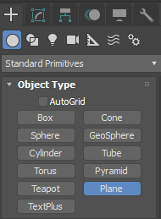

Figure 4: Select the Plane from the Create menu Standard primities.

Select the plane using the Select and Move button (as the plane is the only object in the scene, it may already be selected), then click the Modify button on the right-hand side panel . You will see on the Modify menu the plane has been given a name, in this case Plane001 and you can see the Plane primitive selected under the Modifier List. Figure 5 illustrates the 3ds Max interface with the plane selected and I have circled in RED the parameter you can change to set the plane size, and the circle in BLUE shows the current coordinates for the plane; you will change these to setup the plane size and position it in the scene.

For the observant amongst you, you will notice Figure 5 is a snapshot of 3ds Max 2017, as I look at version 2022 it appears identical, so I am not updating the image in this tutorial. If there is a significant change to the interface I will update the image.

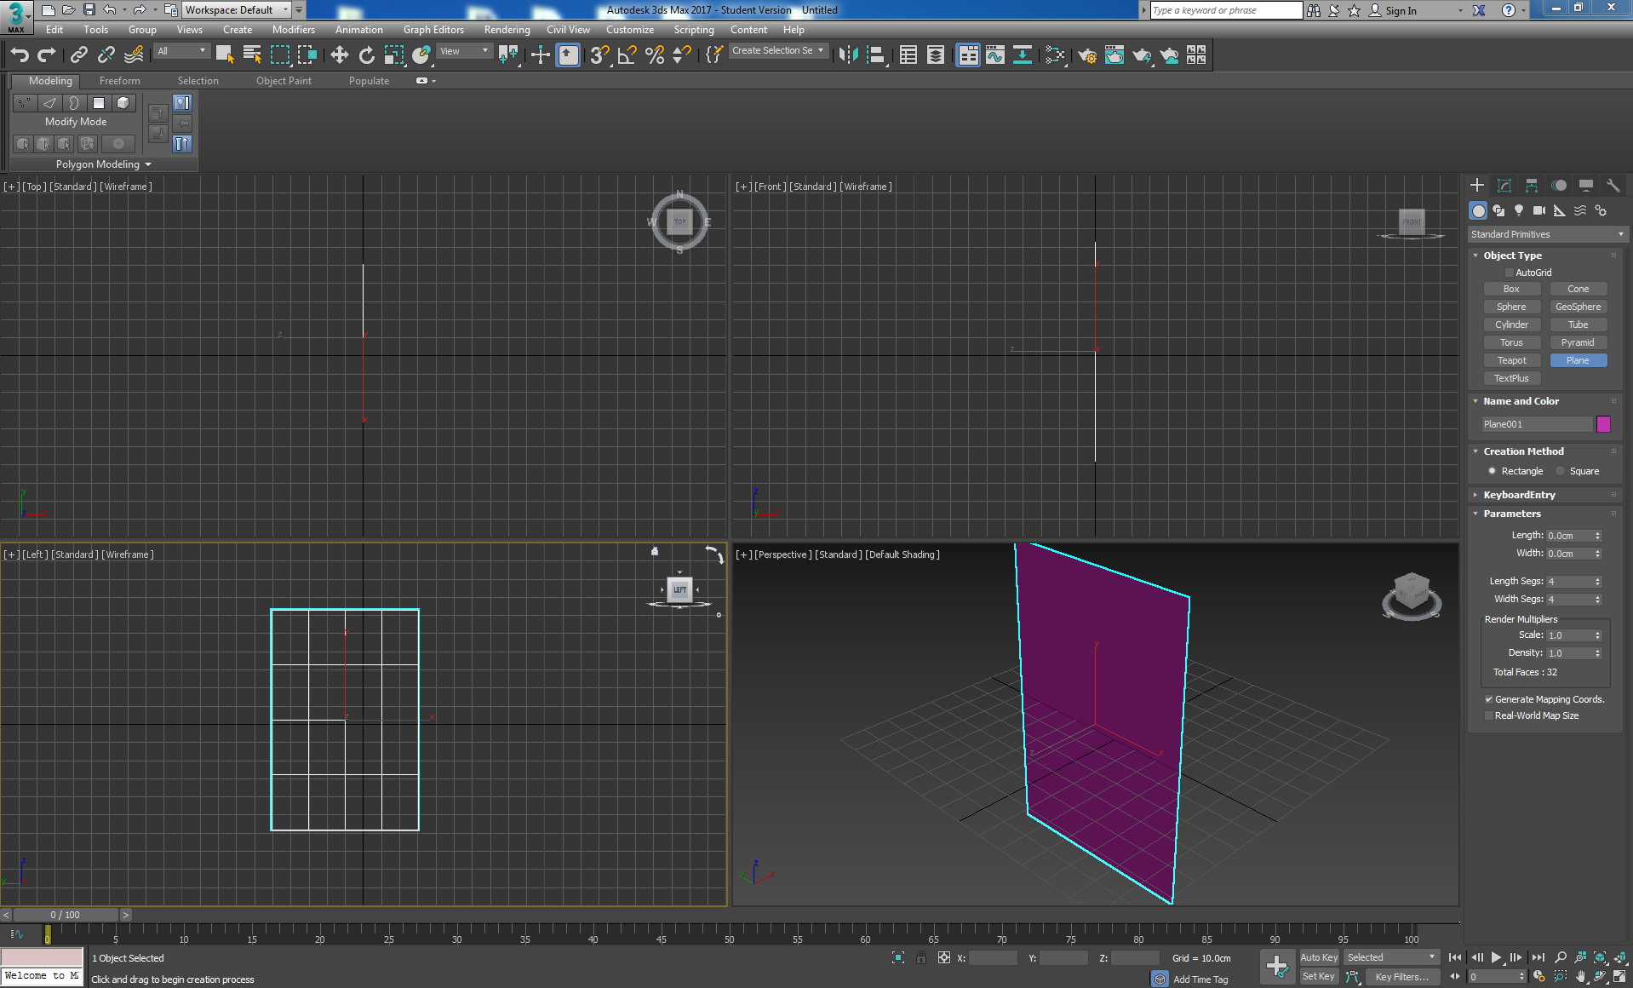

Figure 5: Plane drawn in the left viewport and selected ready to modify its size

Change the parameters for the plane size:

* Length: 1024.0
* Width 728.0
* Length Segs: 1
* Width Segs: 1

Render Multipliers should be set to 1.0 for both Scale and Density, see Figure 6. Note, it is important to get the aspect ratio right for the blueprint, because you will be tracing around the blue print (or reference image). If the aspect ratio is wrong your final model’s aspect ratio will be wrong. Also, we are not bothered about the actual dimensions, so you can to the Customise menu on the top menu bar, navigate down to the Units Setup and select Generic Units, if it is not already selected.

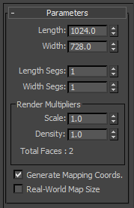

Figure 6: Set the plane’s dimensions, segments and render multipliers.

Then position the plane by setting the X, Y, Z coordinates to that shown in Figure 7 (this is found at the bottom of the screen in the middle, I’ve circled it in blue, Figure 15). Make sure the Plane is selected first. Note, sometimes we have a tendency to select and slightly move the object if the ‘select and move’ button is on in the main toolbar, so keep an eye on this and make sure the following coordinates are not changed.



Figure 7: Set the plane coordinate to 1000, 0, 0

By Setting X to 1000 you have moved the plane 1000 units in the X direction, this puts the blue print for the Coke can back 1000 unit in the X direction so that you can model the object at the origin 0,0,0 of the viewport. You will notice when an object is not selected this shows the coordinates of the cursor in the selected viewport, and when you select an object if you drag the red, green or blue arrows to position the object the corresponding coordinate is updated. Alternatively, as you did, you can type in the position you want. It should look as shown in Figure 8. If you can’t see it as a coloured shape in the viewport, press F3 to disable wireframe mode.

m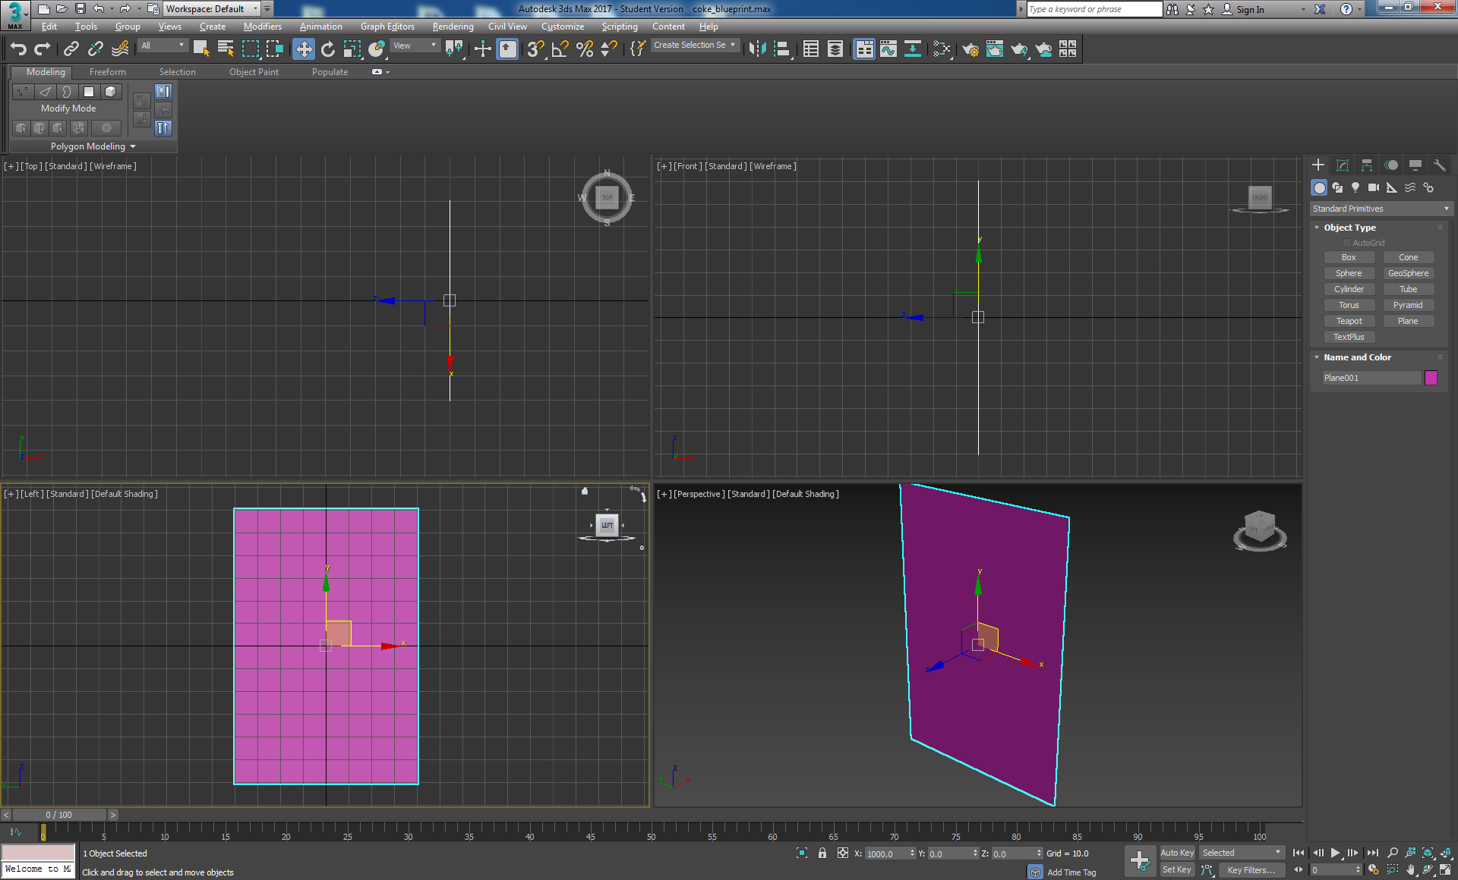

Figure 8: The plane set up ready to texture with the Coke can blueprint.

You are now going to apply the blue print as a texture map to the plane. Open the material editor by pressing “M”, and then make sure you are using the Compact Material Editor. You can select it by clicking *Modes > Compact Material Editor*, see Figure 9. When you open the compact material editor you may find the Material/Map Browser has been set to Physical Material, id so click on it and select Standard (Legacy). This is probably because on starting up 3ds Max the renderer was probably set to a photorealistic renders, i.e. Arnold, rather than a Scan line Renderer. If so, you will also need to select Rendering on the main toolbar and set that to Scan Line Renderer (we are not doing Photorealistic rendering in this module).

Select a material by clicking on the first sphere and change its diffuse parameter to the *can_blueprint.jpg* image. You can do this by clicking on the Diffuse button, Figure 9, and then browsing to the file via the Bitmap button, which should be in your sceneassets folder. Your 3ds Max already knows about this folder if you used the project folder setup.

|  |  |
| --- | --- |
|  |  |

Figure 9: The Compact material editor

If you organised your own files, just navigate to your assets, etc. Select the can_blueprint and open, see Figure 10.

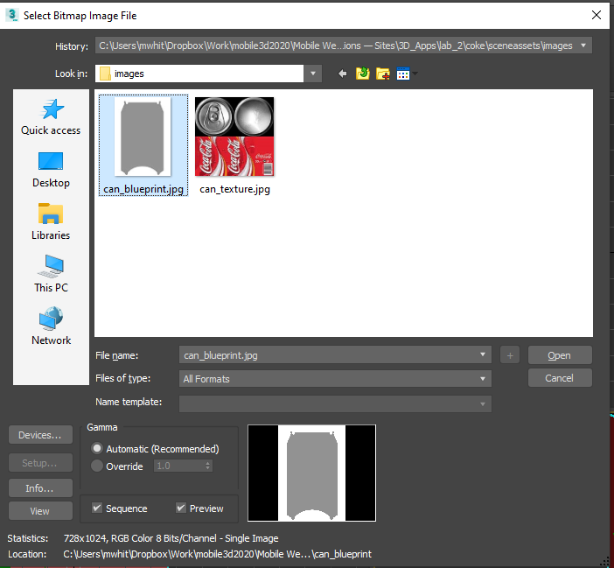

Figure 10: Select the can_blueprint image file for use as a blueprint.

This applies the can_blueprint.jpg to the material sphere**.** However, there is a simpler way of doing this. If you undo the above actions with Crtl+Z, you can re-select the can_blueprint.jpg by simply dragging it from its current location (e.g. sceneassets) and placing it on the first material sphere.

Select a second material sphere and repeat the process for *the can_texture.jpg* file. This will be the texture material for the can that you will use later.

Grab the material sphere for the can_blueprint and drag it onto the plane. If it doesn’t display in the viewport make sure you click the Show Shaded Material in Viewport button in the material editor , see Figure 11.

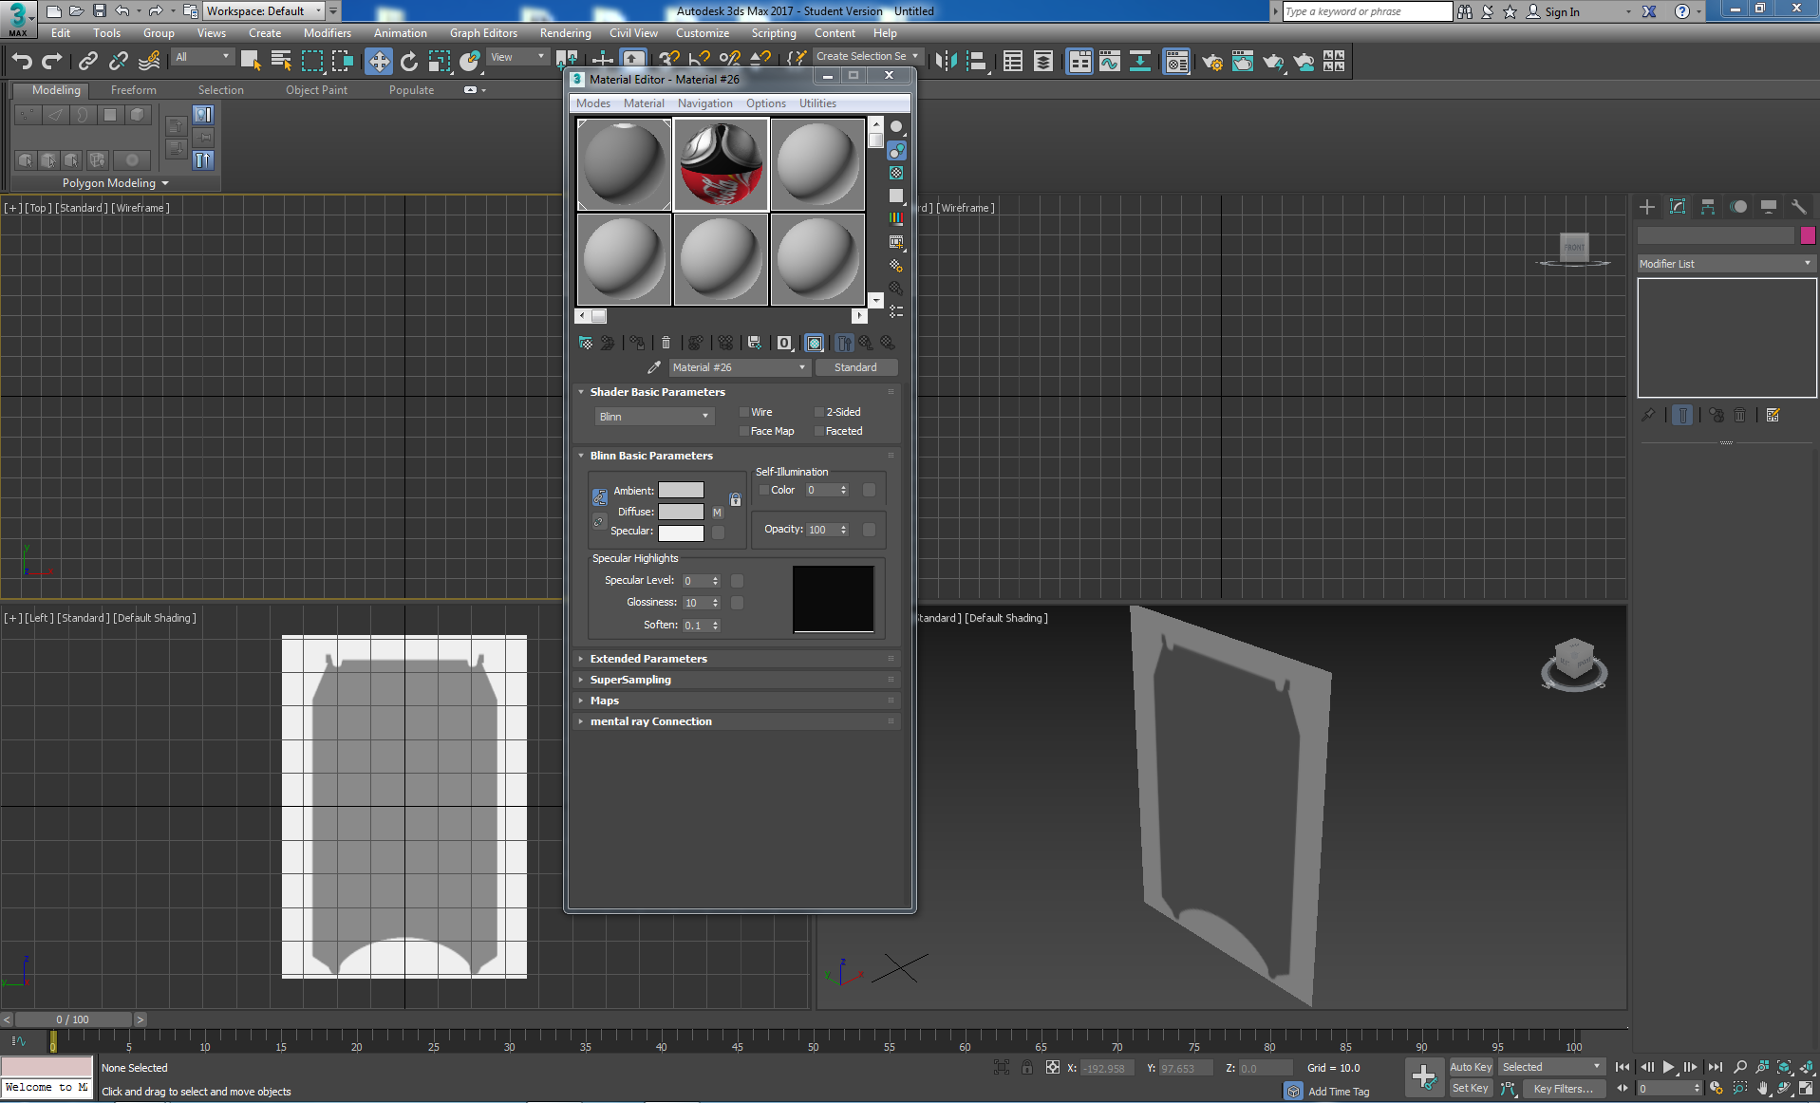

Figure 11: Apply the can_blueprint texture to the plane to act as a backdrop for tracing around

At this point, you might like to work in [Standard + Default Shading], and switch back and forth to wireframe as and when it is useful.

The blueprint is a cross section of a drink can, which will be used as a reference image. This is useful in recreating the correct can shape. If you read up on the airplane tutorial, you may also recall that you are effectively setting up a Virtual Studio, albeit with only 1 side.

This concludes the blueprint setup and it should look like that illustrated in Figure 12 — you can close the material editor for now.

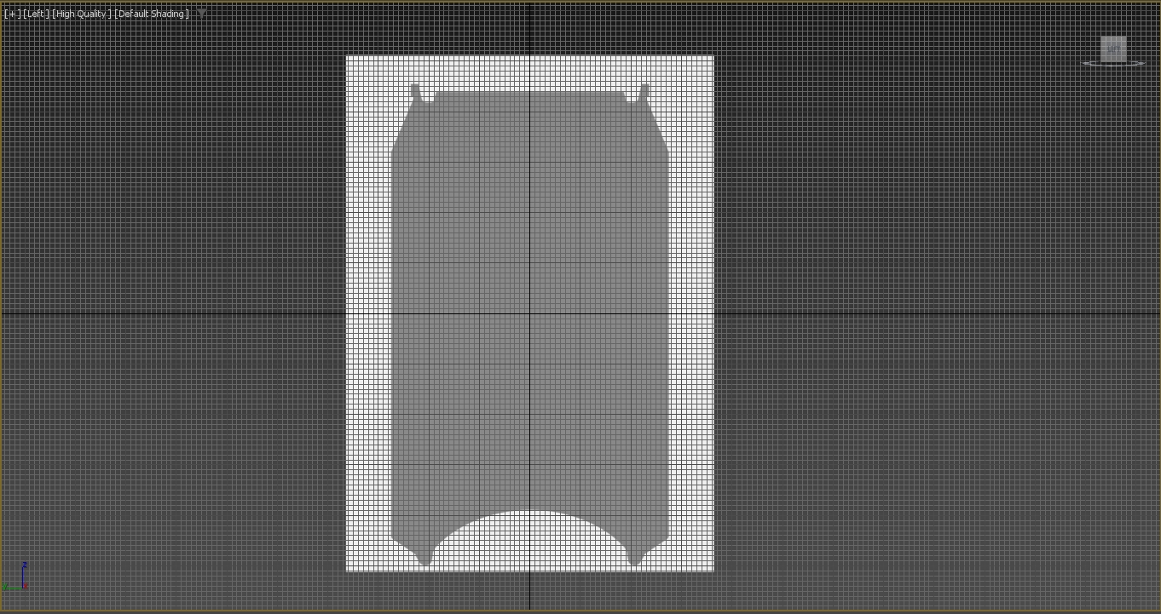

Figure 12: The blueprint setup as required in the Left viewport.

## Building the Mesh

In this section, we will be building the polygon structure of the Coke can using splines and a lathe function. This is quite a popular method for modelling symmetrical objects, but you might like to have a look at Appendix C which details alternative methods for modelling a Coke can, or simply do a Google search for YouTube tutorials.

The method we will use for the Coke can is to trace around the blueprint silhouette using a line primitive called the spline tool. Splines are vector drawn lines that can be used to create polygon structures. Because the can is a symmetrical cylinder, we can begin by tracing the outline of the can blueprint.

Go to the *Create* panel, by clicking the Create button , and select the shape drawing tools , then select the *Line* tool in the Splines dropdown, set up the line parameters as shown in Figure 13 and the line interpolation method as shown in Figure 14. Then enlarge your *Left* viewport, see Figure 15. This is the viewport where you can see the can blue print, maximise this viewport using the Maximise Viewport Toggle button  (lower right-hand corner of the 3ds Max interface) and zoom out a bit depending on your screen resolution. I find this easier than having to adjust the size, and pan around as I trace, but you can do that also. You might also want to disable the grid lines to see the blueprint better by pressing *G*.

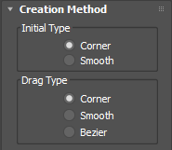

Figure 13: Setup the line parameters.

Note, we haven’t set Bezier, we can convert to Bezier and adjust later if we want to, but we shouldn’t need to. Also, set the interpolation options as follows:

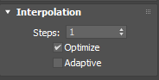

Figure 14: Set up the line interpolation method.

In the *Left* viewport you should see that shown in Figure 24.

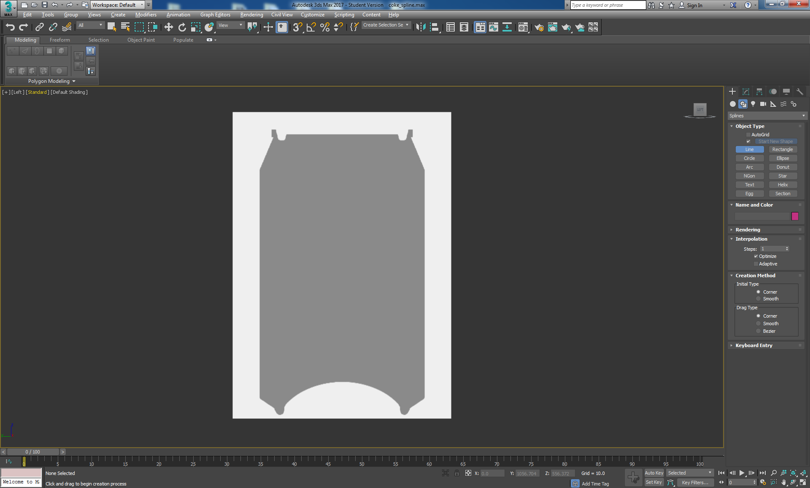

Figure 15: The blueprint setup for tracing round with the Line Object Type.

Carefully trace the right half of the can as shown in the picture below, right click to finish the spline. You can hold the *Shift* key down to draw straight lines for the top and side of the can. It is a good idea to start and finish just short of the vertical centre line of the Coke can, because we will use the lath operation to create the geometry, which will then leave a hole at the top and bottom that can be closed later.

Select the Modify button  to reposition any of the points; you will need to select the Vertex option in the Modify panel. At this stage you can also make more points, or vertex, using the Insert tool, which you will find by scrolling down the geometry rollout. Figure 16 illustrates the initial line drawn around the silhouette of the blue print.

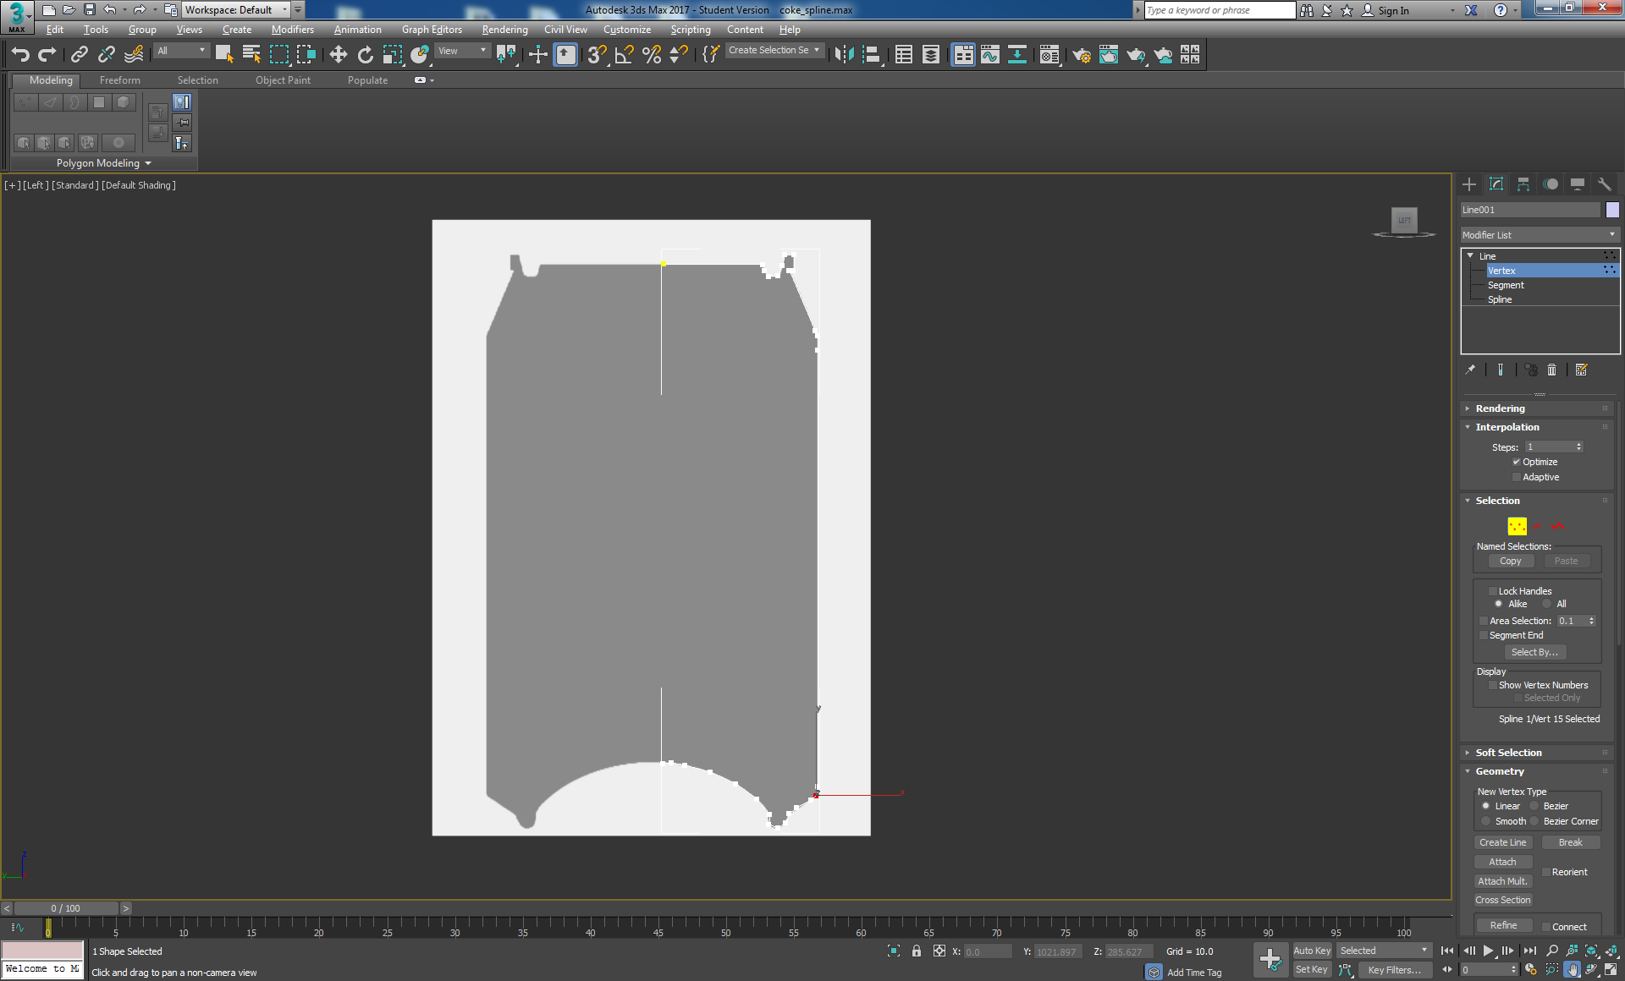

Figure 16: Use of the Line tool to draw the silhouette

If we zoom in and have a closer look, you might find that your vertices, see Figure 17, connecting the spline are out, if so we will need to adjust them.

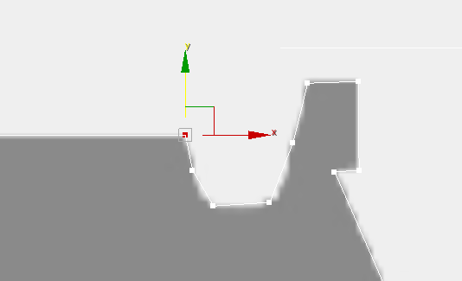

Figure 17: Start to adjust each vertex so that they are more accurately positioned.

This process of adjusting each vertex is a bit fiddly; you will need to zoom in on each vertex to modify (i.e. moving each vertex up and down, left and right to achieve the best position for each vertex in relation to neighbouring vertex and the blueprint outline.

### Pivot the Spline and Lathe

Next, you will need to centre the pivot point of the spline. This step is very important, as we will be using that pivot point to create the polygon structure. Select the *Hierarchy* panel , select the line and click the *Affect Pivot Only* button, see Figure 18.

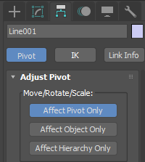

Figure 18: Select Pivot, and Affect Pivot Only.

Set the pivot to XYZ coordinates 0: 

Your left viewport should look like Figure 19 with the pivot point now centred.

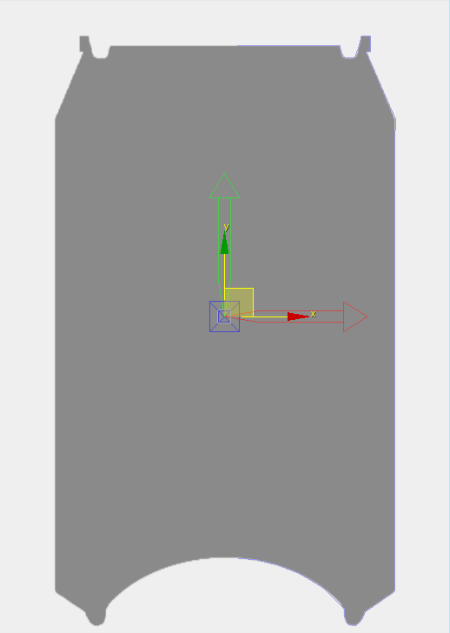

Figure 19: Pivot point centred ready for the lathe operation.

Now disable *Affect Pivot Only* and go back to the *Modify* panel . Click on *Modifier List* and add a *Lathe* modifier with the following settings (or enter L on the keyboard), see Figure 20.

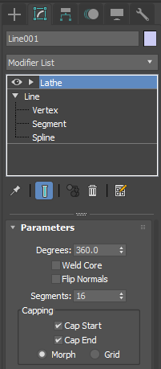

Figure 20: Add the lathe modifier

You should now have a 3D model, see Figure 21, but it is not finished yet. We must fix some small errors caused by the lathe modifier.

Interestingly, notice in 3ds Max the lathe modifier has a Cap Start and a Cap End? But, you can see through the hole to the default colour of the Coke can, so it doesn’t appear to have capped it? We made this hole deliberately large so that it will be less fiddley to close later. However, this Cap Start and Cap End have nothing to do with the holes we made. If we had made the lathe less than 360 degrees and used a spline to lathe an outer and inner surface, stopping short of a 360-degree lathe would have then capped the cross-sectional surfaces at the start and end of the lathe. So, we will cap the top and bottom holes later using a Cap or Collapse operation.

Ok, so why do we see the diffuse colour of the Coke can through the hole? This is odd until you realise that the lathe operation has created the geometry inside out. You can switch to Hidden Line and Wireframe to better see the geometry, and in the perspective, view notice the hole at the top.

We can correct this later adding a Normal modifier on top of the Lathe modifier, or we could tick the Flip Normals box after we lathe. When we texture the model, it becomes obvious then that the Coke can is inside out. So tick the Flip Normals now to correct the geometry.

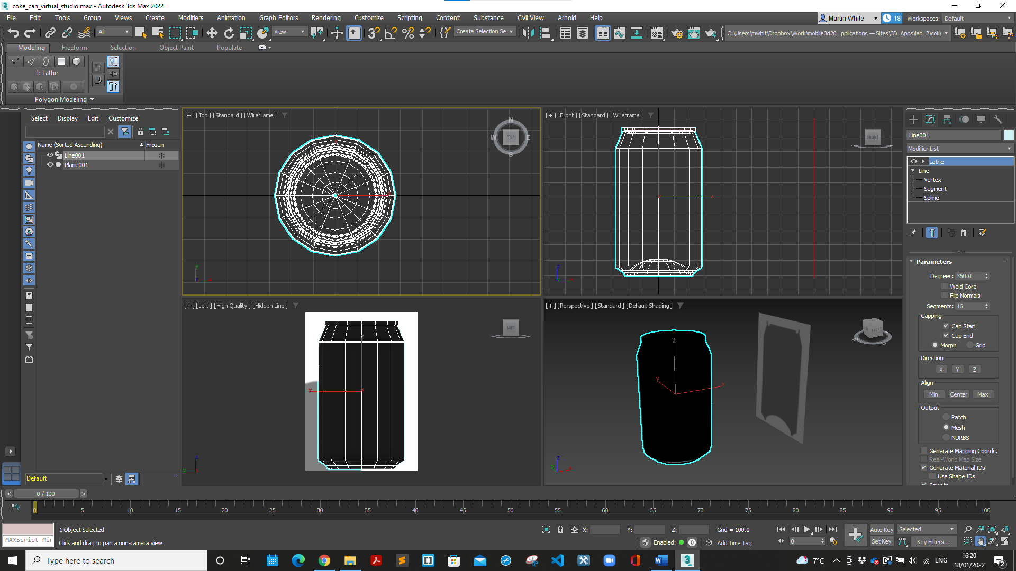

Figure 21: The nearly finished Coke can geometry.

If you haven’t already, toggle the Maximise Viewport Toggle button so that you can see all the viewports, see Figure 22. Go to the perspective viewport and set it to [Standard][edged Faces] to get a feel for the geometry you just created, and to make sure you can see that the Normals are flipped, before we fix any anomalies in the geometry. To correct any geometry, we need to convert the can into an editable polygon structure.

But first, we should **increase the geometry a bit, so set the Segments to 64**, otherwise perspective views will look a little too faceted, see Figure 23.

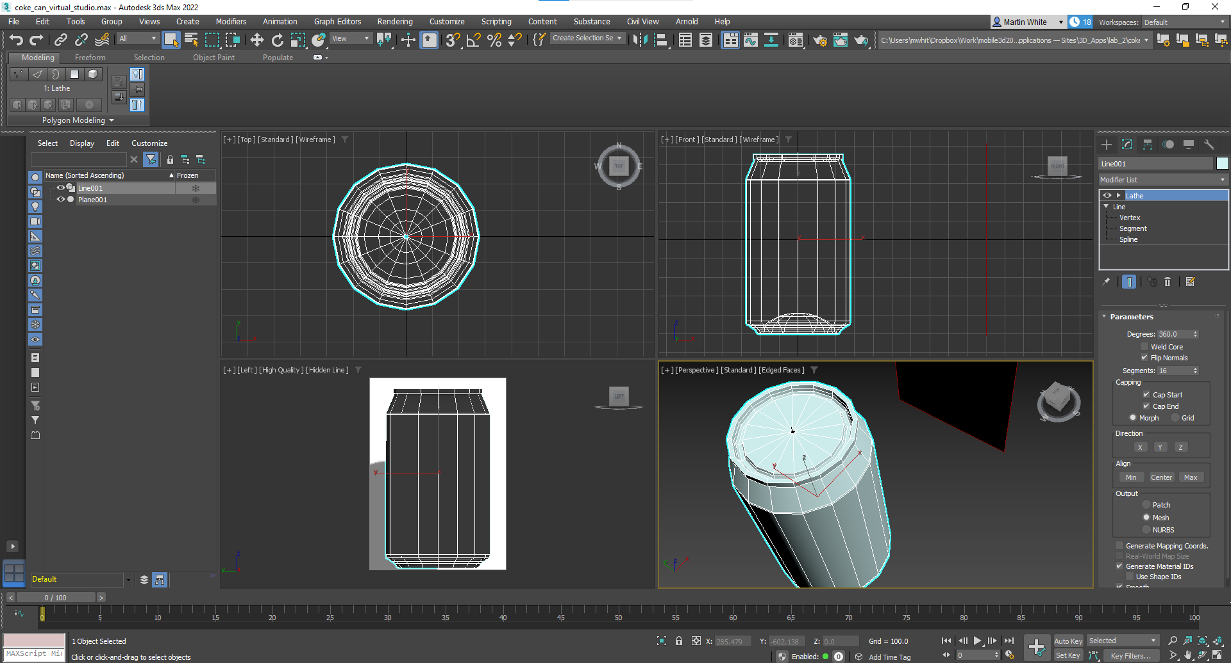

Figure 22: The initial Coke can geometry where the can edges are a little too much faceted.

Converting the model to editable polygons is done by selecting the Coke can geometry, and right clicking in a viewport area, and selecting *Convert To > Convert to Editable Poly*. You might want to enlarge the perspective viewport, see Figure 23.

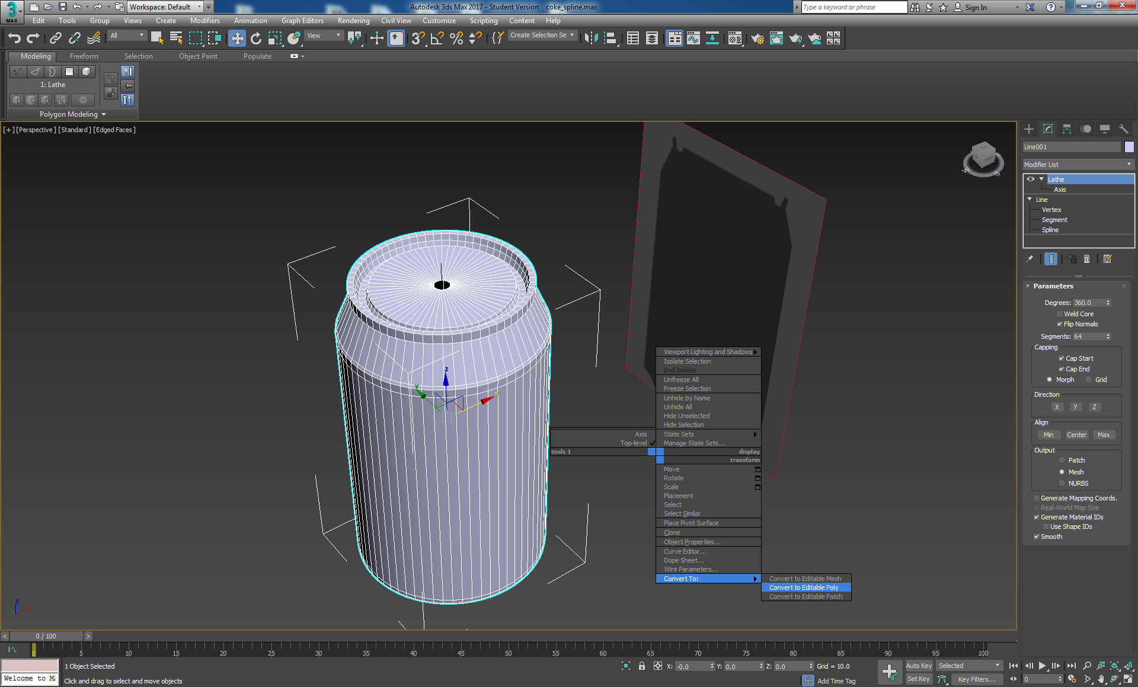

Figure 23: The can geometry increased to 64 and converting to editable poly.

The *Modify* panel  now contains polygon-editing tools. We can use these to weld together the top and bottom holes in the Coke can. Also, we have the Ribbon across the top of the 3ds Max interface that also contains the same tools.

If you zoom into the holes at the top and bottom of the Coke can so that you can see the associated edges (green circle), you can select this border using the modify panel Border Selection (yellow circle) or the Graphite Modelling Tool Border selection (blue circle), then select the Collapse (red circle to close the hole, see Figure 24.

If you didn’t leave a big enough hole when you lathed, or indeed you went past the centre pivot point when you created the original spline, you may find it difficult to find this hole to close it. In which case, don’t worry, just delete the can top, select the outer border left and collapse. Collapse effectively welds all the border edge vertices into a central vertex.

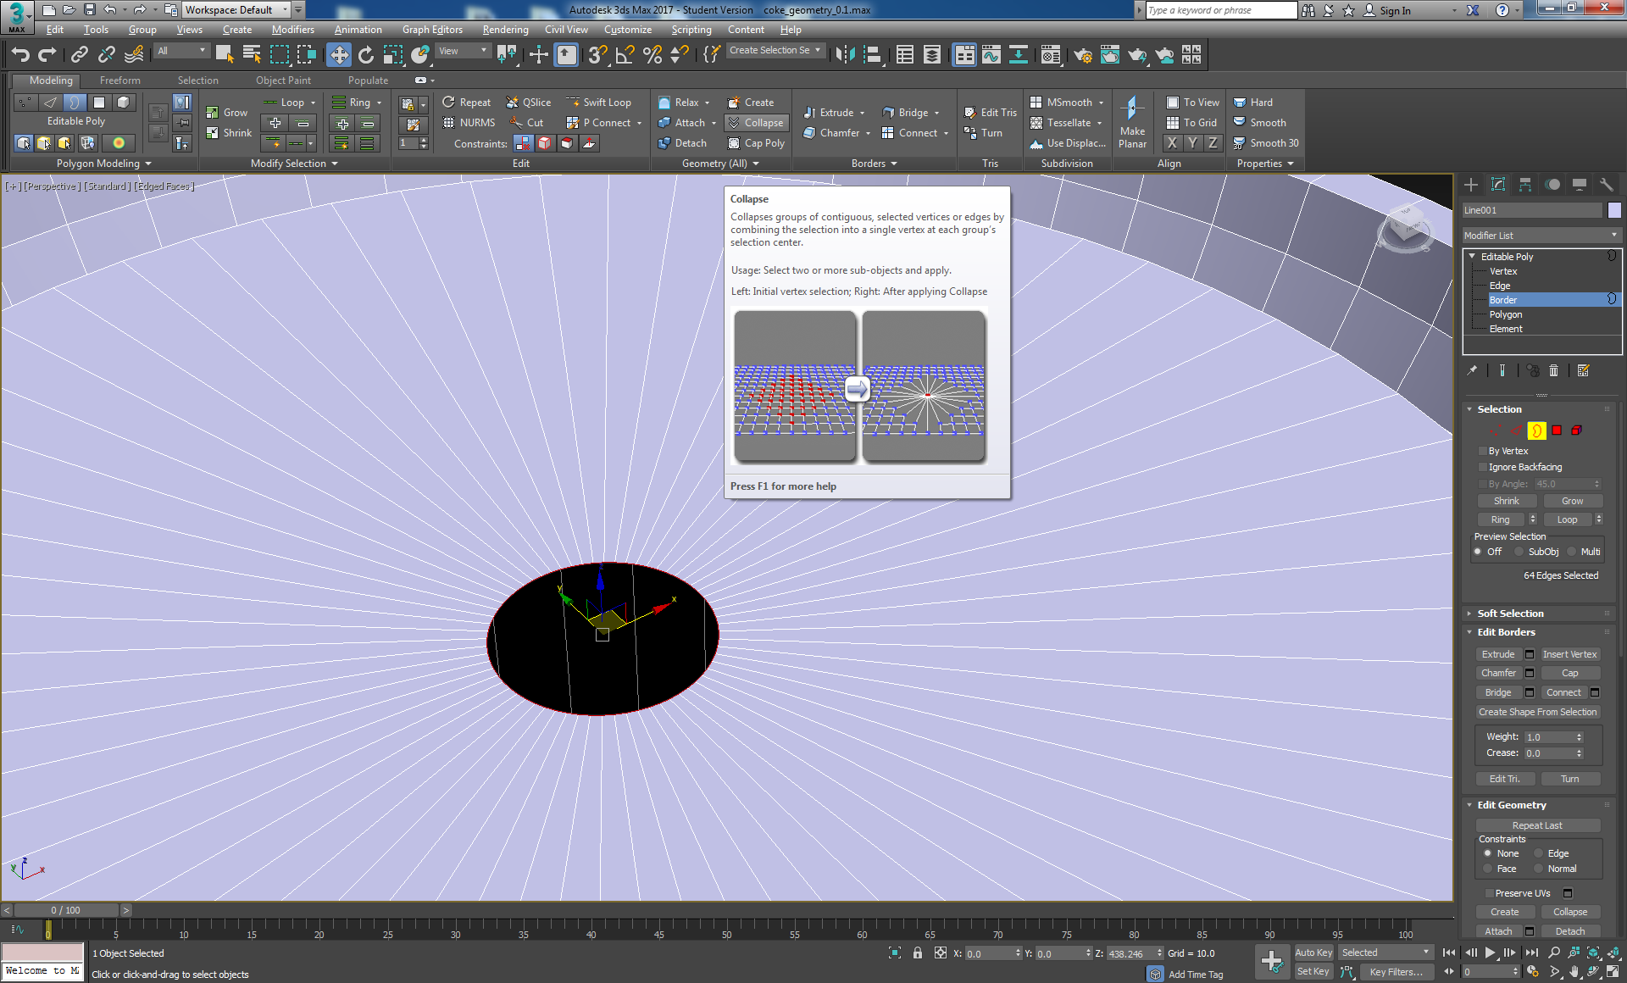

Figure 24: Holes in the top and bottom that need fixing.

Figure 25 illustrates the top hole closed.

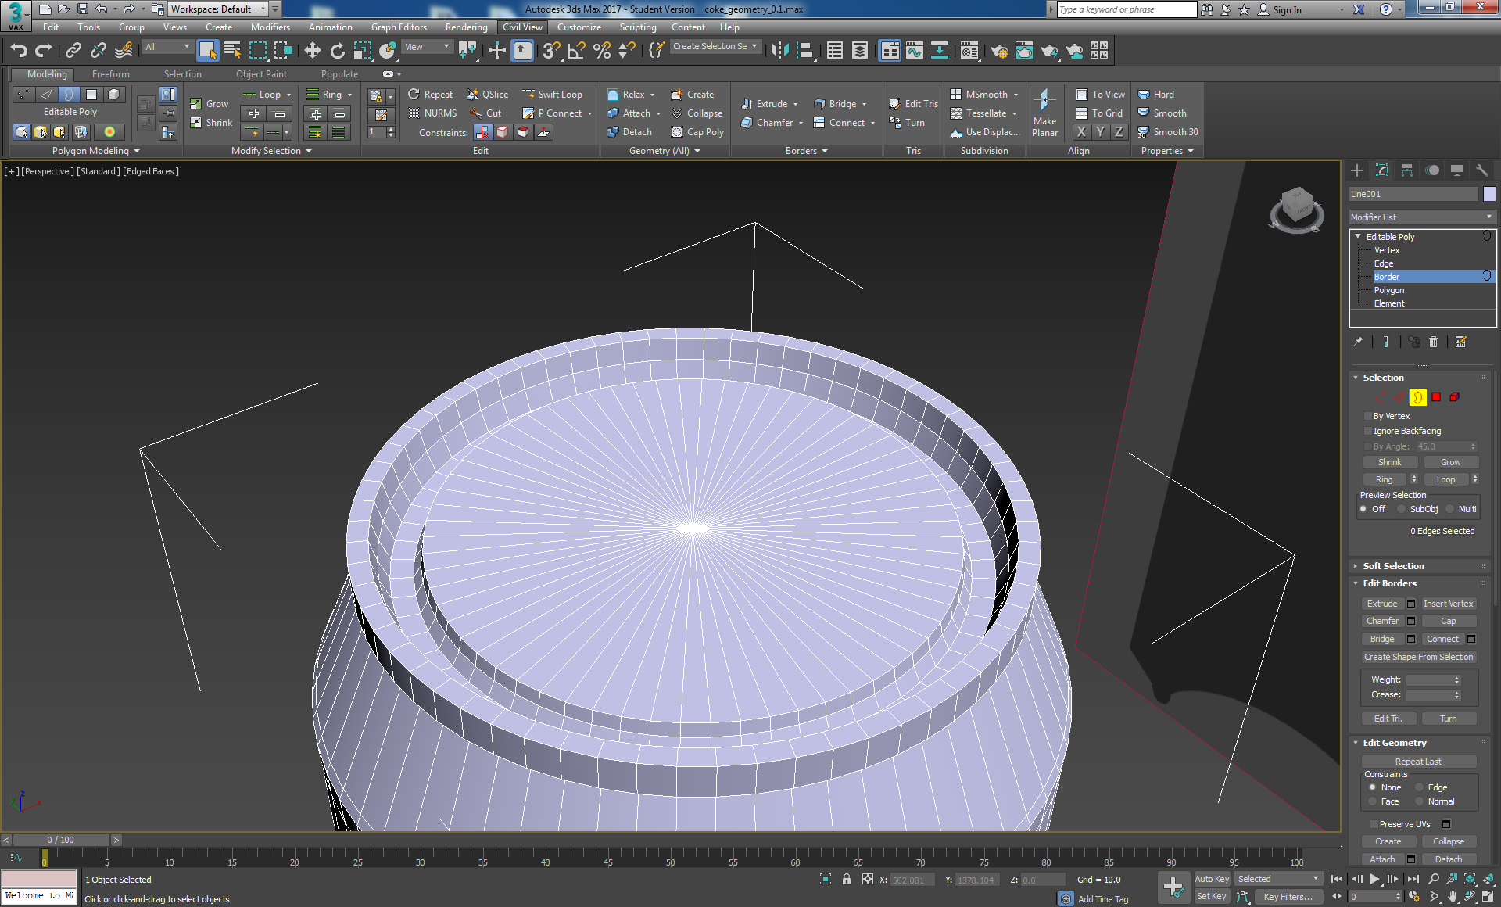

Figure 25: Zoom into the hole and select the vertex

You have now closed the hole on the top of the Coke can. Repeat this process to fix the hole in the bottom of the Coke can.

## Smoothing the Mesh

We have now finished with the can_blueprint, which we used to trace the splines round. While this is offset from the centre of the scene, I still find it gets in the way of positioning the can when working on its geometry. Save a version of the Coke can at this stage, and then delete the plane with the blueprint from the scene. Arrange your viewports so that you can see what you are doing.

Deselect the Editable Poly in the modifier panel for now, and then select [Standard][Default Shading] in the Perspective viewport, see Figure 26, to see the Coke can without wireframe, hidden line or edged faces. If you zoom in on the bottom of the Coke can geometry you will notice edges, concentric circles. Have a play with the settings for rendering in the perspective viewport, top left-hand side, right click on the text in the third set of square brackets and select Edged Faces — you can see the edges coincide with the facet effect. To make the Coke can geometry more realistic we need to smooth across these edges.

Tip! You may need to set up some lights to better see how smooth the geometry is currently; default 3ds Max lights currently provide illumination. If so, go to right hand side menu and select the lights button, then select Standard in the drop-down menu, click on Omni and click in the perspective viewport somewhere close to the can’s geometry (this adds an Omni light to the scene), choose another place and click again to add another light. Click the Move and Select button, then position the lights where you want them to illuminate the can. Do not worry too much about lighting now, we will cover this in more detail later. We are really just interested in smoothing the geometry for now. In my scene, I have not actually bothered with lights for now, because you can easily see the faceted effect before smoothing groups are applied.

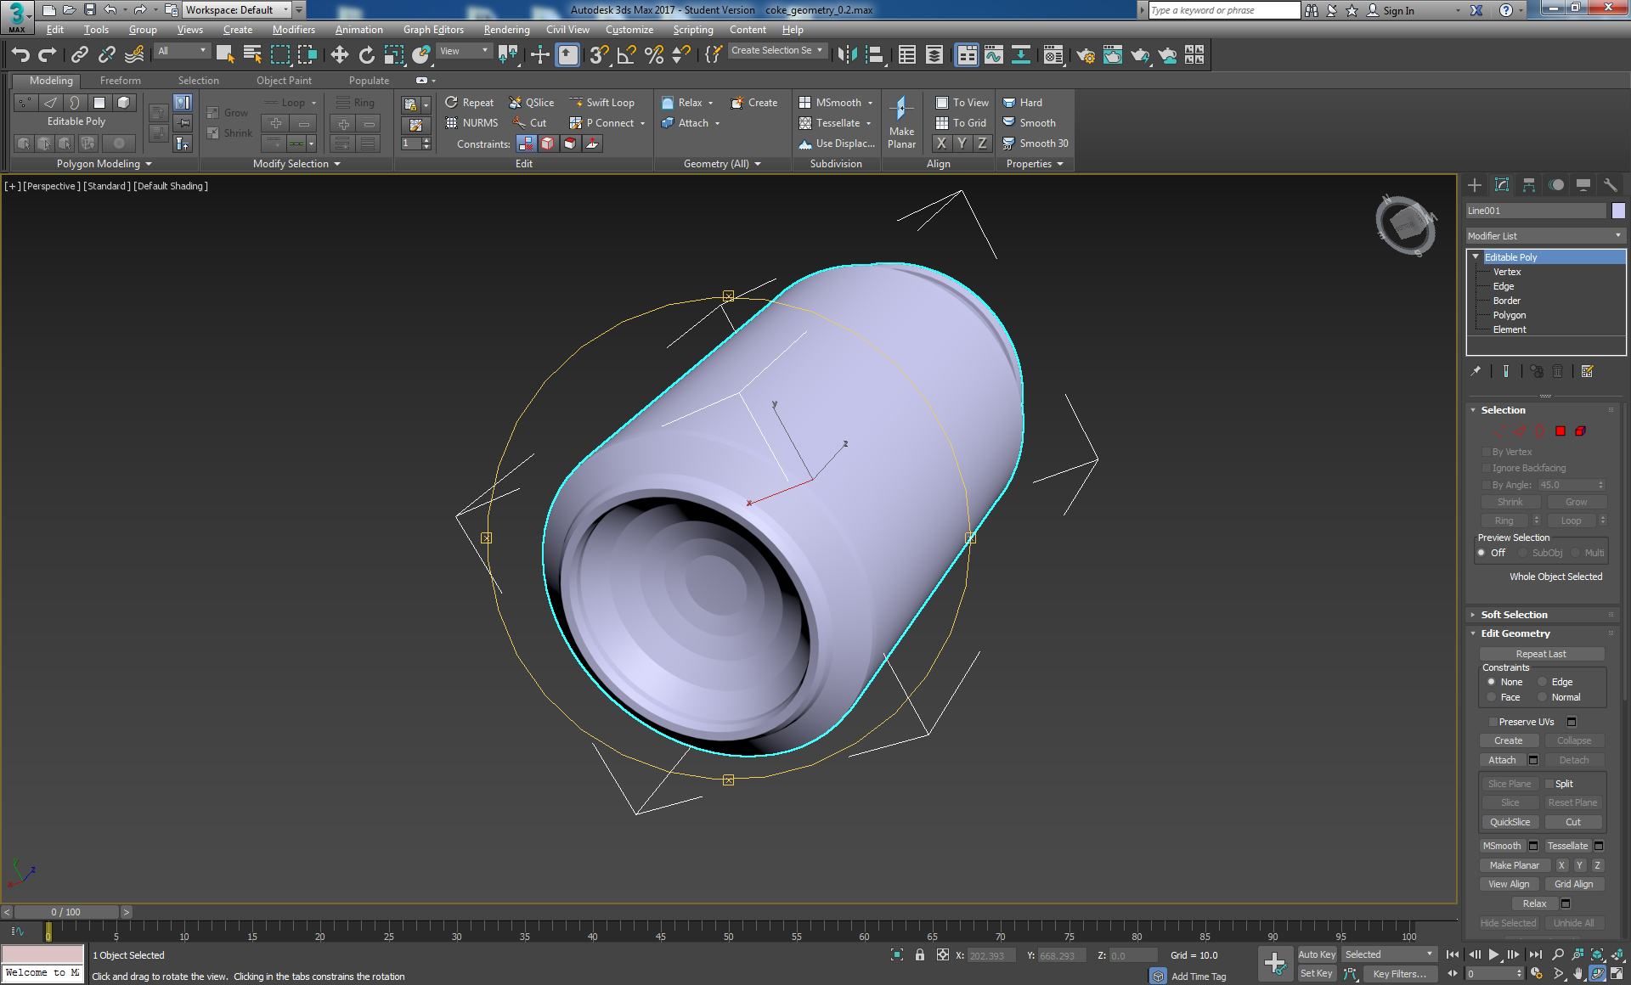

Figure 26: Faceted rendering without smoothing groups.

To smooth the geometry, where appropriate you will use *Smoothing Groups*. it is important to use smoothing groups and **NOT** tools such as the meshsmooth, because meshsmooth will usually create many more unnecessary polygons if not used carefully, which may result in undesirable overhead for web based rendering. If you want, you can have a quick look at a smoothed version by selecting the Coke can and turning on NURMS in the Graphite Modelling Tools, see Figure 27. It is also instructive to try rendering the coke as it is shown in Figure 26 and Figure 27, you can do this by pressing the Render Production (Teapot with Lighting Bolt) button, which you can find at the right hand end of the main tool bar above the ribbon, or simply use Shift Q. Compare and contrast the faceted version with the NURMS version. You will be aiming for the smooth of the NURMS by using smoothing grops.

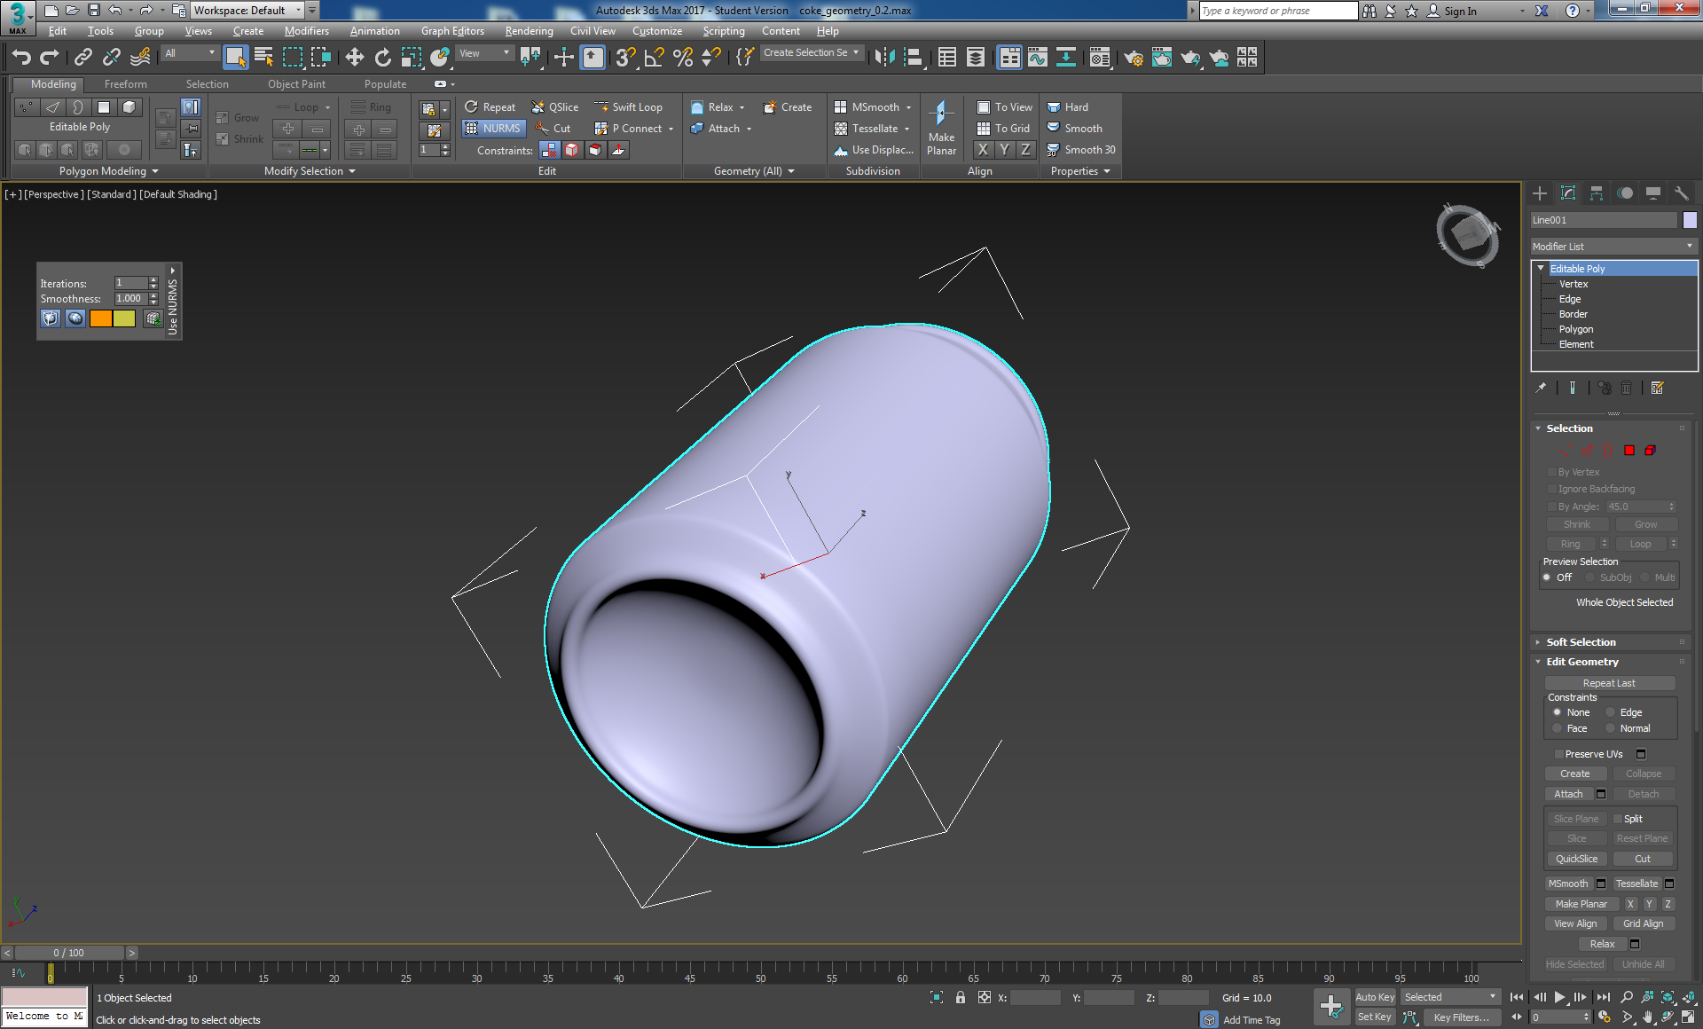

Figure 27: Open the Graphite Modelling Tools and click on the NURMS button, select the Coke can.

Switch off the NURMS and start to allocate smoothing groups to sets of polygons.

First select the Coke can, then go to the Modify panel  and choose the Polygon selection type . Select the body of the can excluding the top ring; you should have something like that shown in Figure 28.

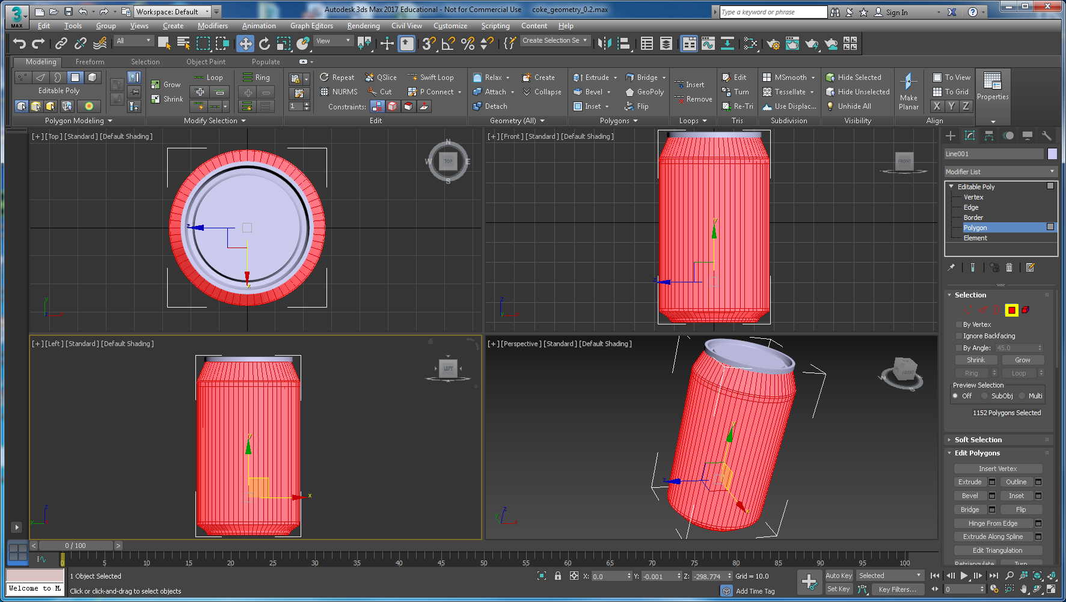

Figure 28: Select the Coke cans body and bottom polygons

Scroll down to the *Polygon: Smoothing Groups* section of the *Modify* panel and unselect any selected ids and tick just *id 1* for the body, see Figure 29.

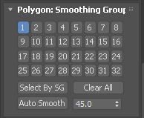

Figure 29: Select Smoothing group ID 1.

The can body will now be much smoother, as we can see on the bottom in the perspective viewport, see Figure 30.

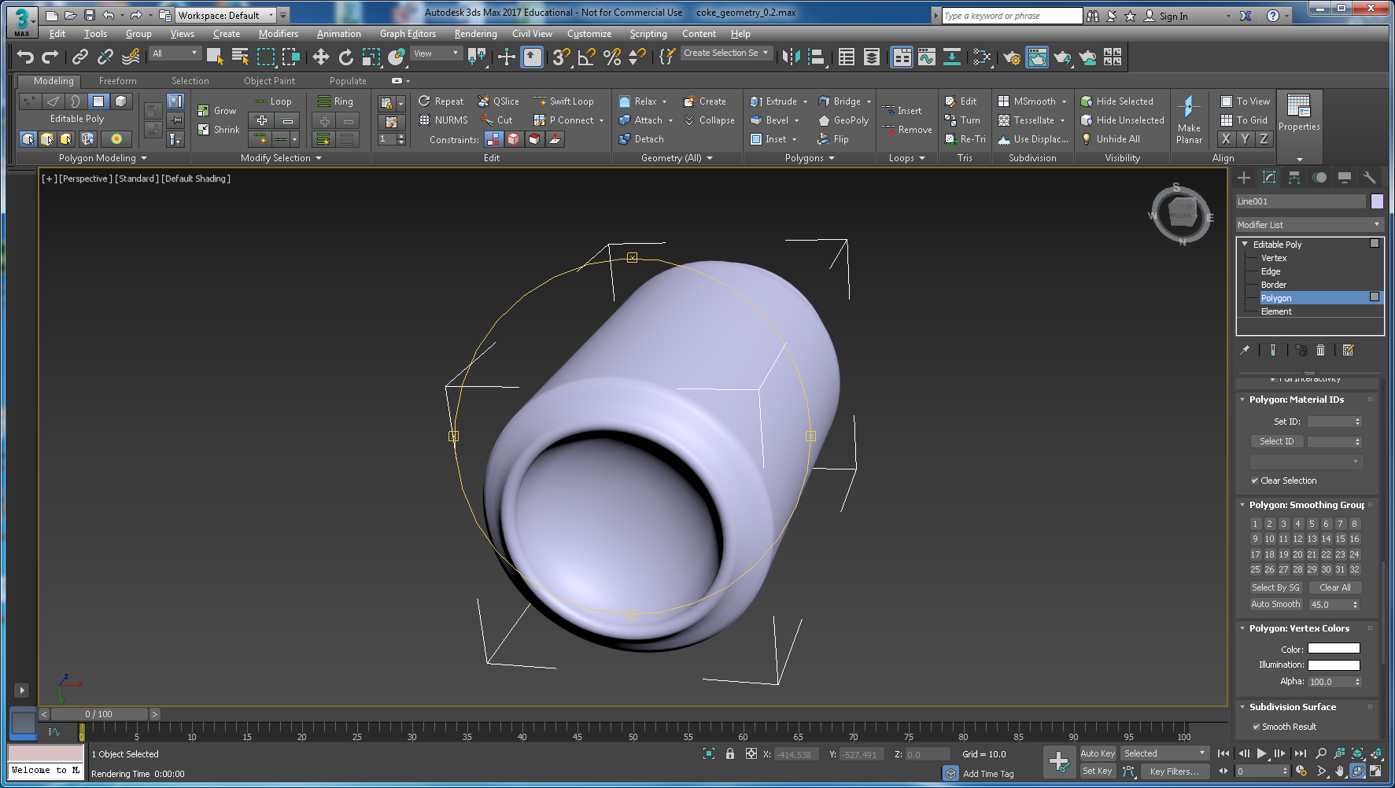

Figure 30: The Coke can body and bottom smoothed.

Remember when you lathed the geometry it quite often turns out that the geometry is created inside out. This means eventually, if you haven’t already done so, that you have to apply a normal modifier and flip it. You can easily tell if you try to render the can and it looks inside out. The render button is the teapot button at the top right. Figure 31 illustrates the Coke can geometry rendered correctly and inside out.

|  |  |
| --- | --- |
|  |  |

Figure 31: The Coke can rendered correctly (LHS) and with geometry inside out (RHS)

We now need to smooth other elements of the Coke can, we do this in the same way by assigning different smoothing group ids to other groups of polygons to smooth the top of the can’s elements, e.g. the neck, rim, etc. You can select multiple polygons by holding *shift* (although this can be tricky, it appears to have got easier as 3ds Max versions get more sophisticated)and clicking on them, while holding the alt key does unselecting, to select extra polygons one by one use the Ctrl key. If you lose selections, do Ctrl+Z to go back and recover selections. Occasionally while clicking you might move the mouse, in which case you will see the polygons move, just Ctrl+Z to get back the original position — you’ll get the hang of it after some fiddling. In addition, you can use the shrink and grow options on the Modifier Panel or the Graphite Modelling Tool Modify Selection panel

I suggest starting by selecting a polygon on the top rim, then hold the shift key and hover over selection over the next adjacent polygon, and you will see that 3ds Max then suggests the polygons you might want to select, i.e. the rest of the top rim polygons. Then select grow twice to select the rest of the Coke can top rim polygons to assign the next smoothing group. Figure 32 shows that I have selected all the rim, for this group set the *Polygon: Smoothing Groups* id to 2. Press F9 to quick render to check the results, or deselect Editable Poly and select [Default Shading] to see the smoothing result. You may also find it easier to do this working in an enlarged perspective viewport set to wireframe (or hidden line), and zooming in to reveal more detail.

Figure 33 show a rendering of the result. Notice the Coke can is partially in shadow; you can better illuminate when you set up some lighting. If you have already set up some lights, you can remove these when you set up lights later properly.

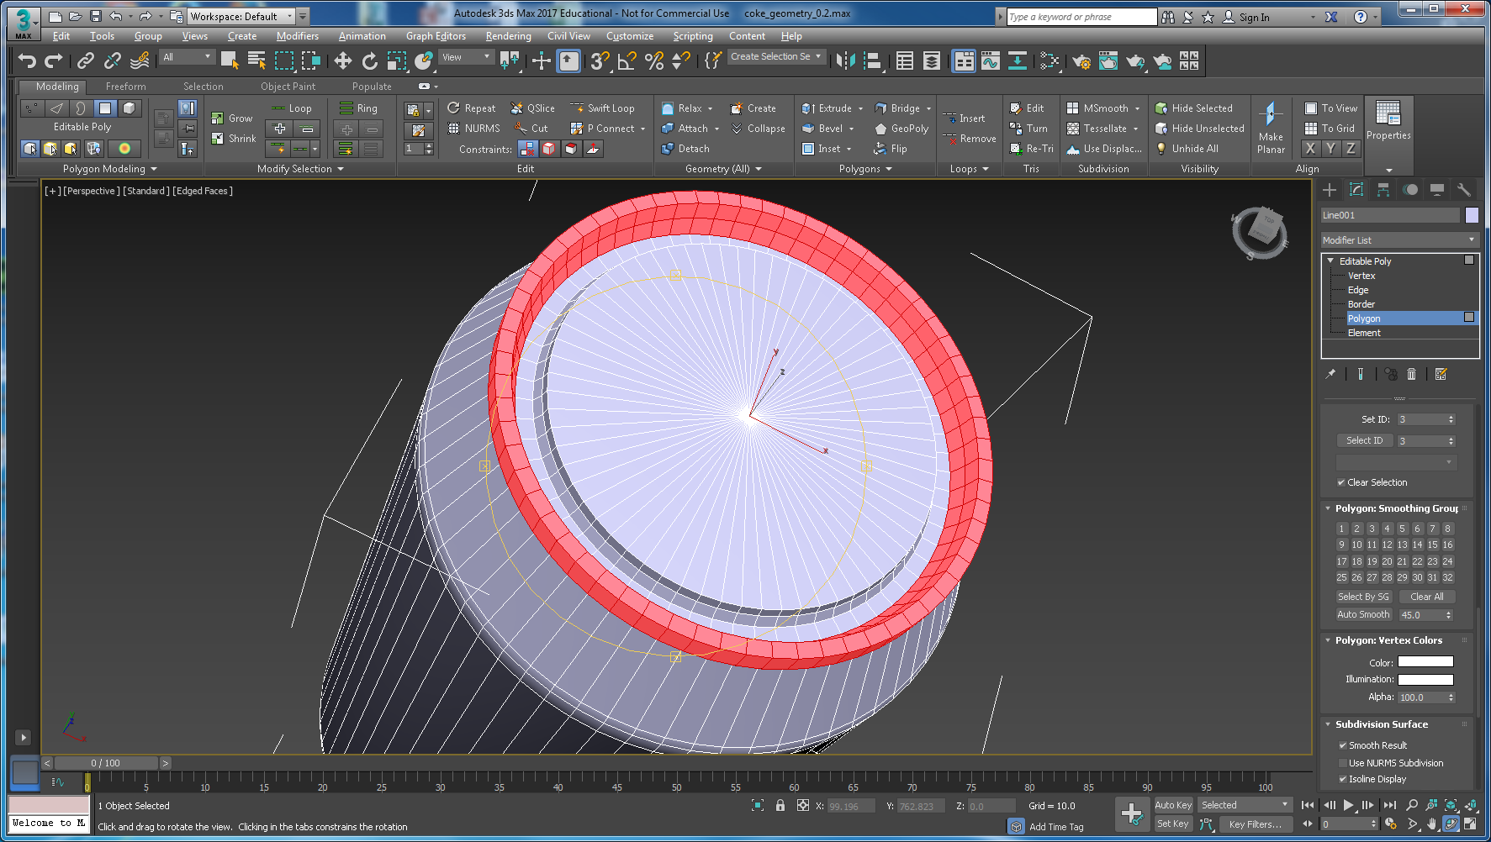

Figure 32: Selecting the rim of the Coke can

|  |  |
| --- | --- |
|  |  |

Figure 33: The rim smoothed.

However, the smoothing of the rim takes away much of the detail, it is over smoothed, IMHO. We’ll deal with that in a minute.

To finish the smoothing groups before we move onto texturing, we suggest you group the polygons forming the ‘valley’ of the lid, and the flat top of the lid itself, and assign *Polygon: Smoothing Groups* id 3 and 4 respectively. You may have realised by now that setting up smoothing groups is dependent on how you originally created your spline. The more points you created in the spline around the lid and rim would have created more edges and corresponding faces to group and smooth. In this particular case smoothing the inside of the rim with the valley may have made a better result, who knows, it is subjective somewhat.

So, our plan is to smooth the valley, then the lid and see how it looks, if we don’t like it, we can always redo it with different smoothing groups to get a better effect. We may also add some more edges to define better, tighter curves.

Tip! Setting the perspective viewport to hidden line (or edges faces) makes it a little easier to identify and select polygons for smoothing.

To smooth the top in Figure 35, I first adjust the geometry a bit. It may help to look at an actual Coke can rim. I did the following steps:

* I first made the rim a bit thinner by selecting the top inside edge, constraining it to edge and scaling it back towards the outer top rim edge.
* I then added some swift loops to the rim, valley floor and the edge of the top to add more definition during smoothing — we could have done this by adding more spline points, but would have been fiddlier.

Figure 34 illustrates the extra edges.

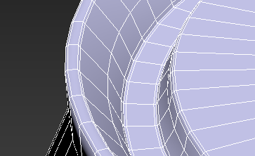

Figure 34: Geometry modified by thinning out the rim and adding Swift Loops to the valley floor and top.

Here’s the whole valley selected for smoothing. Remember to use a combination of Grow and Shrink Polygon with to select polygons, which makes it a tad easier. Figure 35 shows various stages of selecting groups of polygons for smoothing.

|  |  |
| --- | --- |
|  |  |
|  | |
| Take a closer look, swift loop added to get better definition on the smoothing, and I scaled the rim to make it a tad thinner after looking at a physical Coke can — NURMS is switched on to illustrate smoothing at the same time | |

Figure 35: Work in progress, selecting appropriate polygons, smoothing groups, and adjusting geometry.

You will appreciate that mastering the shrink, grow and shift combinations, and deselection of polygon groups will allow you to select much quicker! To get a more defined lid edge, I added a couple of swift loops using the Graphic Modelling Tools. The result so far is shown in Figure 36.

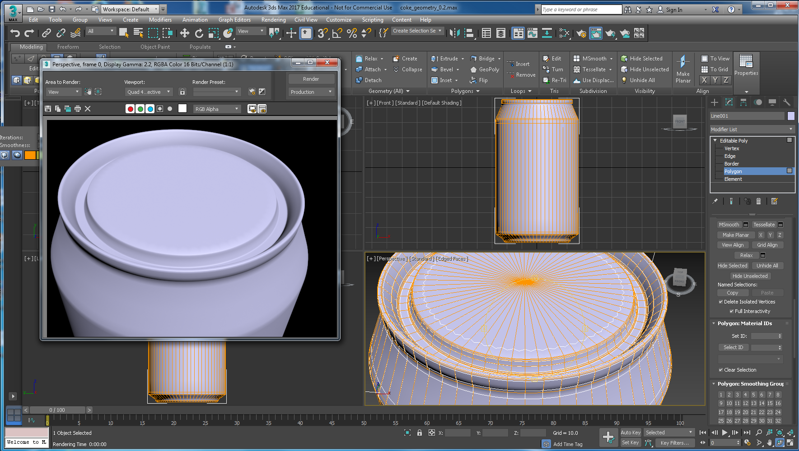

Figure 36: Level of detail in the geometry is improved on edges by scaling and adding swift loops, and setting only 4 smoothing groups.

Now let us texture the Coke can.

## Texture the Coke Can

Actually, even though we are happy with the Coke can geometry, the illusion of detail comes from the texturing. Texturing is important because it gives detail without the cost of geometry rendering. Texturing is the final process in the creation of this Coke can. It involves projecting the *can_texture.jpg* image onto the model.

The easiest way to think about texture mapping would be to recall those paper airplanes the you created as a child, perhaps you still make them, they are great fun! Imagine that you *unwrap* your paper airplane geometry, and glue the texture (e.g. pictures or decals of the symbols and paintwork) onto the appropriate parts of the unfolded paper and fold it back into a paper airplane. We will be doing the same thing with the Coke can, only this method of unfolding the paper (or geometry) and gluing on the decals is called *UVW mapping*, and the glue pot and brush will be the UVW Unwrap Modifier tool in 3ds max.

If you want to take a break and watch a video on UVW Unwrap, jump to Appendix E (recommended), which is the method we are going to use.

Let us start by simply dragging the texture material that you placed in your sceneassets/images folder in the section ‘Blueprint Setup’ onto the Coke can (remember, you can open the material editor by pressing *M*). You will not see anything at first until you follow the next step, see Figure 37.

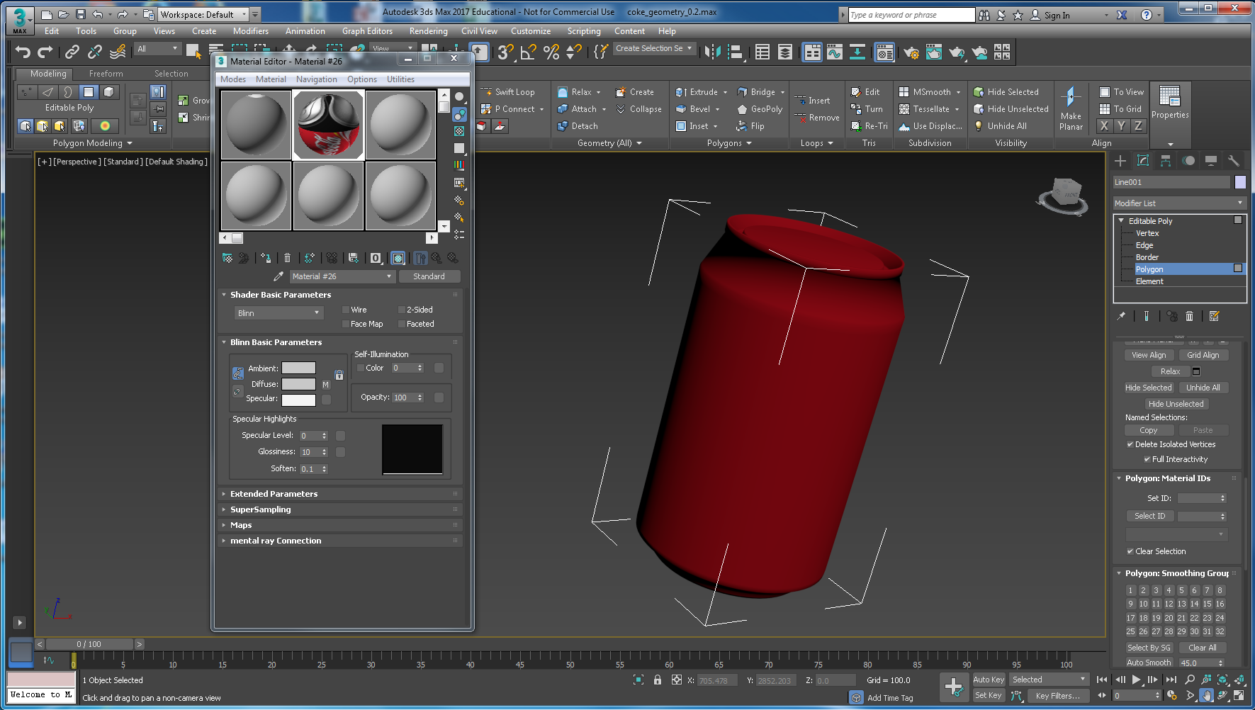

Figure 37: Drag the Coke can texture material from the sphere onto the Coke can geometry.

The reason you won’t see your texture applied to the coke can at the moment is simply because you have not yet assigned any texture coordinates (UVW) to the coke can. You do this using the Unwrap UVW modifier. You could apply the UVW coordinates first, but then you also need to apply texture projections to the various parts of the coke can. Indeed, all the basic primitives supplied by 3ds Max, e.g. Box, Sphere, etc. should already have these UVW coordinates built in.

Go into *Modify* panel  and add an *Unwrap UVW* modifier. You will find the Unwrap UVW modifier in the Modifier List down near the bottom of the list; see Figure 38, which shows the Unwrap UVW modified added on top of the Editable Poly modifier. You can also close the material editor now.

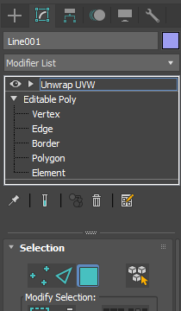

Figure 38: The Unwrap UVW modifier added, select the polygon

Once you have the texture applied to your coke can and the Unwrap UVW modifier applied you can see that the Coke can’s texture looks wrong, see Figure 39. This is because it requires a specific texture projection — the texture project is a mathematical operation that maps the texture UVW coordinates onto the objects XYZ coordinates, only this mathematical projection is hidden from you by the clever folks at Autodesk.

Tip! You could have got close if we had broken the Coke can geometry into different parts, e.g. the cylinder body and created just the texture for that, and so on. Actually, you will do this for the Sprite bottle, because the Sprite bottle decal (or label) is simply a cylinder mapping. However, we want to be able to create composite textures (in Photoshop) for efficiency, and use the UVW Unwrap Editor to position the textures onto the geometry where we need it.

In the selection roll out, select polygon the Polygon option (circled in blue in Figure 38 and Figure 39, and note that depending on which version of 3ds max you are using, the interface symbols may vary a little), and open the *UVW Editor* on the Modify panel Edit UVs pane, it should be somewhere near where I have circled in red. It is located on the Parameters rollout in the Modify panel on the right-hand side of the 3ds Max interface. Specifically, the UVW Editor is located on the Edit UVs roll out panel, see Figure 39.

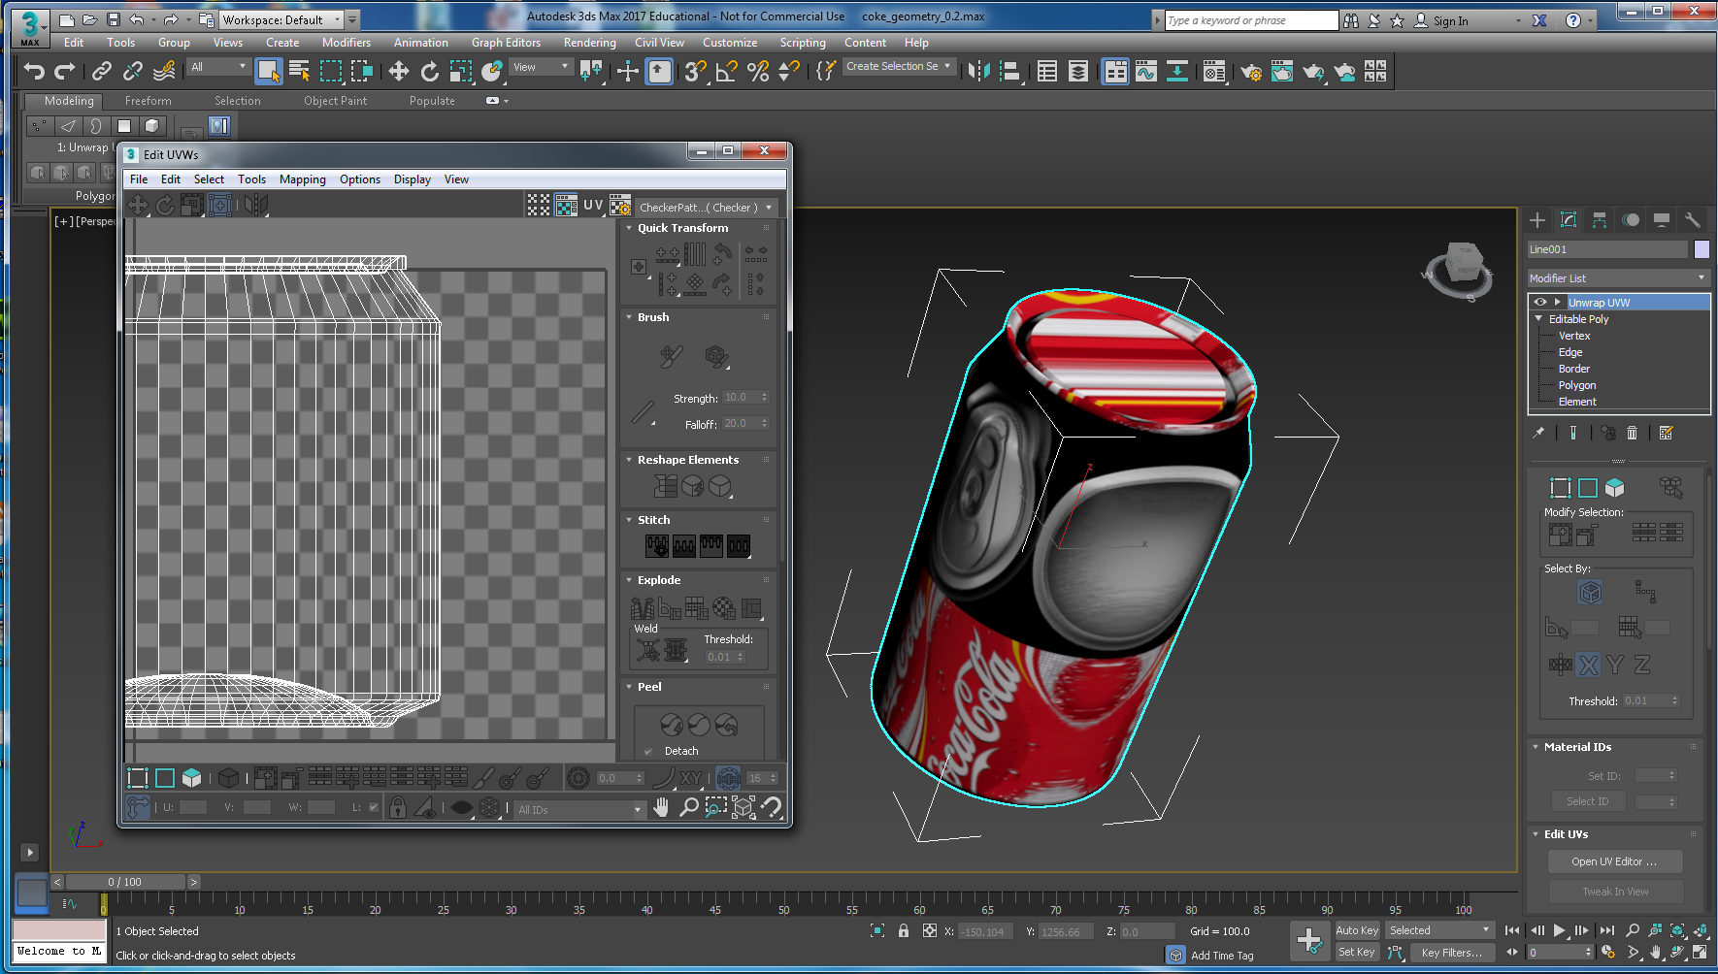

Figure 39: Select the polygon of the Unwrap UVW modifier, click on open UV editor

The UV editor is a set of tools that we will use to create the correct texture projection. Make sure the Display Quick Planer Map is selected, Figure 40.

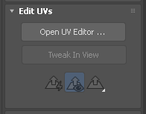

Figure 40: Select Display Quick Planer Map.

When the UVW Editor is opened, you should see the following Edit UVWs interface, which shows the Coke can polygons sort of flattened out, i.e. unwrapped, see Figure 39 above.

In the top right corner of the UVW Editor, you should select the *can_texture.jpg* to make texture visible in the editor, see Figure 41.

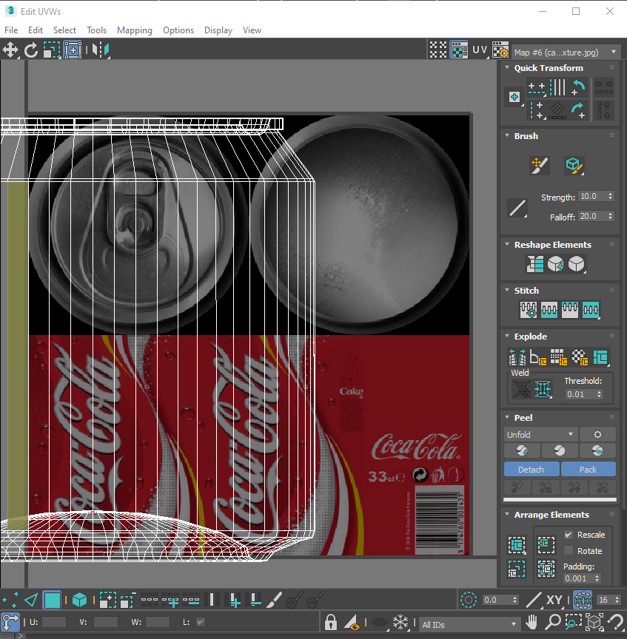

Figure 41: The UV Editor showing the Coke can geometry and texture map.

This is the Coke can’s default projection. The UV Editor interface looks a bit complicated, but it is manageable. This is a good time to save your work to a new version so you can reload back at this point if you cock up the texturing.

We first want to try to map the Coke decal (texture map of the Coke label) onto the cylindrical part of the can, that is, from just below the rim at the top to the bottom of the can. To do this you need to select (either in the in the UVW editor itself, or in the Left viewport for example) the polygons onto which you will map the Coke texture map. You may have to increase the size of the UVW Editor to see all the unwrapped polygons before selecting them.

If you use the Left viewport to select the polygons, then it is easy to just drag and select. However, you have to be careful here because sometimes not all the polygons for texture mapping have been selected. Switch to perspective view and rotate the Coke can to check all body polygons are actually selected. If you do not select all the correct ones, your texture will not look right. However, in this case it is much easier to select the body polygons in the UV editor, see Figure 42.

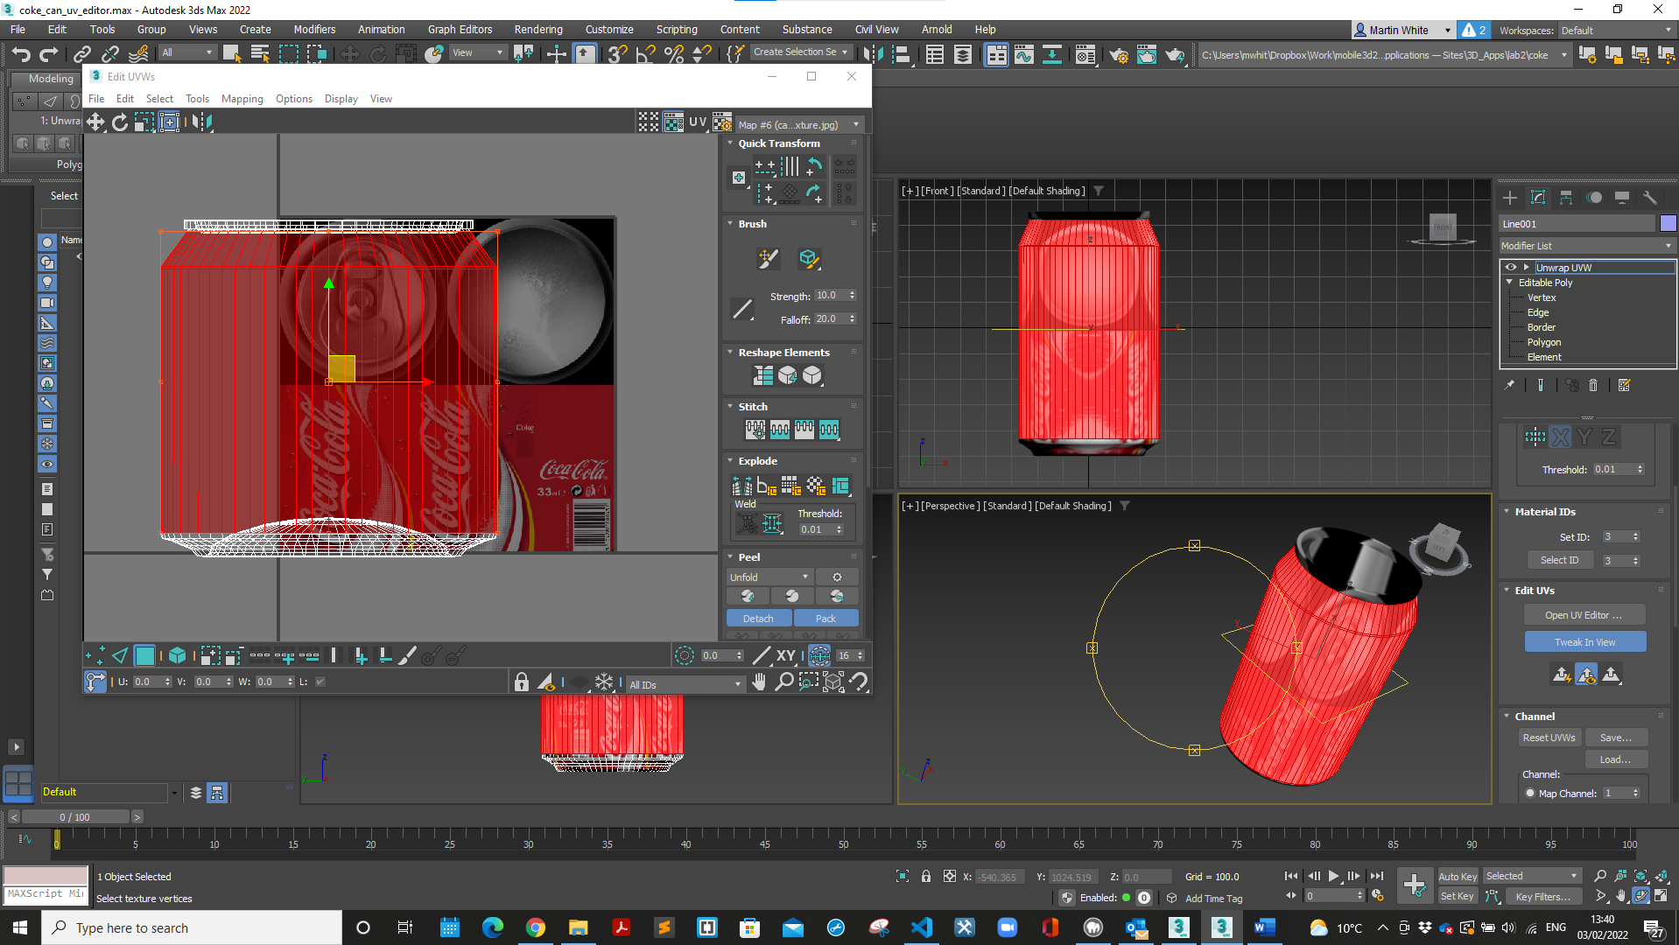

Figure 42: Coke can body selected in Left view, and we can see this geometry is selected in the UV Editor.

So, set your UVW Editor and Perspective viewport like shown in Figure 42, and make sure Polygon is selected (I spent over an hour stuck here once because I hadn’t noticed that I had Edge selected, you have to map textures to polygons NOT edges or vertex.

You will observe two things: 1) the polgons are selected in the Edit UVW editor, and they look like a mesh; and 2) in the perpsective viewport you should notice a yellow plane bounding box for the texture. At the moment we haven’t selected the texture projection or mapping.

Next we want to try one of the available mappings to see if we can get a better mapping onto the body of the coke can selected than the original default, let’s try the *Cylindrical Map* projection. To do this go to the Projection roll out on the Modifier menu (you will most likely have to drag the Modifier panel up a bit to find the Projection roll out. When you find it, you will see 4 shapes representing common projections for texture mapping (Planar, Cylindrical, Spherical and Box); choose Cylindrical because this best fits the shape of the geometry of the polygons selected, see Figure 43.

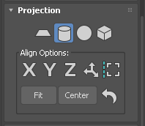

Figure 43: Select the Cylinder projection.

Notice the polygons to be textured are now decoupled from the lid and bottom polygons, and they have moved to map onto the texture — the polygons still have to be scaled to the correct part of the texture, i.e. the body. The texture is a composite texture representing the can, bottom and lid, and we can see that the polygons have been scaled to the combined texture. Also, in the perspective viewport we can see two things: 1) the yellow plane has now become a cylinder representing the cylindrical mapping or projection, and 2) there are some green lines, which represent seams in the texture. Use that square thing in the upper right corner to examine the can more closely. One other thing, you might also notice that the geometry is upside down in relation to the texture map depending on whether you still have the geometry inside out. In my case the geometry just needs aligning more carefully, see Figure 44.

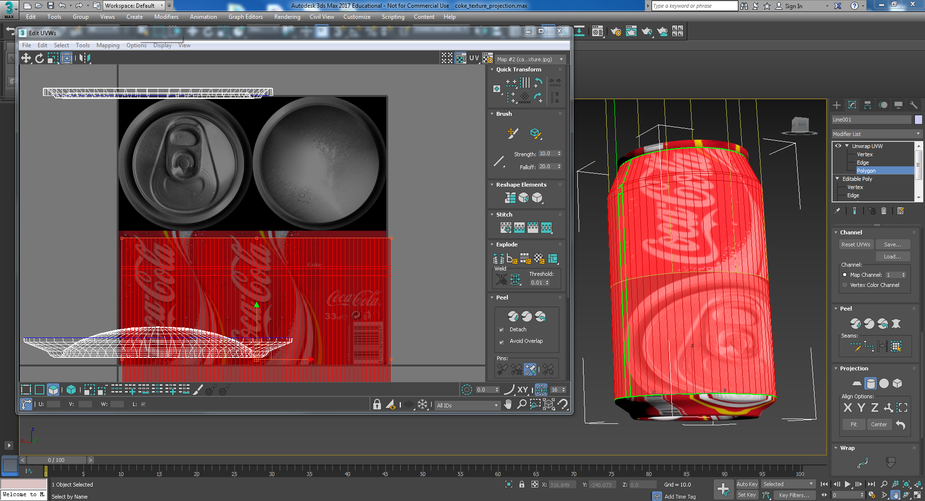

Figure 44: Using the cylinder projection.

You can select the yellow cylinder to move, rotated and scale to modify the projection of the texture onto the polygons selected, and in my case I will just move it down to better align. However, generally, it is better to use the UVW Editor to manipulate the geometry mesh onto the appropriate part of the texture map. Click on the UVW Editor window, you will notice in the bottom right hand corner there are a selection of tools for zooming, etc. Click on Zoom Extents to get a better view, or use the hand to move the screen about, if you have not already.

The cylinder projection has done a good job, but will require some tweaking. Therefore, we will need to use the move, rotate, scale and freeform functions to map the polygons to the appropriate part of the texture map.

Note, in my 2022 version, my mesh elongated for miles in the top bottom direction, so while selected I had to use a combination of scaling down (shrinking) down the mesh and widening it to fit the can body texture.

**First, select the Tweak in View button on the Map Parameters roll out on the Modify panel**. Then select Scale in the UVW Editor. You cannot manipulate (tweak) the geometry in the UV Editor unless you select the Tweak in View. You will find Freeform (upper left corner of the Edit UVW interface) is need to initially scale the polygons to the lower half of the texture map, then fiddle a bit with move and scale again when zoomed in to get an accurate mapping. Figure 54 shows the tools needed to scale the geometry to the correct part of the texture map.

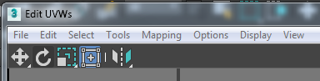

Figure 45: Use these tools to map the geometry onto the texture.

You should have matched the body part of texture projection to the Coke decal as shown in Figure 46. Noticed, we have moved the top and bottom geometry out of the way a tad so that we can scale the body geometry onto the correct part of the texture map with interference.

Figure 46: The mesh body of the Coke can with the correct texture project mapping.

Once you have the textured mapped, you should get a result something like Figure 47:

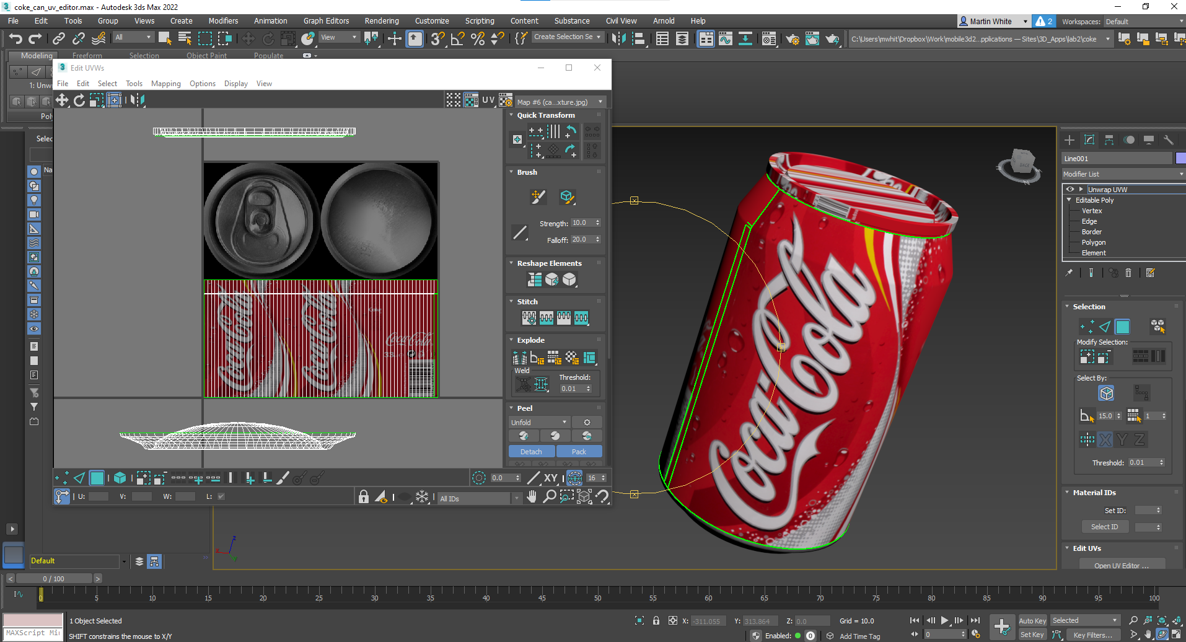

Figure 47: The body of the Coke can textured correctly.

Next, the top and bottom sections need to be projected properly. Using the same methods, select the polygons of the top of the can and apply a Planar Map projection — make sure you have selected the modify panel, Unwrap UVW, Polygon and click on the Open UV Editor to bring up the Edit UVWs editor if you have closed it. Figure 48 and Figure 49 illustrates stage of selecting the top of the Coke can geometry in the UV Editor, selecting a planar map, make sure ‘tweak in view’ is selected, and then scaling and positioning the texture and geometry together.

Note again, in my 2022 version, my mesh suddenly scaled up very large, so while selected I had to use a combination of scaling down (shrinking) down the mesh fit the can top texture.

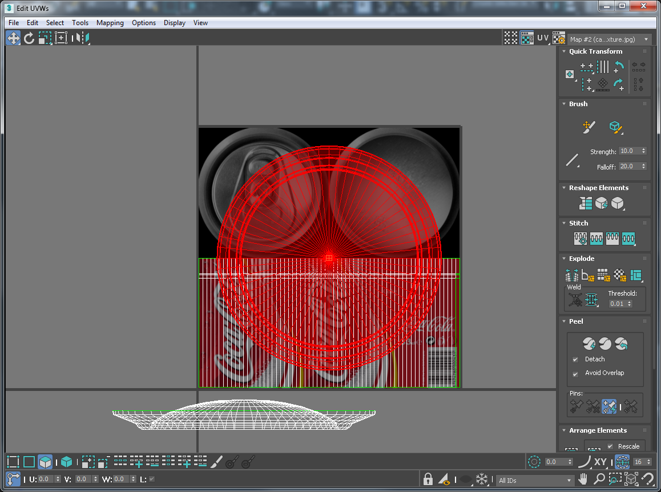

Figure 48: Select and planar map the top geometry.

This projection must also be scaled and repositioned to overlay the top left quarter of the texture corresponding to the top of the can; do not forget to click on Tweak In View. You can hold the *ctrl* key down while scaling to maintain aspect ratio. It should be placed as shown in Figure 49.

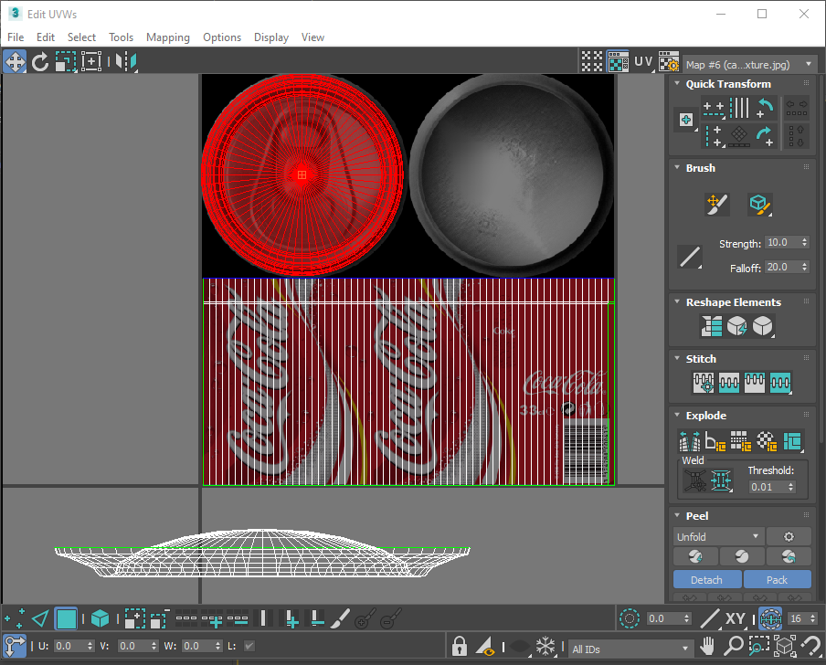

Figure 49: Correctly position top geometry.

Repeat the process for the bottom of the can using the planar mapping and the texturing will be complete. Figure 50 shows the completed position of the geometry in relation to the texture maps.

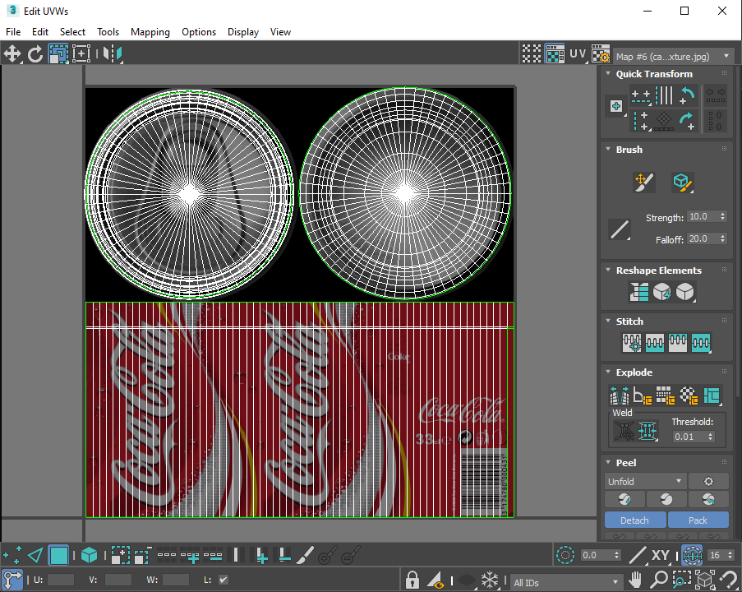

Figure 50: Texture mapping completed in the UV Editor.

When you have finished the texture mapping you can close the Edit UVWs interface, and deselect the Unwrap UVW on the modifier panel. In fact, select the Create button, because you will be sorting out lights soon. Also, it might be a good time to save a new version! You can collapse the Unwrap UVW by right clicking on the coke can and ‘converting to edible mesh’ or right clicking on the Unwrap UVW and selecting ‘Collapse All’. Again, save when collapsed. Also render the can to see the final result, see Figure 51.

You should now have a textured Coke can, well done! After setting up lights, and cameras next you should then use the same principles to create the other two models, i.e. the Sprite bottle and the Dr Pepper cup — that’s really to get modelling practice in.

## The Textured Coke Can

Your results so far should like this that shown in Figure 51.

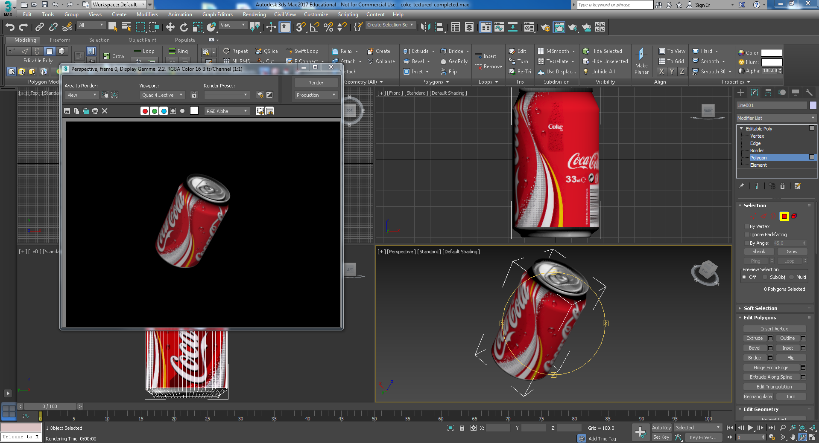

Figure 51: Final modelled and textures Coke can.

Next, we’ll play around with some lights and cameras to produce some 3D images for your Mobile Web 3D Application. First, zoom in al all parts of your Coke can, do you notice any texture anomalies? Depending on the level of detail required, how close up the model will be viewed you may or may not notice any anomalies. You could spend some more time trying to get better results, but this is good enough for now, see Figure 63 after lighting.

## Lights and Cameras

You should now add (or modify) some lights and a camera or two to illuminate and see your 3D models from different angles, etc.

### Lights

We suggest you initially surround your 3D object with 3 Omni lights, see Figure 52, above and the same from underneath (could be less). Go to the Command panel tabs and select Lights, then choose Standard (not Photometric) and select Omni, then drag it onto one of the viewports and start to position it. Repeat for the other Omni lights. Feel free to have a go at using the Spot and directional light sources. You have a choice between target and free versions. Target allows you to select a target at which the light will shine.

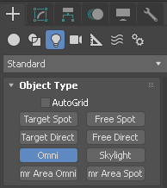

Figure 52: Select Omni lights

With 6 Omni lights in the scene it may be washed out, so select Tools > Light Lister to adjust the multiplier and tone it down. Figure 53shows a final rendering.

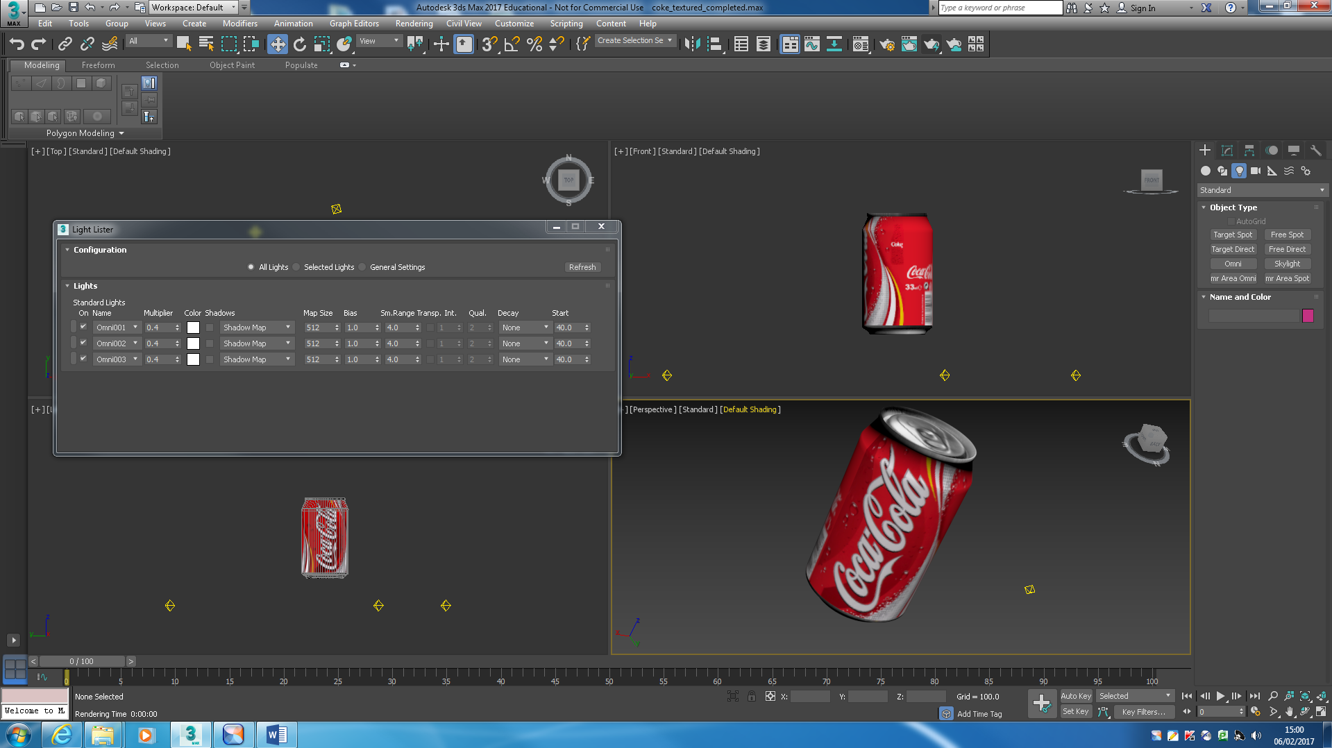

Figure 53: Added a constellation of Omni lights, each set to 0 .4 multiplier to tone the overall illumination down in the Light Lister (Tools> Light Lister)

Of course, there are many ways you can improve this 3D model of the Coke can. You could, for example model the Coke can top more carefully with geometry, and develop better aluminium textures to map onto the constituent parts. More care over the lighting could be done, this version has too many Omni lights and is still washed out somewhat. I leave you to consider improvements, see Figure 54 for final close up render.

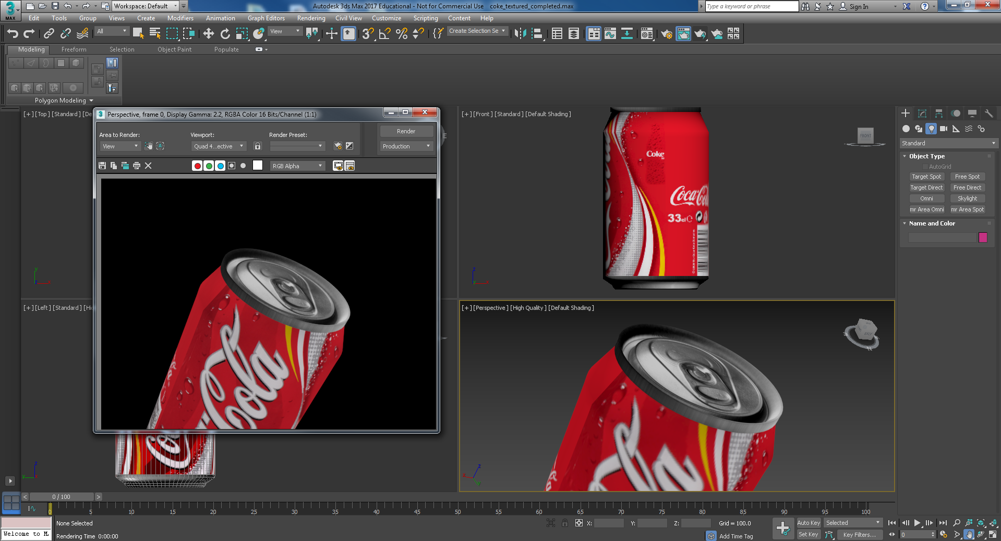

Figure 54: Final close up rendering.

### Cameras

Now add cameras, you have a choice of free and target cameras. Go to the Command panel tabs and select Cameras, then choose target. You might want to maximise the perspective viewport to insert the cameras. After Target camera selection, click in the viewport and drag to initially position the target element. You can then use Select and Move to position the target and the camera. Next add either more free or target camera. If you add a free camera click on the free camera and then click in a viewport. Then use Select and Move to position the camera, and Select and Rotate to aim the camera. You may also want to play round with the camera parameters, see Autodesk 3ds Max Help … for more information on setting up cameras. Pressing Ctrl C also implements a Physical Cameras from your current view point.

Figure 55 show the 6 Omni lights and 3 target cameras. When you complete your 3D App, you will pay more close attention to cameras because you will add buttons in the 3D App to select chosen camera views, and for that matter to turn off and on lights.

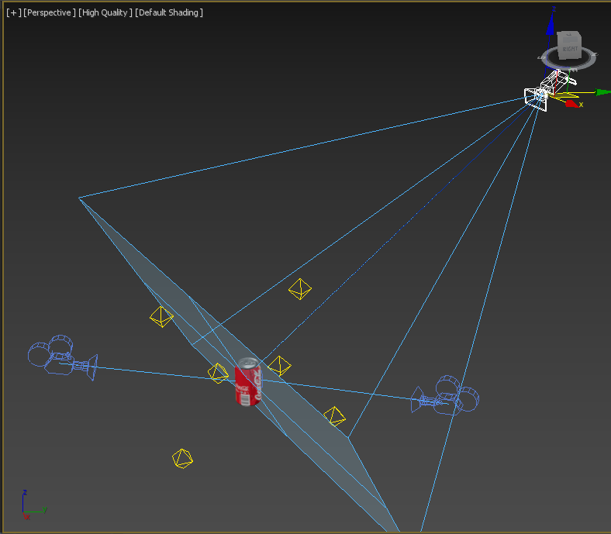

Figure 55: Lights and camera setup for the Coke can

Well done, that concludes all the minimum 3D modelling, texturing, lighting and camera work you may need to get complete models for your assignment.

However, there is a caveat! If you wish to use your modelling work to gain one of the extra 5 mark blocks in the assignment you will need to model at least one object at a more sophisticated level. In that case, please complete the following sections (Sprite and Dr pepper Cup) of this tutorial over the coming weeks in your own time to gain more experience. Of course, there are many online tutorial, you can follow too. Your assignment may contain 3D Objects of the complexity of the Coke can and Dr Pepper Cup and this will open up all the marks assigned for the 3D modelling, but not the deeper understanding marks.

Examples of gaining deeper understanding marks for the 3D modelling part could be:

* [5 marks from the deeper understanding mark allocation] Create a model of similar complexity to the Sprite bottle
* [5 marks from the deeper understanding mark allocation] Investigate and use Photorealistic rending to create Photorealistic 3D images of your models to use as media elements in your 3D App.

Add these marks to those deeper understanding marks gathered from using different 3d content authoring [5 marks] and a different workflow, see Lab 3, [5 marks] and that completes a full house of 20 marks automatically allocated. There are, of course many other ways to gather those deeper understanding marks across the whole 3D App development space.

# Creating the Sprite bottle in 3ds Max

Completing the 3D coke can in 3ds Max 2022 version has been tested above. The following sections, Sprite Bottle and Dr Pepper Cup have been written for 3ds Max 2019, but as you can see above I have interwoven screen shots from both 3ds Max 2019 and 2022 and there is basically no discernible difference in process so we wont change the text and images below for this season.

Now you have finished the Coke can we will have a go at modelling the Sprite bottle, however, let’s try a different technique this time — you will have seen such techniques in some of the video links in Appendix C, or in previous 3ds Max tutorials. Again, you will need to use a suitable blueprint. Search for a suitable image to use as a blueprint on Google, download and create a sprite_bueprint.jpg, and while you are at it you may as well create your dr_pepper_blueprint.jpg too. I think, if I recall correctly, my Sprite blue print is not 100% symmetrical, so you might find a better one, but having said that, it doesn’t matter that much because this modelling method will produce a symmetrical Sprite bottle.

It is a good idea to use blue prints as reference images to ensure you have the right scale between the three objects you are modelling. You will also need to find suitable textures. However, as before you should feel free to follow/adapt any other online tutorial for creating similar objects if you wish. The objective is to get some 3D modelling experience. As before, for alternative techniques jump to Appendix C.

So, we will now model the Sprite bottle in about 20 key steps:

**Step 1:** Set up an image for reference — you could alternative build the geometry shape by eye, see Figure 56. Don’t forget to push back the blueprint, say 500 in the X direction.

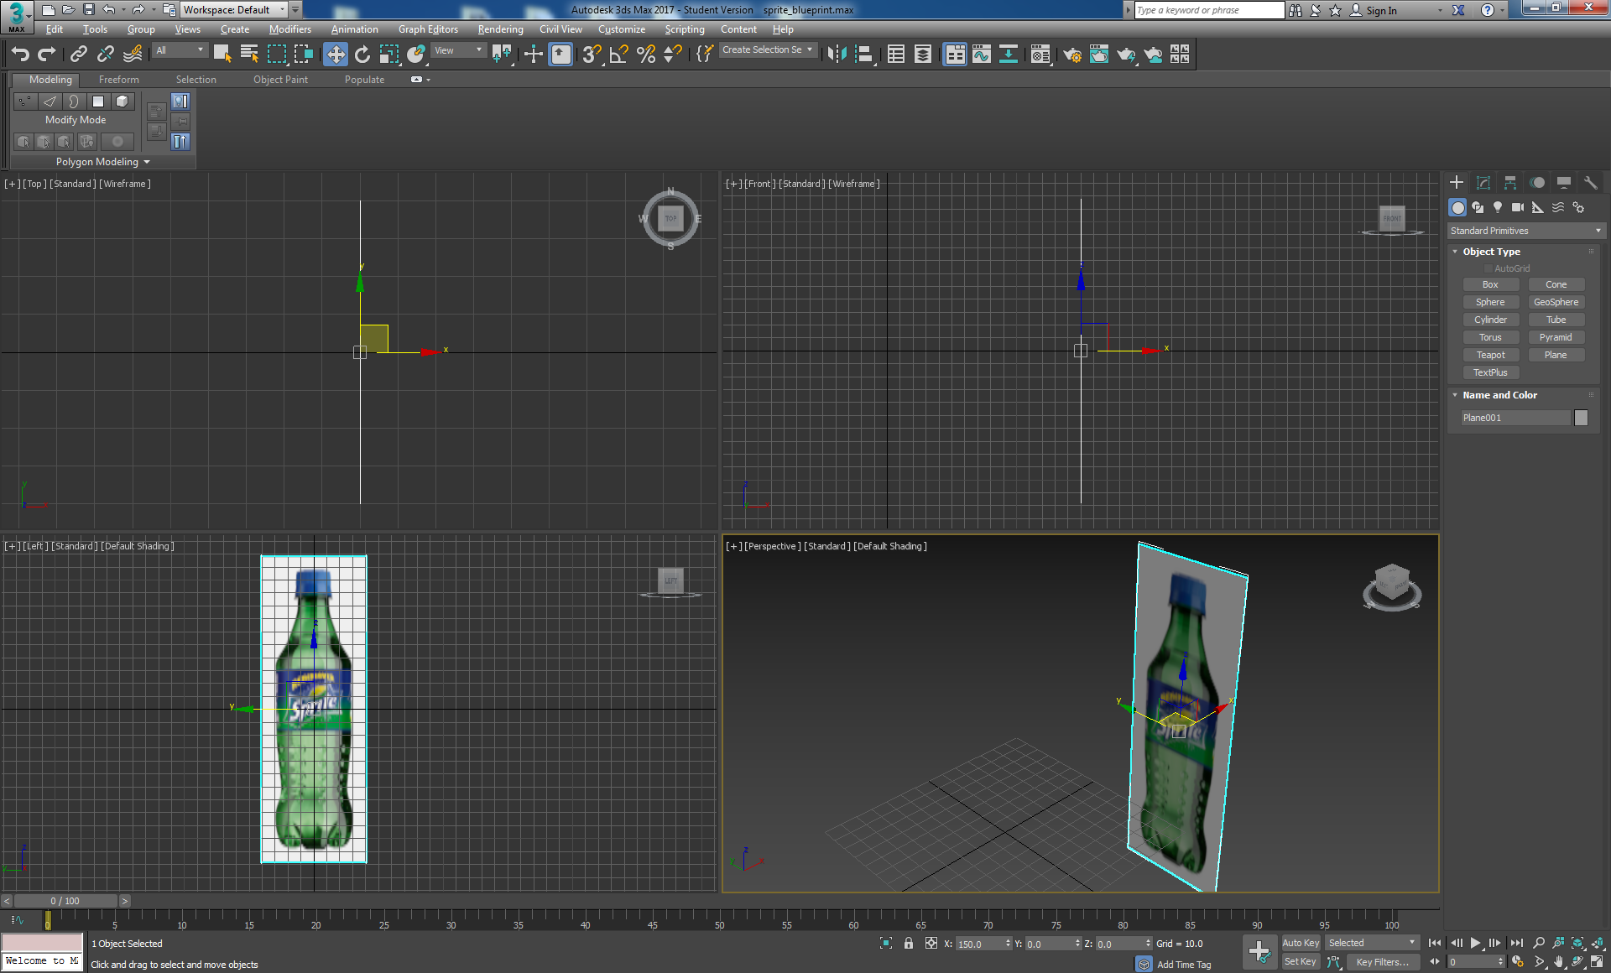

Figure 56: Setup the Sprite blueprint

**Step 2:** Start off with a cylinder primitive (height segments 1, sides 20) positioned 0,0,0. Work in the Left view port, but initially place the cylinder in top view port so that is oriented correctly in the Left viewport, and check the other viewports for accuracy regularly.

We have chosen 20 sides to achieve a reasonably complex geometry to get a better smoothing without being too outrageous on final polygon count — remember, rendering for the web, we need to keep polygon count as low as possible while achieving the desired effect. The reason for choosing 20 sides is that if you look at a physical Sprite bottle and count the dimples and feet they divide into 20 nicely. See Figure 57.

**Step 3:** Move and scale the cylinder to match the Sprite image silhouette, see Figure 57.

**Step 4:** Convert cylinder to editable poly.

**Step 5:** Select and delete the cylinder top cap, see Figure 57. Note here, you can now see inside the cylinder, which appears dark because the surface normal is now opposite to the outside and this is used to determine how you see the render. If you actually render the scene the inside disappears unless you force-2-sided rendering or apply a material to both sides.

|  |  |  |  |  |
| --- | --- | --- | --- | --- |
| Screen Shot 2015-01-05 at 08 |  |  |  |  |
| Step 1 | Step 2 | Step 3 | Step 5 | Step 6 |

Figure 57: Steps 1, 2, 3, 5 and 6 illustrated.

**Step 6:** Select the cylinder and move it down until the bottom edge lines up with the bottom of the label. Scale the bottom to match the silhouette. Select the top ‘Border’, drag up to the top edge of the label and scale again to match the silhouette.

**Step 7:** You can now continue to create segments all the way up to the top of the bottle by selecting the border’, shift and drag up to create a series of segments, each time scaling to match the silhouette, all the way to the top of the Sprite label. Note: you can also use the ‘Extrude’ tool. Continue creating new segments this way all the way to the top of the bottle. You may want to zoom in on various view ports.

**Step 8:** At the bottle top you will need to ‘Extrude’ out, up, in and up to make the rim before modelling the blue top. Figure 58 shows what you should have by now. The top segments are where the bottle top screw thread would go, but we won’t try and model that!

|  |
| --- |
|  |
| Step 8 |

Figure 58: Model the rest of the bottle upper half.

**Step 9:** Continue to model the blue top using the same techniques. You will now need to extrude out a bit, down, out and up again.

**Step 10:** As you get to the top surface of the bottle top start to bevel the top in by make smaller cylinders and scaling in to leave a small hole, then either cap or collapse it, see Figure 59.

|  |  |
| --- | --- |
|  |  |
| Hole needs to be capped or collapsed. | If capping, then select Border, then cap. If collapsing, select edges and collapse. |
| Step 10 | |

Figure 59: Cap or collapse the hole in the bottle top.

**Step 11**: That’s the top half of the bottle modelled, now use either the same techniques to model the bottom half — a combination of shift + move, move, shift+scale, etc. Or alternatively, try the ‘Extrude’ and ‘Bevel’ tools

**Step 12**: Orientate the top half of the model created so far in perspective view, select the polygon, i.e. the bottom cap (make sure ‘Polygon is selected in the ‘Editable Poly’) select the ‘Bevel’ tool (Graphite Modelling Tools), left click and drag up or down to extrude, let go of the left mouse and drag up or down to bevel. Left click again, and repeat to continue creating new bevel cylinders. This is the equivalent of selecting a border, shift move and scaling to follow the shape of the bottle silhouette, except a key difference is that now we are working with polygons rather than edges. See Figure 60. Be careful to make sure only the bottom cap is selected during the bevel operations. You may want to use the Xray, Alt X, mode.

|  |
| --- |
|  |
|  |
| Step 12 |

Figure 60: Start to model the bottom half of the Sprite bottle

**Step 13:** Arrange your viewports to work in the Left viewport and zoom in to continue these bevel operations until you reach the bottom of the bottle following the bottle silhouette as close as possible (note the image I am using as a reference is not exactly orthogonal, but we are only using the reference image as a guide) with the bevel, see **Error! Reference source not found.**.

|  |
| --- |
|  |
| Step 13 |

Figure 61: Using the bevel tool, create segments for the bottom half of the bottle, check your work in each view port.

Figure 62 illustrates the completed segments to the bottom showing the geometry positioned to accommodate the dimples later. At this stage make sure you create as close as possible same height segments for the shape of the areas where the dimples will be created. This is important to get the spacing of the dimples uniform.

|  |  |
| --- | --- |
|  |  |

Figure 62: Segments completed to the bottom of the Sprite bottle, and positions quads to accommodate the dimples

**Step 14:** Continue to use the Bevel to shape up the basic foot geometry on the Sprite bottle, we will return to this later to better shape the feet, see Figure 63.

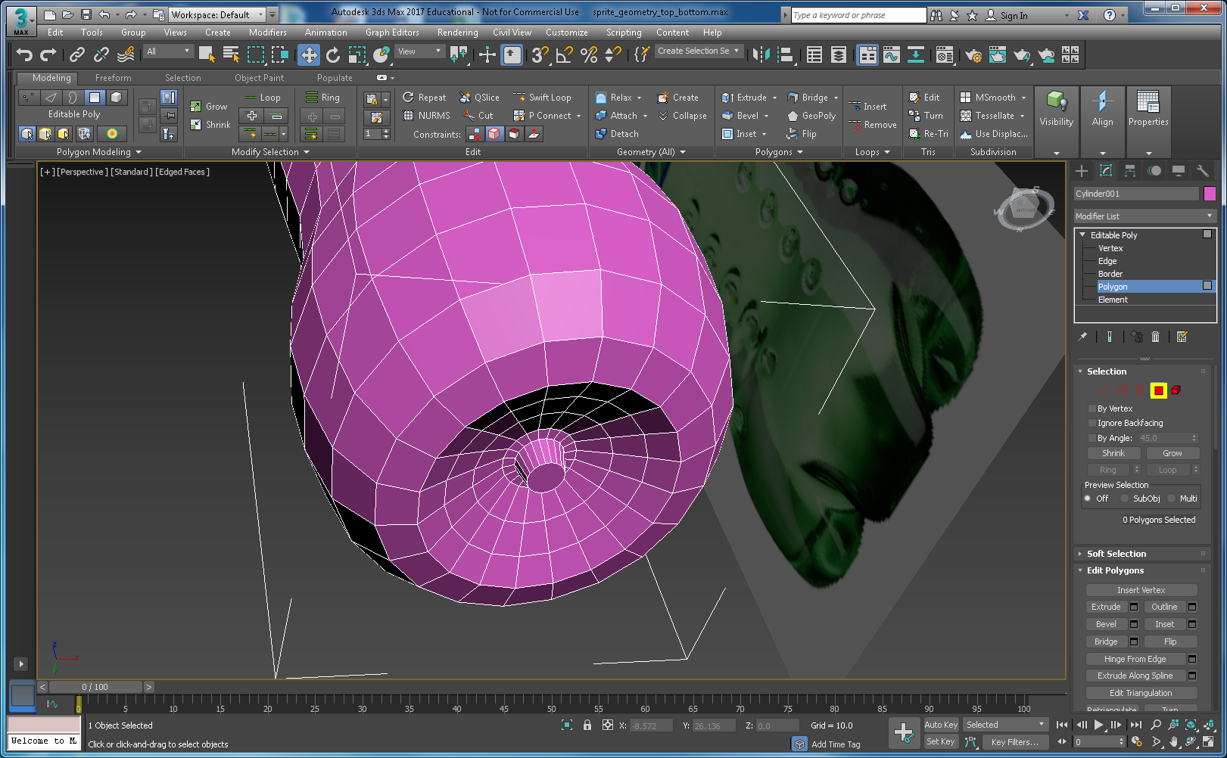

Figure 63: Basic bottom geometry shaped up on the bottom.

**Step 15:** There are now three areas where we can improve the geometry of the Sprite bottle: 1) the feet, 2) the dimples and 3) the thickness/transparency of the bottle. We need to figure out reasonably cost effective (in terms of polygon count) ways to refine the geometry of your model to achieve the best rendering effect for real-time.

Let us work on the dimples first. A cost effective, but crude, way to create the dimples is to use Graphite Modelling Tools such as tessellation, with other operations to create the dimples. Figure 73 illustrates one such. This renders quite well. However, in this part of the tutorial, I don’t write down every single micro-step on how to do the modelling, rather I leave you to explore a bit through trial and error. Consequently, I can never remember exactly how I created the dimples here! Some selection of subdivision and extrude produced the geometry, have a go.

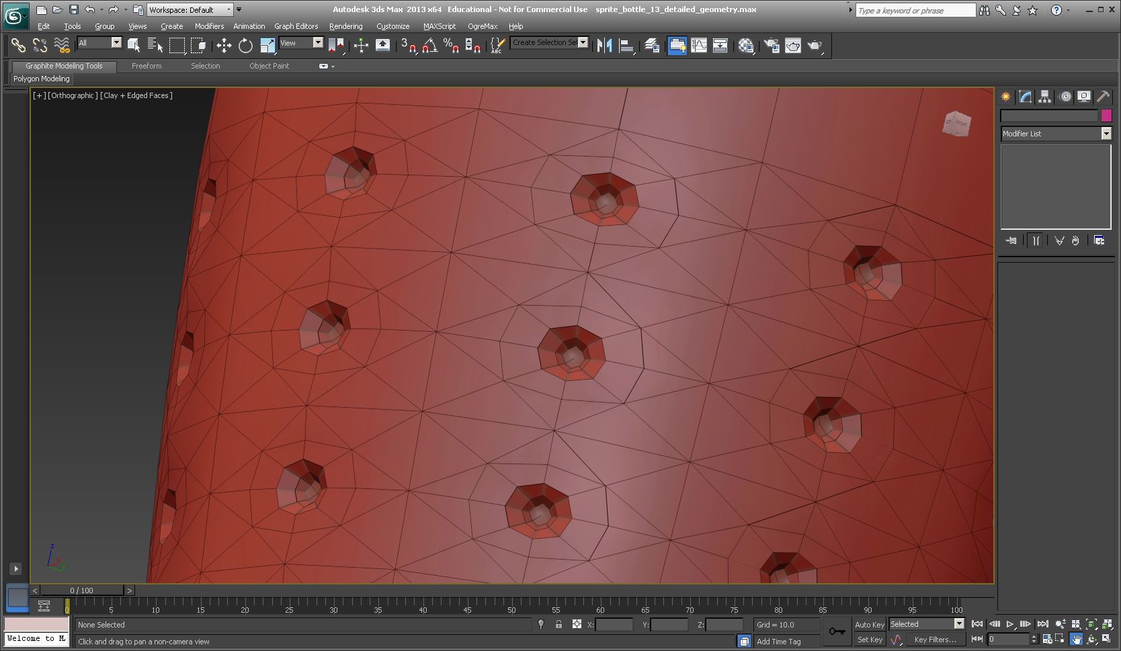

Figure 64: Dimples created by subdividing the polygons and extruding into the bottle

Tip Again! Experimenting with a way to create some simple geometry for the dimples can lead to you needing to do many undo’s. (Ctrl Z). Did you remember to set up the undo level to 200 or more? If not, first, save the current version of your Sprite bottle, e.g. sprite_geometry_dimples.0.1. Then select Customize from the top menu bars, then Preferences and set your undo to 200, or more. Also save often, there is nothing more distressing than having to comfort one of you guys with an unhappy face having lost loads of work. While trying to show loads of sympathy, I will inevitably ask you if you saved regularly, have you checked the Auto backup, and so on.

Anyway, here is one method:

* First, tessellate only the polygons needed to create the dimples with 1 iteration, you will need to select an array of them around the cylinder and down each cylinder — this is where setting the segments to 20 is going to pay off! See Figure 65. Save this selection as dimple-quads, just in case you need to select again more easily. You can do this by typing a name into Named Selection Sets box in the main Toolbar. Once you have the selection saved, you can hide the blueprint because it is getting in the way. You will need to select it, right click and hide selection. Then, reselect the complete bottle, and select polygon in the modify panel, then you can click on the dimple-quad selection to get you selected quads back.
* Next at the position where each dimple will be create select the single vertex, see Figure 66. Again, save the selection, red circle, just in case you accidentally lose it and need to get it back.
* Next select Chamfer and create what is effectively an array of diamond shapes to represent the basic dimple geometry, see Figure 66.

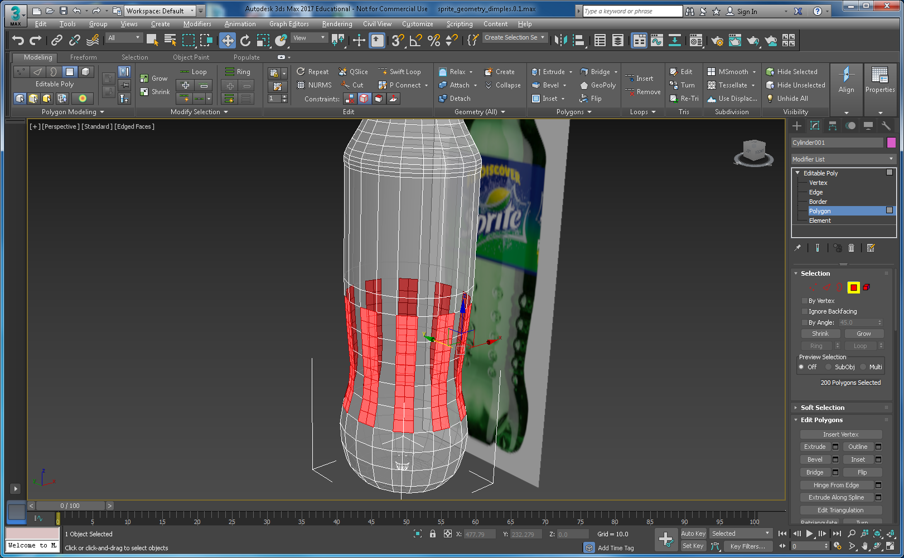

Figure 65: Quads selected and 1 tesselation iteration applied, save the selection.

* Depending on how careful you are with this method (and there are many variations) you may get varying results. This method is a bit trial and error getting the right size of dimple, level of tessellation, and subsequent bevel operations to coax the polygons into a reasonable dimple shape. Nevertheless, it can produce reasonable results, see step 15, Figure 66.

|  |  |
| --- | --- |
|  |  |
| Select the centre vertex | Apply the Chamfer to the vertex |
|  |  |
| Select polygons on the Editable Poly, and shrink if needed to get the centre diamond | Bevel a couple of times |
|  | |
| Nurms and 2 Iterations, and renderd produces a reasonable result, at this stage | |
|  | |
| Smoothing groups applied to the dimples, just to see what the results might look like — could be better! | |
| Step 15 | |

Figure 66: Some simple operations to achieve reasonable dimple geometry.

The last images in Step 15, Figure 66 illustrates the same bottle geometry with NURMS and 2 iterations turned on, and also with smoothing groups applied to the dimples just to see what it might look like. We need to get the dimple geometry similar to the NURMS result.

At this point if you have achieved a decent result like that shown in Step 15, well done. However, you won’t use NURMS, and as you can see smoothing for the dimples could be better. The solution is to:

1. Continue with the Graphite Modelling Tools, e.g. subdivision methods, etc. You can see from Figure 64 that you can get a better geometry, and then apply smoothing groups**. Tip! One iteration of Meshsmooth is ok applied to the bottom of the bottle to include the feet, and smoothing groups applied**, or.
2. Try a different approach, e.g. Boolean some spheres into the bottle to create better geometry. This will take a while.

Feel free to investigate this approach further, but plan your time carefully, you still have the bottle feet to model yet! Let us shape up the feet geometry, and fine-tune the overall geometry. You should also use the Shell Modifier to create an inner shell to simulate the liquid.

**Step 16**: Let us have a go at the bottle feet. Here, I will simple show you a series of images at each stage depicting the way I did it; you may be able to do much better. See Figure 67.

|  |  |
| --- | --- |
|  |  |
| Select the polygons you wish to start manipulating, save as a selection group | Start with a single bevels, judge by eye, then scale it down constrained to face. You can get a feel for what it might look like by clicking on the NURMS. |
|  |  |
| Click on the indicated polygons and constrain to surface, then scale as shown | Select the edges as indicated and scale while constrained to surface, judge by eye. You are trying to widen the feet at the top and narrow them down as you move toward the bottom and go under following the shape of the silhouette curve. Save the edge selection groups, so you can iterate back and forth adjusting the scale of one group of edges compared to the following or previous. |
|  |  |
| Continue to select and scale the next set of edges, repeat all the way down and under the bottle to shape up the feet. You will need to scale the edges inside the foot creases also. You should end up with something like this — [Hidden Line +Edged faces] | If you switch on NURMS, you will get an idea how smooth you can get it. A grat trick here, assuming you have saved your edge selections, is to switch to NUMS, selected the groups of edges and scale in real-time while in NURMS to adjust the feet shape,. |
|  | |
| On the left is a view of rendering with 1 meshsmooth and smooth group applied to the dimples and feet. I applied the smoothing groups. On the right you can see the geometric detail in the Clay rendering. It is interesting to compare Figure 64 with this version. Figure 64 did not use the mesh smooth, if I recall correctly. | |

Figure 67: Shape up the feet

**Step 17**: Make a clone or internal shell of the bottle geometry using the shell modifier, which creates an inner surface facing the opposite direction. You will need to flip the normals on the shell so it faces backwards because you will make the outside surface transparent to a degree, and you will want to see the inside shell surface, which will also be transparent. You might only want to select polygons up to the liquid level to make the shell, then cap it at the top. See Figure 78.

**Step 18**: Break the outer bottle into separate parts to facilitate internal simulation of the liquid — you will need to clone the bottle, select various parts, detach them, etc. see Figure 68.

You might also find it easier to separate the outside polygon section where the texture label goes, to make texturing easier; see Figure 78, which shows the constituent models parts. Rename all parts for easy identification.

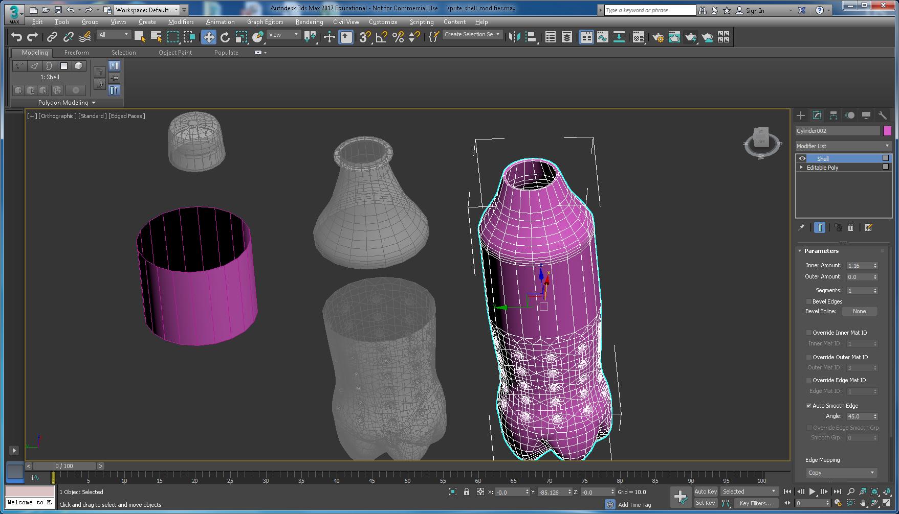

Figure 68: The bottle cloned and chopped up with the Shell Modifier applied to the right hand part to create the inner surface and liquid level.

You will need to collapse the shell and zoom in on the shell’d part to select the outer surface only and delete it. Then cap the inner. You can now apply materials and textures to all the parts and reset their positions to 0.0.0, see Figure 69. You will also need to convert to editable polygon too, as the Shell collapse does not do this. Figure 69 shows the outer shell, the old outer body moved aside and selected ready to delete it; we need the inner body. Don’t forget to cap the inner body, and you will need to Flip Normals on the inner body too.

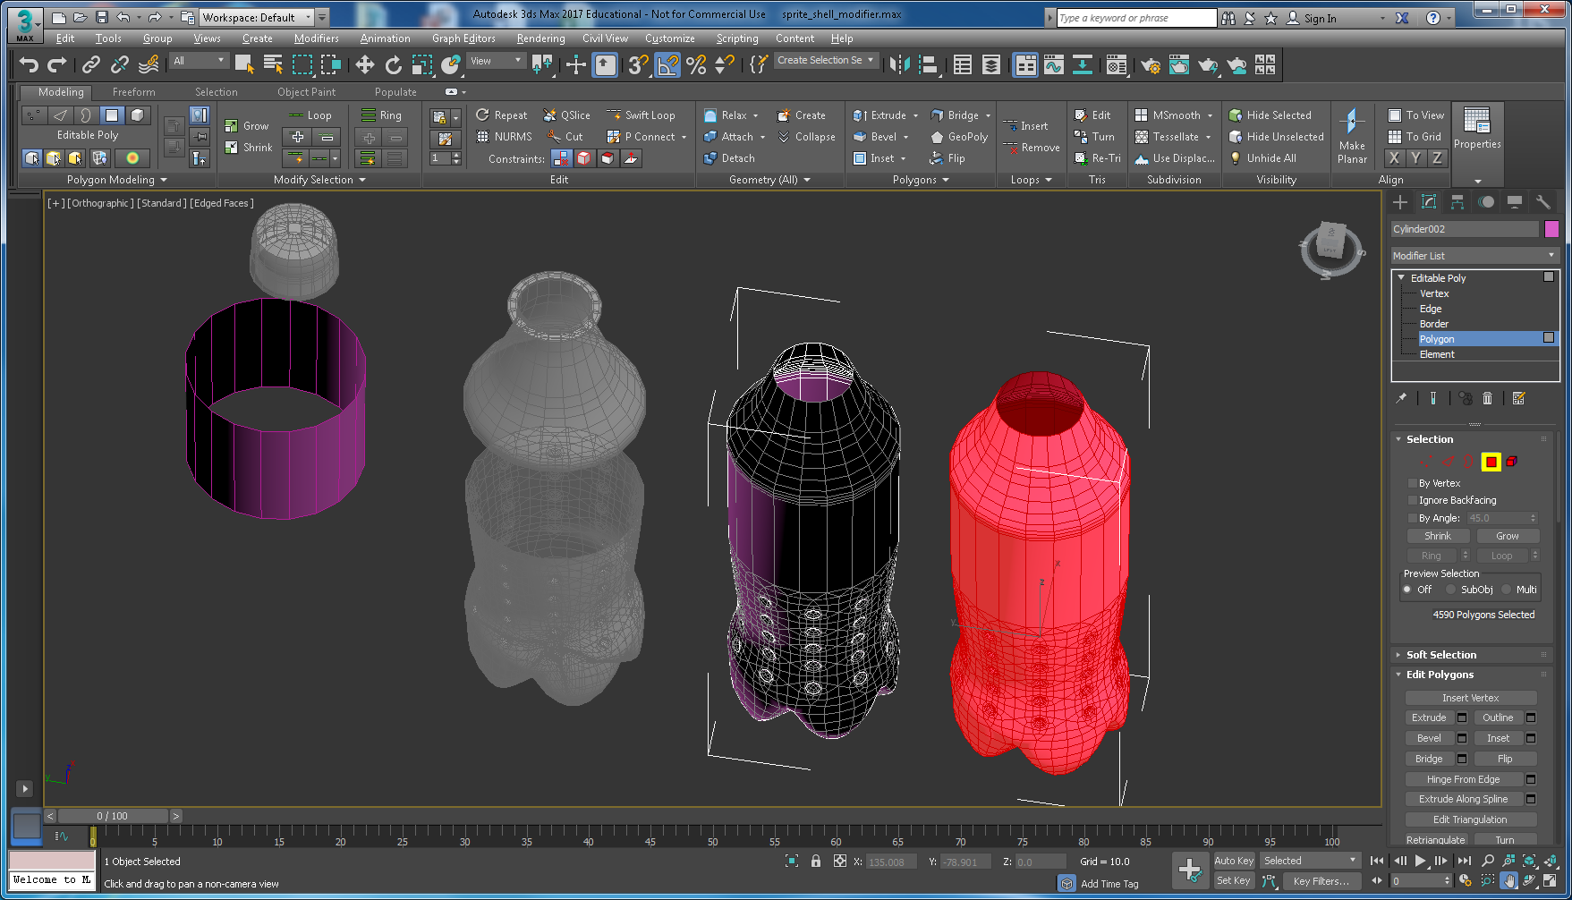

Figure 69: Separate parts of the Sprite bottle

Figure 70 shows the tided-up components ready to apply materials and textures. Inner body on the RHS top capped.

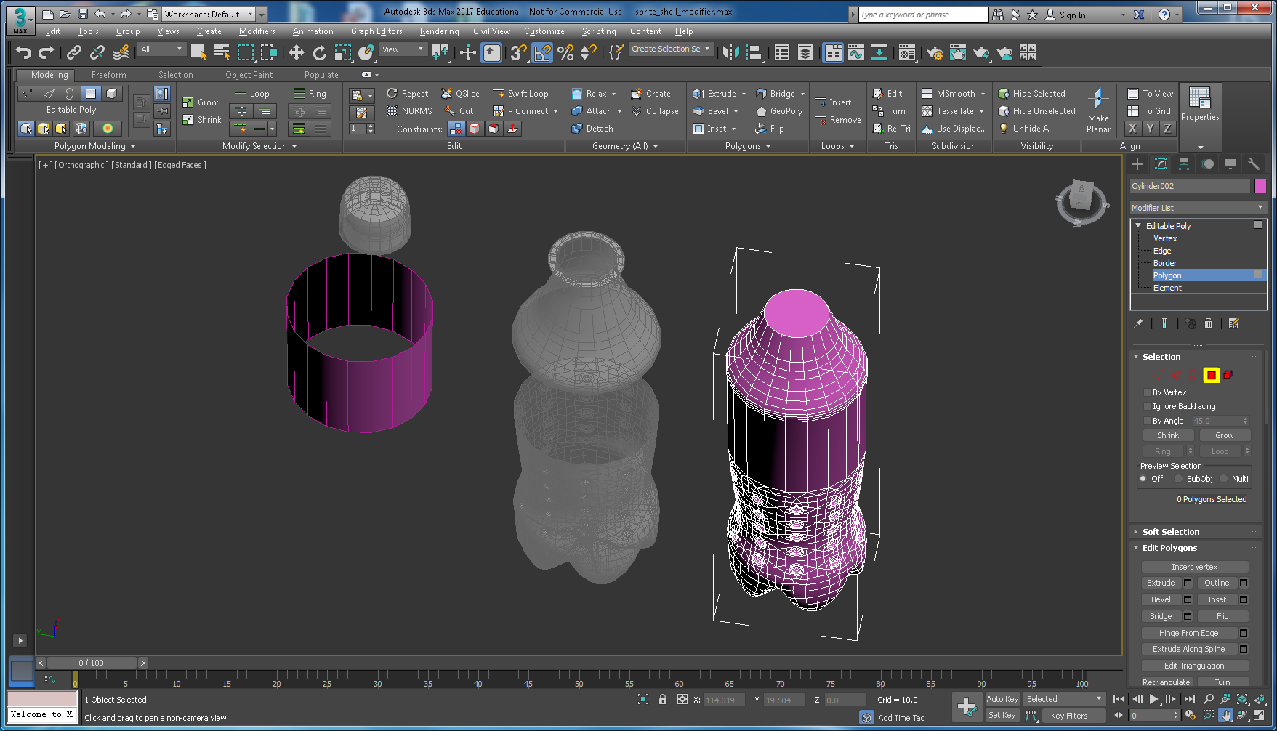

Figure 70: Separate parts of the Sprite bottle ready to apply materials and textures.

**Step 19**: Apply appropriate materials (light green’ish colour and opacity) to simulate the plastic bottle and liquid, and apply the label texture. Don’t forget the bottle top, it’s obviously blue, but you might also want to apply a texture to the top of the bottle top. See Figure 71. This step takes quite a bit of iteration setting the diffuse and specular colours in combination with the opacity in the material editor to get something that looks ok. You need to carefully consider how the opacity (or transparency works) in additive or subtractive mode — search for help on this in 3ds Max. Subtractive works best with light background and additive with dark backgrounds. See Figure 72, which illustrates my first attempt at applying the label texture (as you did the Coke can) and materials to the rest of the bottle.

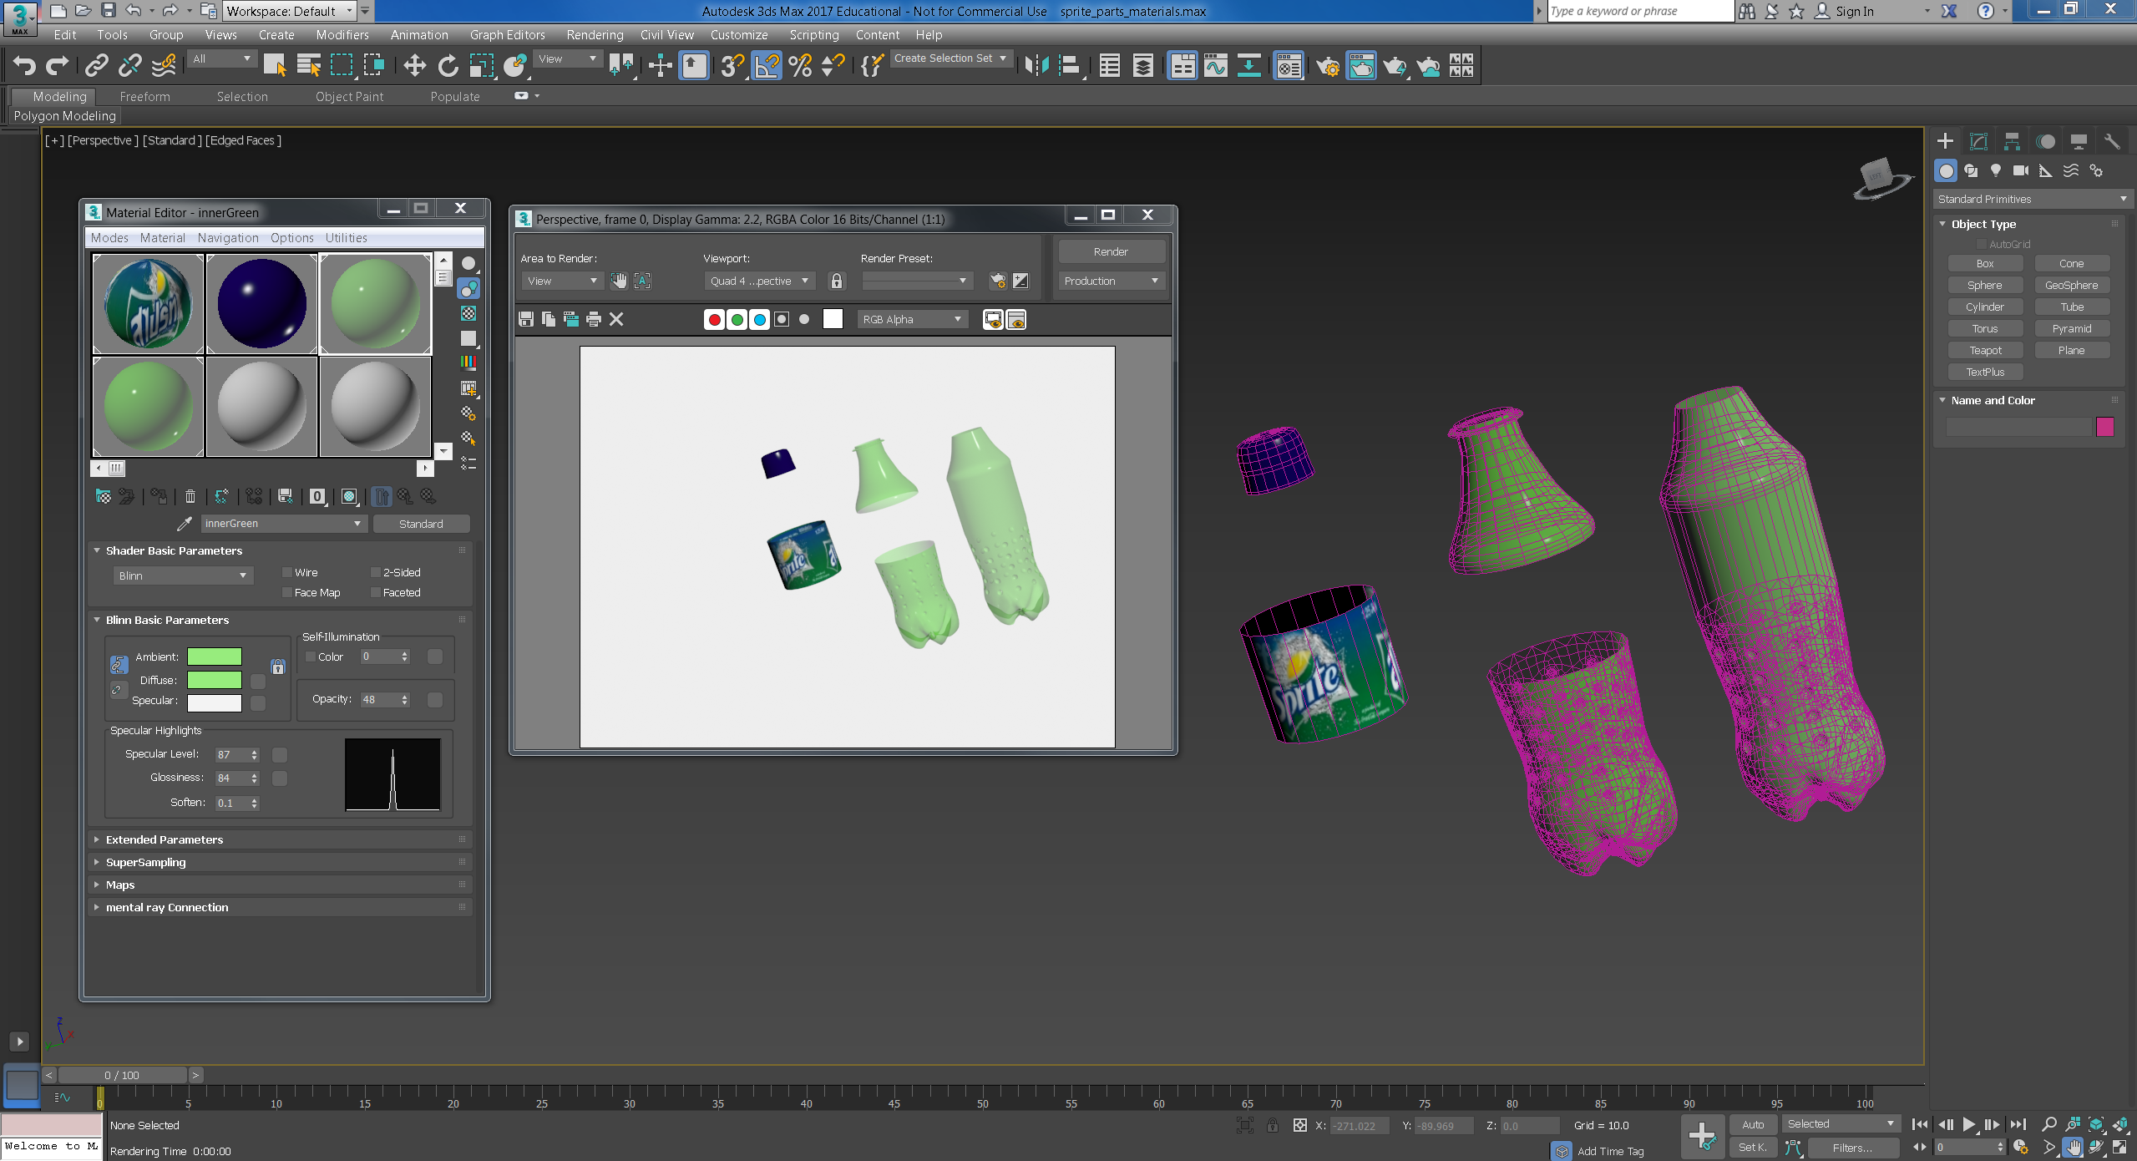

Figure 71: Completed geometry for the Sprite bottle.

**Step 20**: At this point, you could reassemble the Sprite bottle, i.e. reset coordinates for the Sprite bottle constituent parts to 0, 0, 0. Then iterate around adjusting material properties and render to find a good final render. Note, in Figure 71 I set the render background to light grey — go to the Rendered Frame Window and select the Environment and Effects Dialog (Exposure Controls) to change the render background colour. This is important. Later on when in Lab 3 you will export to VRML97 and convert to X3D, your materials properties that govern the render should be chosen with a background colour in mind. So, when you build your assignment models and assign textures and materials you should bare this in mind, i.e. what will be your 3D App background? Also, you can add Background VRML Helper.

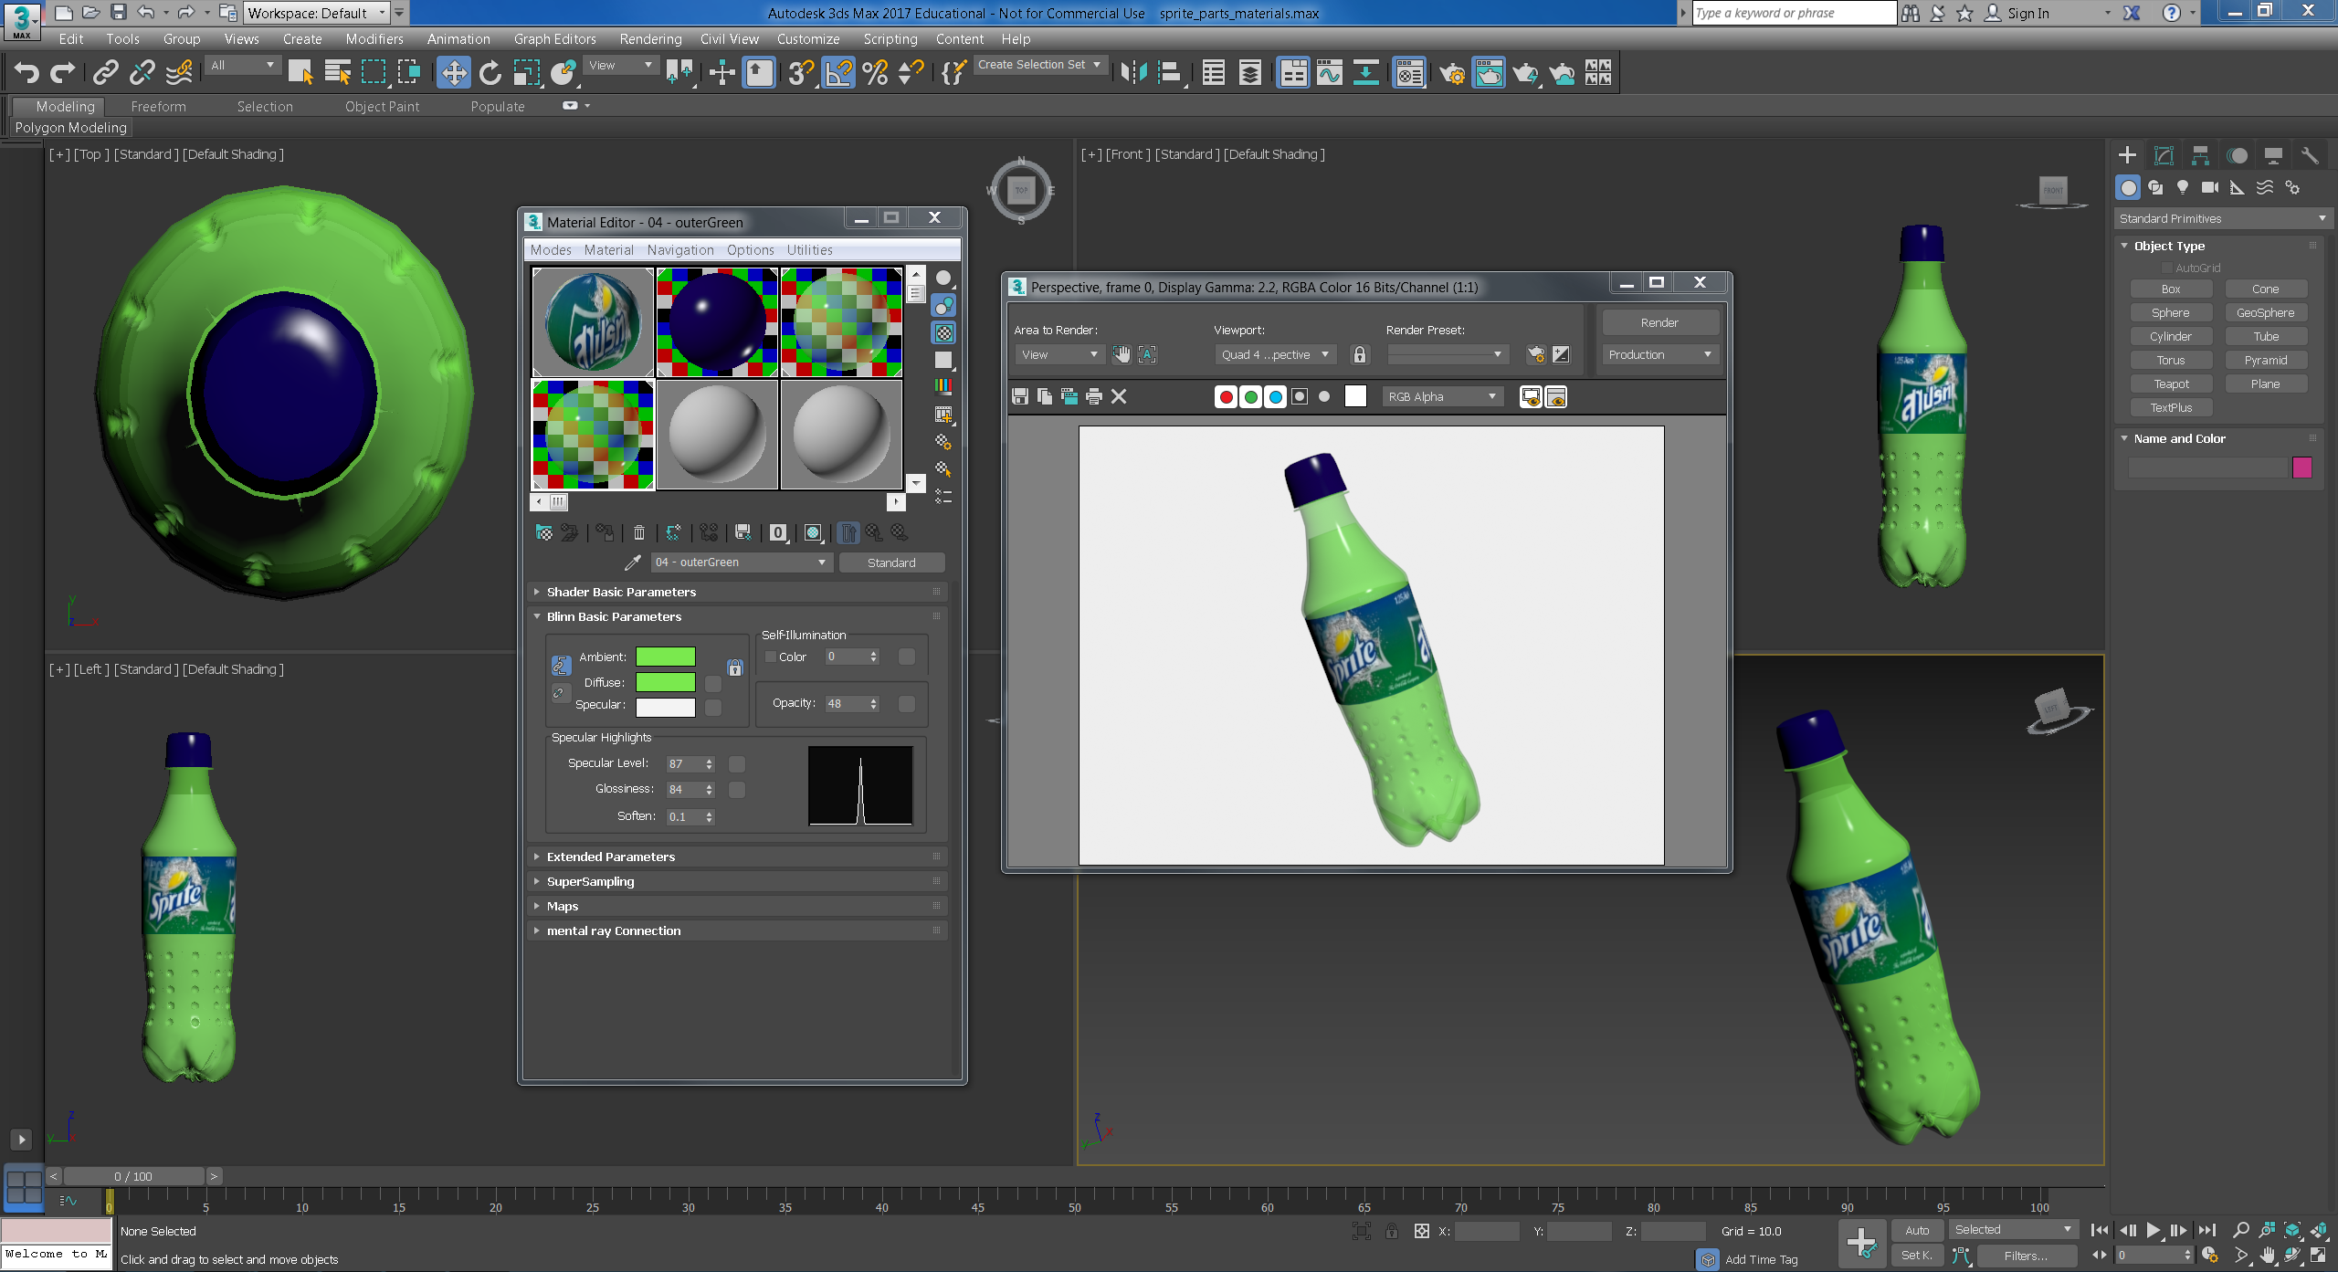

Figure 72: Sprite bottle assembled with materials and textures added

**Step 21**: Do not forget to add appropriate lights and camera viewpoints, then recheck the rendering. I would be surprised if the illumination design does not involve adjusting the materials and, transparency, specular highlights, etc.

To see what the Sprite bottle looks like, export to a Web 3D format (i.e. VRML) see Figure 73. We can see that the materials (Green colour) is a little dark, and I have not really set up lights and cameras properly, so we would go back into 3ds Max and adjust the colours, etc. More on that next week when we look at Web 3D formats.

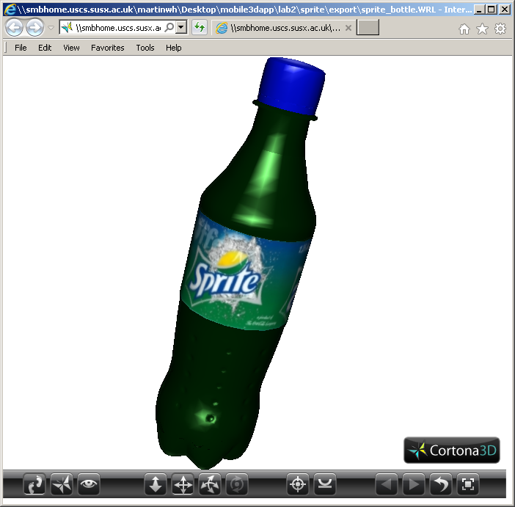

Figure 73: The Sprite bottle exported toVRML and rendered in the Cortona 3D Viewer.

# Creating your third model in 3ds Max

You should create a third coca cola drinks model, perhaps based on one of their other brands. For example, the **Dr Pepper cup is perfectly acceptable**. However, you are not restricted to modelling the Dr Pepper Cup, you could try a more complicated geometry coca cola glass, coca cola bottle, etc. See Figure 74. If you decide not to do the Dr Pepper cup, I suggest you do not simply repeat the coca cola can geometry and then apply a Dr Pepper texture, etc. because the geometry would be the same. If you did, however, add more geometry, e.g. model the lid more carefully, or deformed the can in some way, this would be good. You could also choose to model another bottle with different geometry, or a coca cola glass, or see the image for the vintage Dr Pepper bottle. For example, this gives you the opportunity to demonstrate more modelling technique.

|  |  |
| --- | --- |
| ../../../Desktop/Screen%20Shot%202017-02-13%20at%2009.58.37.png | ../../../Desktop/Screen%20Shot%202017-02-13%20at%2010.00.48.png |
| [CGStudio](https://www.cgstud.io/3d-model/coca-cola-glass-with-drops--16382) | [3DLand.net](http://3d-land.net/3D_model/coca_cola.html) |
| ../../../Desktop/Screen%20Shot%202017-02-13%20at%2010.07.04.png | ../../../Desktop/Screen%20Shot%202017-02-13%20at%2010.15.15.png |
| [3D Molier](http://3dsmolier.com/3ds-model/aluminum-can-033l-dr-pepper) — note the can lid geometry | [3D Molier](http://3dsmolier.com/3ds-model/aluminum-can-033l-dr-pepper) — crushed geometry |
|  | Screen Shot 2015-01-05 at 09 |

Figure 74: Examples of other drinks models

Using either of the methods previously described, or any other method, you should create a third drinks model. You should end up with something like that illustrated in Figure 84 depending on the reference image, textures and style of 3D model you choose to create.

# Appendices

## Appendix A — 3ds Max Tutorials

The tutorials presented in this module (above) are sufficient, to acquire the skills needed, to model 3D objects required for your 3D App assignment. However, if you haven’t already done any 3D Modelling and Rendering as part of a previous module using 3ds Max you will most likely need to try out some of the 3ds Max Tutorials that you can find in the help link on the 3ds Max toolbar.

However, before you start the above tutorials, we particularly recommend that have a play around with 3ds Max first by trying out some of the built-in modelling and rendering tutorials. For example, these tutorials are very useful as they give you the skills needed for your assignment:

3ds Max 2017

* [Modelling a Helmet using the Ribbon](https://knowledge.autodesk.com/support/3ds-max/getting-started/caas/CloudHelp/cloudhelp/2018/ENU/3DSMax-Tutorial/files/GUID-A8AFC8F7-AC83-428C-A9FC-A103CBE5F000-htm.html)
* [Modelling an Airplane](https://knowledge.autodesk.com/support/3ds-max/getting-started/caas/CloudHelp/cloudhelp/2018/ENU/3DSMax-Tutorial/files/GUID-E1B42D4D-E193-4290-83D8-72FB66E467F6-htm.html)
* [Materials and Mapping](https://knowledge.autodesk.com/support/3ds-max/getting-started/caas/CloudHelp/cloudhelp/2018/ENU/3DSMax-Tutorial/files/GUID-B26EFD30-0A9B-4B22-897F-CB259AFBA592-htm.html)
  + Introduction to Materials and Mapping
  + Controlling a Texture with Unwrap UVW

3ds Max 2016

* [Lighting Tutorials](https://knowledge.autodesk.com/support/3ds-max/getting-started/caas/CloudHelp/cloudhelp/2017/ENU/3DSMax-Tutorial/files/GUID-9EBFF43C-3477-4406-B81E-9EFC311AD289-htm.html)
  + Lighting and rendering a daylight scene

You can use either 3ds Max 2017 or 3ds Max 2019 installed on the Informatics lab machines to follow the above tutorials, the interface hasn’t changed that much, and it will be a good exercise in trying to find your way around 3ds Max using the older tutorials; The 3ds Max 2019 Getting Started tutorials may have different contents for its tutorials.

Either way, Figure 75 illustrates where to find the Help tab that will lead you to other resources and tutorials that will get you started.



Figure 75: Locating the 3ds Max Tutorials

If you click on [Modelling a Helmet using the Ribbon](https://knowledge.autodesk.com/support/3ds-max/getting-started/caas/CloudHelp/cloudhelp/2018/ENU/3DSMax-Tutorial/files/GUID-A8AFC8F7-AC83-428C-A9FC-A103CBE5F000-htm.html) youwill find most of the useful tutorials illustrated in Figure 76 that will get you modelling if you haven’t done any modelling at all before now, or if you want to refresh your skills.

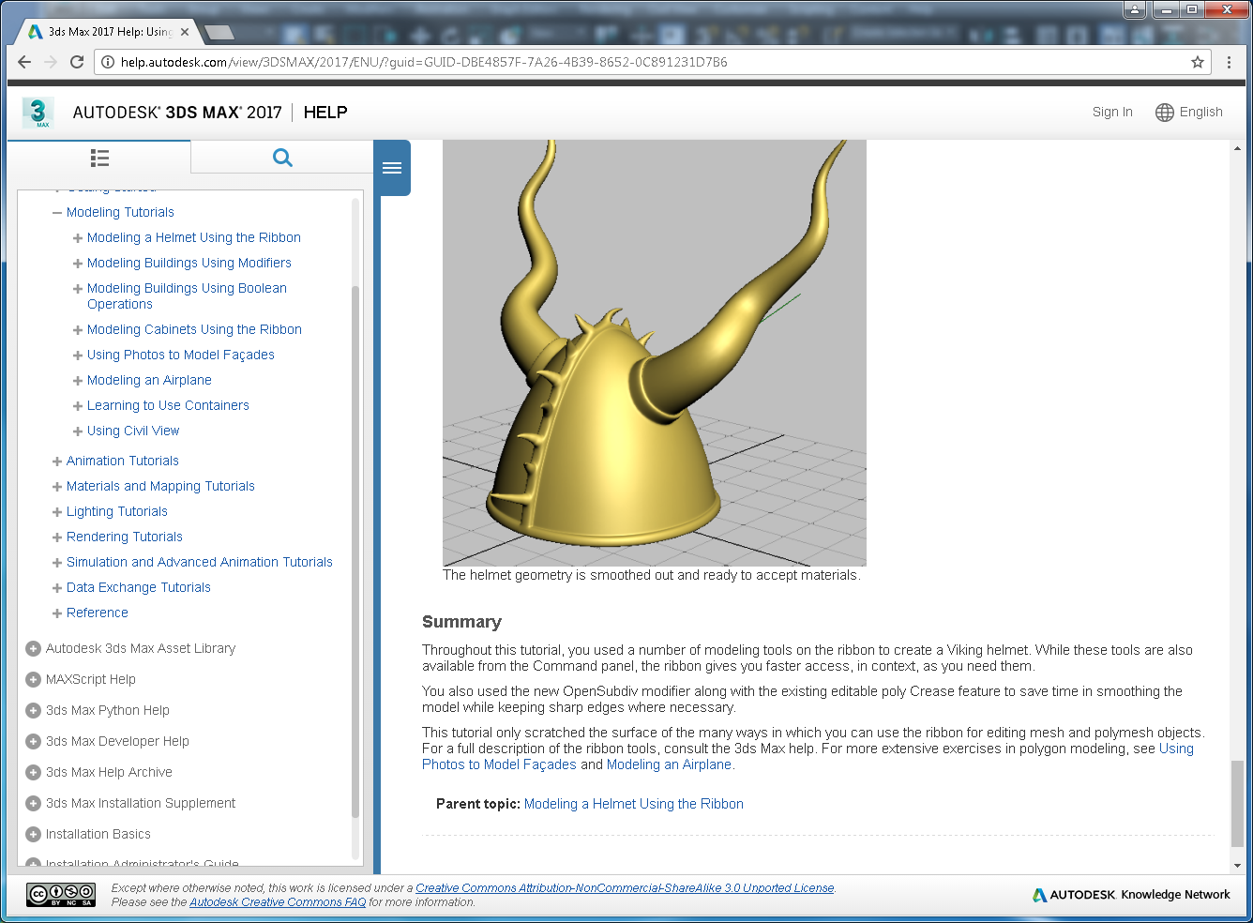

Figure 76: Check out these tutorials if you have not done any modelling at all so far

And, for those of you who haven’t used 3ds Max before, to help find your way around the 3ds Max interface, you can check out the [3ds Max 2019 Interface](http://help.autodesk.com/view/3DSMAX/2019/ENU/?guid=GUID-F8326C68-F2F9-47F7-AC1D-BA41D7825C7C) and compare it to the 3ds Max 2017 Interface, see Figure 77, you can see it hasn’t changed significantly such that you won’t be able to follow an old written tutorial, or one on YouTube from a different 3ds Max version:

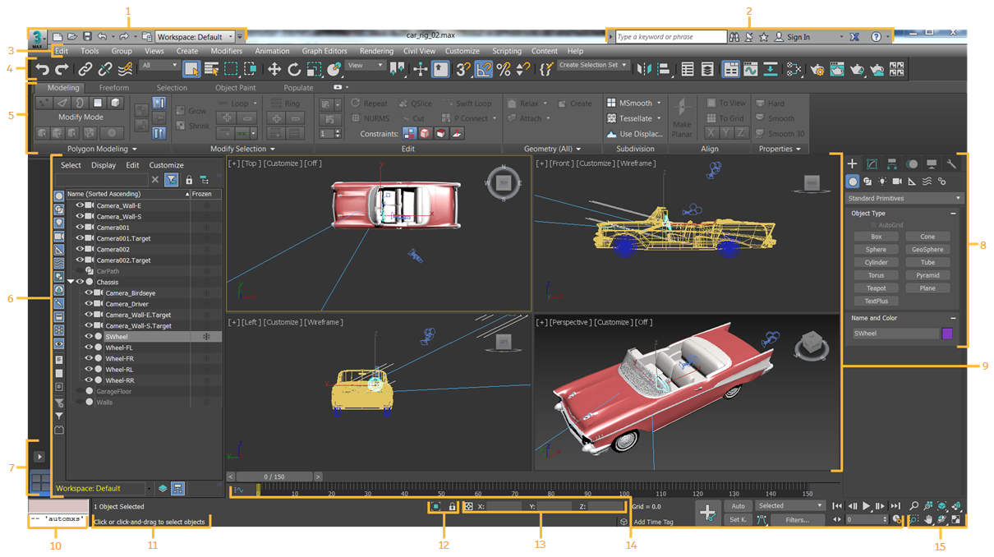

Figure 77: The 3ds Max user interface

This link will take you to a [description online for each of the user interface sections 1 to 15](http://help.autodesk.com/view/3DSMAX/2017/ENU/?guid=GUID-F8326C68-F2F9-47F7-AC1D-BA41D7825C7C). Alternatively, click on each individual link below.

|  |  |
| --- | --- |
| 1. [Application button](http://help.autodesk.com/cloudhelp/2017/ENU/3DSMax/files/GUID-739079B7-84E6-484F-90AD-CDB064BC4C28.htm#GUID-739079B7-84E6-484F-90AD-CDB064BC4C28) and [Quick Access toolbar](http://help.autodesk.com/cloudhelp/2017/ENU/3DSMax/files/GUID-D514BB5E-36B8-4419-A75F-69EEADE4A060.htm#GUID-D514BB5E-36B8-4419-A75F-69EEADE4A060) 2. [InfoCenter](http://help.autodesk.com/cloudhelp/2017/ENU/3DSMax/files/GUID-E26CFCD2-BC24-48CA-8CB2-9E39E2D2E88B.htm#GUID-E26CFCD2-BC24-48CA-8CB2-9E39E2D2E88B) 3. [Menu bar](http://help.autodesk.com/cloudhelp/2017/ENU/3DSMax/files/GUID-90D08333-ADB3-4E8C-9579-1A0A71985604.htm) 4. [Main toolbar](http://help.autodesk.com/cloudhelp/2017/ENU/3DSMax/files/GUID-D60DB151-D25D-498D-AF02-410D4237A140.htm#GUID-D60DB151-D25D-498D-AF02-410D4237A140) 5. [Ribbon](http://help.autodesk.com/cloudhelp/2017/ENU/3DSMax/files/GUID-AFD78D67-DFBE-42E7-A747-E15BBB2A532A.htm) 6. [Scene Explorer](http://help.autodesk.com/cloudhelp/2017/ENU/3DSMax/files/GUID-2569461E-C859-4D54-BAFF-C8BD078B53AC.htm) 7. [Viewport Layouts](http://help.autodesk.com/cloudhelp/2017/ENU/3DSMax/files/GUID-6640623A-4931-4C09-81CB-C798D1396B94.htm) 8. [Command panel](http://help.autodesk.com/cloudhelp/2017/ENU/3DSMax/files/GUID-E3CB809D-94ED-4C30-892B-1D12B8721EA5.htm) | 1. [Viewports](http://help.autodesk.com/cloudhelp/2017/ENU/3DSMax/files/GUID-B39C0590-058C-4E59-B03D-AEC52DE830AB.htm#GUID-B39C0590-058C-4E59-B03D-AEC52DE830AB) 2. [MAXScript Mini Listener](http://help.autodesk.com/cloudhelp/2017/ENU/3DSMax/files/GUID-628797AF-5233-4007-AAD7-8CDB8A6A930E.htm#GUID-628797AF-5233-4007-AAD7-8CDB8A6A930E) 3. [Status line](http://help.autodesk.com/cloudhelp/2017/ENU/3DSMax/files/GUID-F97320FC-29C1-4A25-97A1-5DBF0B24B961.htm) and [Prompt line](http://help.autodesk.com/cloudhelp/2017/ENU/3DSMax/files/GUID-260073BD-A5C2-44AE-B81D-1F83FE5E9BA8.htm) 4. [Isolate Selection toggle](http://help.autodesk.com/cloudhelp/2017/ENU/3DSMax/files/GUID-DFA0A6EB-0062-44CA-A578-EBDE1FCA0F5C.htm)and [Selection Lock toggle](http://help.autodesk.com/cloudhelp/2017/ENU/3DSMax/files/GUID-AF0D75B5-4CD4-463F-8B53-5DD486D3D8E0.htm) 5. [Coordinate display](http://help.autodesk.com/cloudhelp/2017/ENU/3DSMax/files/GUID-4D5639DA-9029-42D5-9116-EC0A143832D8.htm) 6. [Animation and Time controls](http://help.autodesk.com/cloudhelp/2017/ENU/3DSMax/files/GUID-818205DD-D58A-495E-BD0C-DC69BDE8DAC2.htm) 7. [Viewport Navigation controls](http://help.autodesk.com/cloudhelp/2017/ENU/3DSMax/files/GUID-010B3CF4-0D7E-4886-8C65-BF332313D423.htm) |

## 3ds Max Interface Familiarisation

However, TBH, if you have not used 3ds Max at all before it’s definitely worth knocking up some standard geometric objects into a scene to have a play with. But, first do try out some of the 3ds Max Tutorials mentioned above. These are very useful, because they also show you how to use the Graphic Modelling Tools located in the Modelling Ribbon, see Figure 3. On the otherhand, if you are now already familiar with the 3ds Max interfaces you can skip this next sub-section and jump back up to start the Lab 2 modelling of the Coke can.

### For the 3D modelling beginner

Begin by opening 3ds Max as available on your lab computer. At first, the complicated 3ds Max interface may be intimidating, but we will only be using a few tools and features. First, it is important to identify the main 3ds Max interface components — Figure 78 shows the 3ds Max 2013 version, as you can see over the years little changes. Whichever version you are going to use, make sure that 3ds Max is set up by default to use the scan line renderer

You are presented with four 3D viewports: top, front, left and perspective. Take a moment to locate these viewports in the 3ds Max interface.

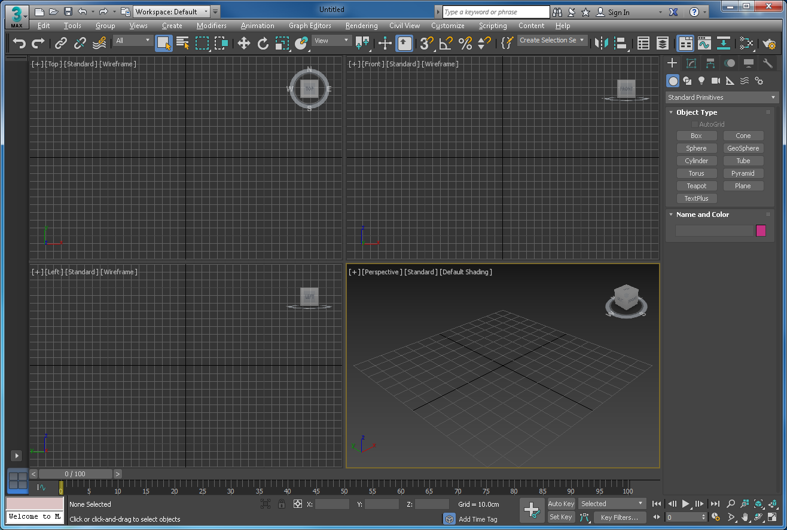

Figure 78: 3ds Max’s 4 main viewports on start up

You may interact with the viewports using the mouse and the buttons found at the bottom right of the screen, see Figure 79.

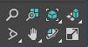

Figure 79: Viewport navigation controls

Take some time to play around with these Viewport navigation controls to see how they manipulate the viewport.

For example, try the following: In the Command panel tab’s (see Figure 77 if you can’t remember your way around the interface) Object categories (Create panel) Object Type Rollout menu click on one of the objects (Cone, Box, whatever) then click somewhere central in the perspective viewport, drag the mouse to create the first dimension of the object, release the click, then drag again to create the next dimension, then click again to finish. Assuming you clicked ‘box’ initially, you will have created a box object. Play around with these primitive objects, place several in the perspective viewpoint, and don’t worry where you place them, see my example in Figure 80.

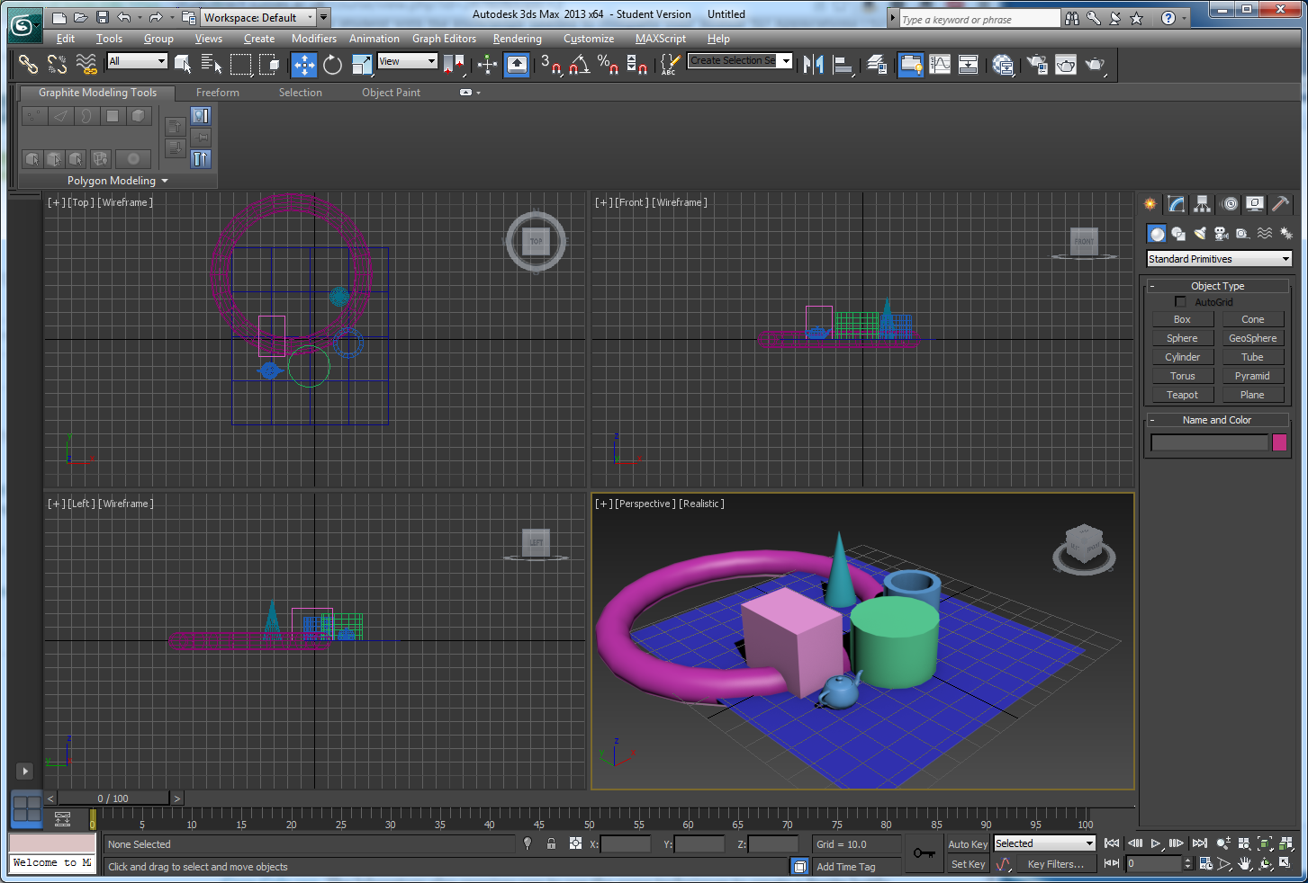

Figure 80: Place some random standard primitive objects into a scene

Now play around with the Viewport navigation controls to zoom, pan, rotate the objects, etc. For example:

1. Click on the Zoom button  and position the mouse pointer in a viewport, e.g. the perspective viewport, and use the mouse to zoom in and out on the view port — note you can also use the scroll button on the mouse if there is one.
2. Click on the Orbit Sub-object button  and position the mouse pointer in a viewport, e.g. the perspective viewport, and use the mouse to ‘orbit’ the objects. Note if you have no objects selected you will orbit the scene, if you have an object selected the centre of orbit is around that object.
3. Click on the Maximise Viewport Toggle button  (bottom right corner) to maximize the perspective viewport. This allows you to see the objects (or model) closer to work on more detailed modelling when needed.
4. Play with the remaining buttons: Field of View, Zoom Extents, Zoom Extents All, Pan, etc. to see what they do.

Now we have explored how to manipulate viewports to position objects, etc. let us let us consider the main object creation and editing features found in the Command panel tabs, see Figure 81.

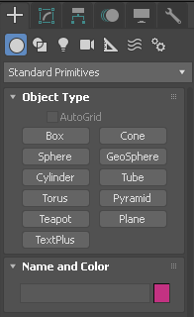

Figure 81: The Command panel tabs

There are two menus of most concern to us for this Lab 2 tutorial, Create and Modify:

1. The Create menu is accessed via the Create button , which reveals the object primitive menu used to create primitive shapes that can be sculpted into a new model — you may recall this approach in the 3ds Max ‘Modelling a Helmet using the Ribbon’ and ‘Modelling an Airplane’ tutorials. When you click on the Create button, the default is Standard Primitives, which you already explored above.
2. The Modify menu is accessed via the Modify button , which reveals all the editing tools you will need to model your objects (remember, in this lab you are going to model a Coke can, Sprite bottle and a Dr pepper paper cup). However, if you have completed the ‘Modelling a Helmet using the Ribbon ’tutorial, you will also be familiar with the same tools laid out on the Modelling Ribbon. If you are lost finding a tool, it is most likely to be found in this Modify menu or the Modelling Ribbon, e.g. the Graphite Modelling Tools. During the rest of this lab we will explore these tools while creating these three models.

Take a few minutes to explore these two menus: Create and Modify. For example, select an object (e.g. the Box, change its Length, width and height to 30.0 and changes its segments to 4 for each side, no particular reason why, just to explore the modifier tool for that object — I also like to set the rendering to [Shaded + Edged Faces] so that I can see the geometry well, Figure 82 illustrates.

Select some more objects and modify them to see what happens —in general, at least on this Mobile Web 3D Applications module, you are encouraged to adopt a discovery learning approach, i.e. learning by doing. Therefore, you need to explore further independently to get the best out of 3ds Max!

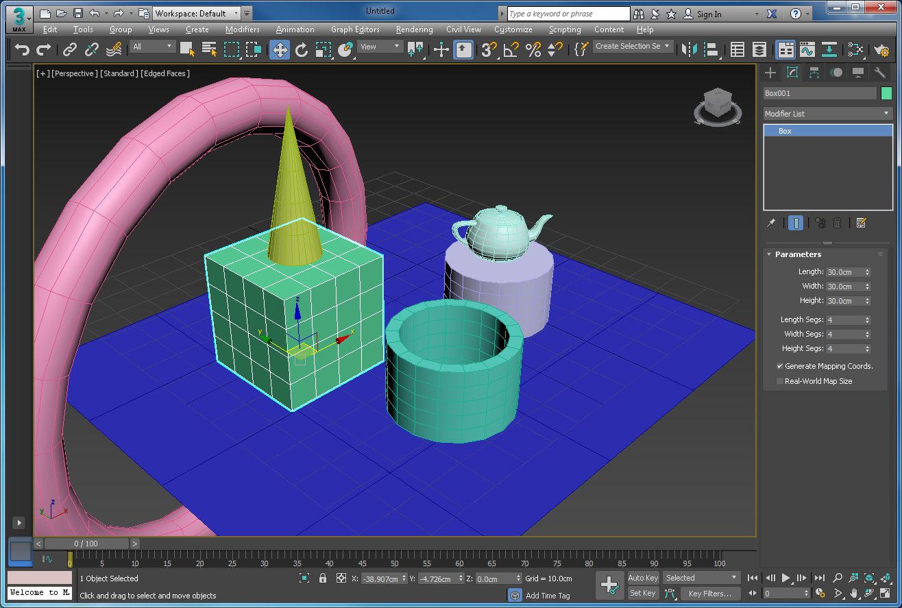

Figure 82: The box selected and its geometery changed

Just have a play with whatever modelling tools you see and find out what they do. You will want to switch on the Graphite Modelling Tools in the Ribbon, if it has disappeared, if so go to Customize > Show UI >Show Ribbon and select modelling to reveal a whole host of modelling tools. In Figure 83, I have done some manipulation of the cylinder object using some of these tools. Have a play and see if you can replicate it taking note of which tools you used and what they did.

Now I have a cylinder with 4 legs, but with a bit of imagination it might become a cow one day!

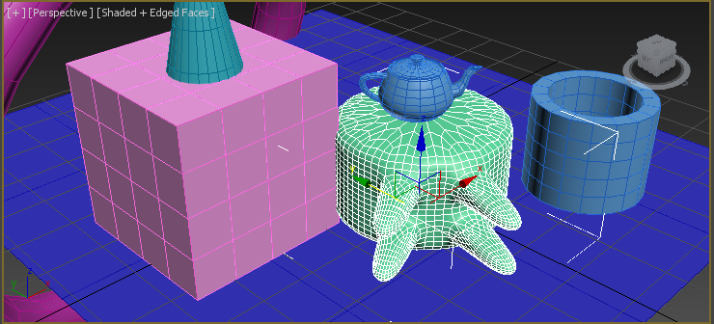

Figure 83: Have a play with some of the modelling tools

Finally, there are three more object manipulation tools used to move, rotate and scale models, which are very important. Clearly, one look at the 3ds Max interface will reveal that there are many more tools you could use in a modelling, texturing, lighting work flow to develop 3D models for the web — however these tutorials should give you access to most of the tools that you will need for the assignment, and an inquisitive mind will do the rest!

The Select and Move, Select and Rotate and Select and Uniform Scale buttons are found in the top toolbox, see Figure 84.

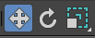

Figure 84: Move, Rotate and Scale buttons

You should still have your cluster of primitive objects (box, cone, teapot, whatever) arranged in the viewports. You can use these Move, Rotate and Scale buttons to select and manipulate each of these objects or groups of them until you are happy that you know how to use these tool, see Figure 85.

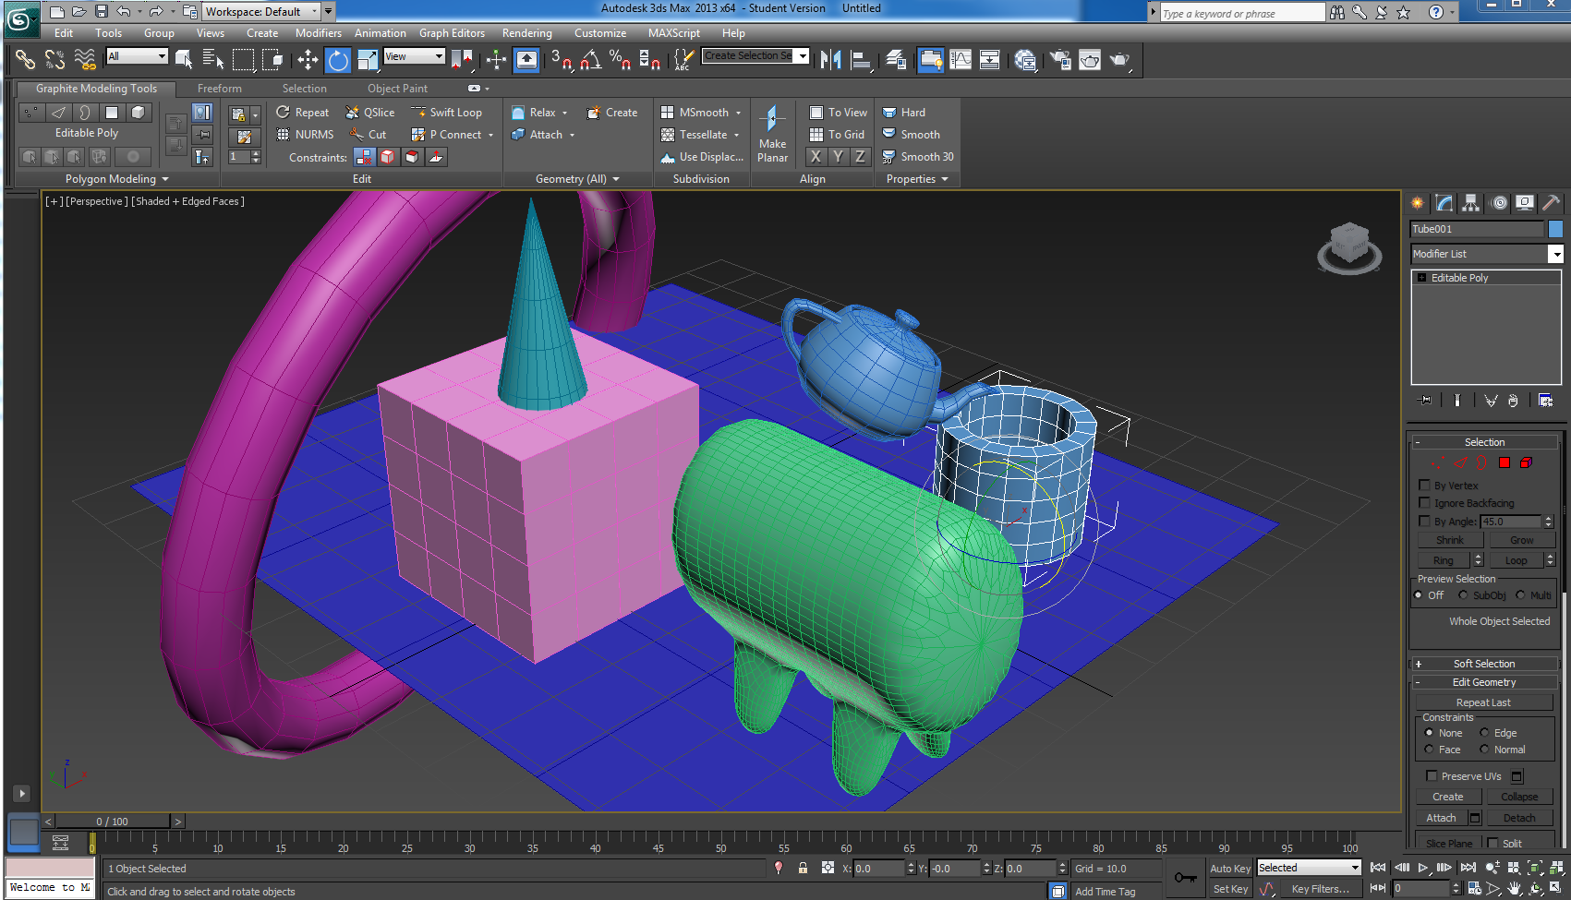

Figure 85: The scene after scaling, moving and rotating some of the objects.

Incidentally, you may have noticed a cube with a ring around the bottom located in the top right-hand corner of the perspective (and the other) viewports. You can use this to manipulate the viewport too; click on it and see what it does. It allows you to select different views on the scene in the viewport.

**Big Tip before we start modelling the coke can!**

Modelling often involves some experimenting with a way to create some simple geometry that does not work well or simply goes wrong, which can lead to you needing to do many undo’s. (Ctrl Z). So before you start any serious modelling, save the current version of your model if you have already started. Then select Customize from the top menu bars, then Preferences and set your undo to 200, or more. Don’t do too much though because 3ds Max can sometimes blow up in your face! So, also save often, there is nothing more distressing than having to comfort one of you guys with an unhappy face having lost loads of work. While trying to show loads of sympathy, I will inevitably ask you if you saved regularly, have you checked the Auto backup, and so on.

Ok, let’s get on with modelling the Coke can.

## Appendix B — Download 3ds Max

Ok, before we get started on the Lab 2, for those of you who missed the link on the Canvas page suggesting that you download 3ds max 20nn, you can set up an account with Autodesk at [Autodesk Student Account](https://www.autodesk.com/education/free-software/3ds-max) and download an educational copy of 3ds Max for use at home.

## Appendix C — Alternative Methods for Modelling a Coke Can

### Coke can modelling

Alternative methods for modelling a Coke can are illustrated in the following videos:

* [Coke can Part 1 Modelling](https://www.youtube.com/watch?v=_vQSD0I0Qmc)
  + This method is similar to the one detailed in this tutorial in that it uses the line primitive to trace around the Coke can silhouette. However, the modeller separates the can from the top and bottom, modelling these separately. He converts the line to a Bezier to get a better fit to the silhouette — seems a bit fiddly when you could simply pick off more points in the line, and the bottom is not a true modelling of a modern Coke can? This method is a combination of lathing and extrusions to create the model. Still looks like a good tutorial if you prefer to watch a video rather than continue to read this tutorial.
* [How to make a Coke tin can in 3ds Max](https://www.youtube.com/watch?v=bURB7YLd-n8)
  + This method uses extrusions and scaling to modify a standard primitive, a cylinder to shape up the Coke can geometry. We use this method on the Sprite bottle.

And, I am sure you can find many other tutorials on the Internet, for example, here is a Redbull Can, which you could adapt:

* [3ds Max tutorial – Part 1 – Mogdel and Texture a Red Bull can UVW Unwrap](https://www.youtube.com/watch?v=t9M5f9u58PE)
  + Focus on the modelling part 1 first.

### Sprite bottle modelling

There are several tutorials for modelling a Coke bottle with 3ds Max on the Internet that you could adapt to model the Sprite bottle, do a Google search and choose one if you wish. The same applies when you choose your models for your assignment, you may find many tutorials online. If you do decide to do some advanced modelling and rendering in this regard, please plan your time appropriately. **All modelling marks in the assignment will be gained from your 4 models, but there also some marks portioned off to allocate to ‘going beyond’ what has been shown in this tutorial.** Going beyond can include using more advanced modelling and rendering techniques, for example utilising advanced rendering to create 3D images for your 3D App.

But, we digress, here are a couple of online tutorials you may find interesting:

* [3ds Max Beginner Tutorial - Coke Bottle](http://www.youtube.com/watch?v=qUDC0f4Ts1c)
* [Modelling a beer bottle in 3ds Max](http://www.youtube.com/watch?v=CxGihNnd0Mc)

BTW, if you want to follow a 3ds Max Coke bottle tutorial online and create a Sprite can in lieu, that’s fine. If you have already created the Coke can, all you have to do is swap the textures! Also, many of these tutorials use the same method that we used for the Coke can for the actual modelling, i.e. use of a suitable reference image or blue print and the lathe tool. The trick will be to model realistic glass (or plastic) in 3ds Max, again there are plenty of tutorials you can access to investigate this, but the above tutorials should cover this too!

Ok, so the Coke can tutorial above provided quite a bit of detail, but now you are becoming more familiar we will reduce the detail somewhat and show you a different technique to model the Sprite bottle (it’s basically the same as the 3ds Max Beginner Tutorial – Coke Bottle, see link above.

## Appendix D — Using Boolean Operations to insert Dimples

It may be ok to create the dimple geometry using Booleans; if done well it can look good. However, Boolean operations also tend to leave behind very messy mesh geometry that does not smooth easily. This is generally because a Boolean operation really needs to have both meshes aligned carefully in the first place, and it works much better if your tessellation level is a bit higher than the level of geometry on the spheres. Autodesk have a very good [article](http://knowledge.autodesk.com/support/3ds-max/learn-explore/caas/CloudHelp/cloudhelp/2015/ENU/3DSMax/files/GUID-EC3DD1B9-6524-418C-B18C-567938A9DD24-htm.html) on how to use Quad Meshing and Smoothing using the ProBoolean, ProCutter and Quadify Mesh Modifier that can achieve good results if used carefully. Read the article if you want to try this method of achieving a professional dimple. Figure 86 illustrates the issues arising when you don’t do it well.

You need to ensure that the bottle has a reasonable level of tessellation to allow a decent Boolean into its surface with the dimple. A **critical part** is to align the sphere’s axis so that they are orthogonal to the surface of the bottle at the position where the dimple is being created. You also need to create the sphere at a reasonable level of polygons and you can meshsmooth once perhaps.

If you look carefully at the rendering result you can see the carefully aligned sphere has Boolean’ed nicely, while the one to the right has not — there are rendering artefacts due to meshes not aligning well. You must also select the advanced Quadify option. See the Autodesk article mentioned above for more detail. Final tip on Boolean, you might be better off creating a vertical line of Boolean dimples, the doing some sort of pivot, clone rotate, to create and next column, and so on. You need to make sure the first column of dimples are perfect, I would assume.

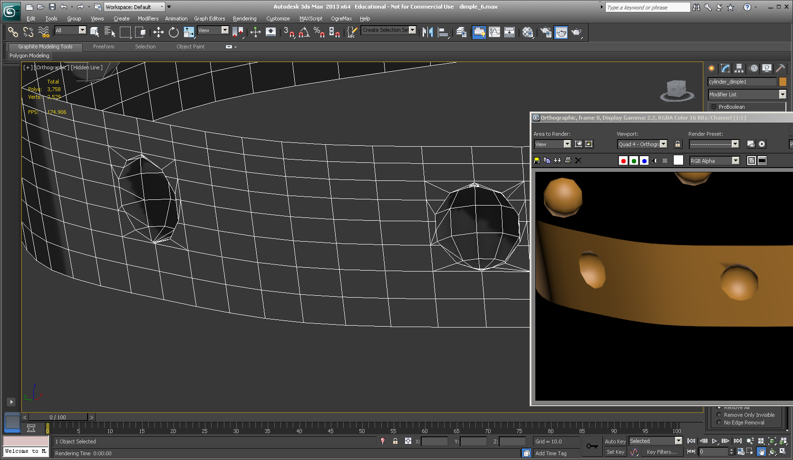

Figure 86: A not so good attempt at using Booleans, can you see the mesh artefacts in the rendering on the right.

## Appendix E — UVW Unwrap Modifier in 3ds Max

It is very instructional to watch a video on UVW Unwrap, which is the method you are going to use in this tutorial, this is a good one, but there are many others you can watch:

* [Basic UVW Unwrap Modifier in 3ds Max](https://www.youtube.com/watch?v=F-e43rUcF8I)

If you want to get into texture mapping in more detail using 3ds Max there are many tutorials available on the Interweb, and of course in the 3ds Max tutorials.

Here is are some interesting videos that explains in detail how to use the 3ds Max Unwrap UVW modifier:

* <https://www.youtube.com/watch?v=MEtYL0UnFjE>.

And a series of three videos that go into a large amount of detail that shows many ways to unwrap your model geometry, and apply texture coordinates using the Unwrap UVW modifier :

* <https://www.youtube.com/watch?v=EEtPGUovpK0> : Part 1
* <https://www.youtube.com/watch?v=koQ_Ay_rLik> : Part 2
* <https://www.youtube.com/watch?v=VD4a5ih8HZU> : Part 3

However, you don’t need this level of detail for the coke can. Further, if you choose your assignment objects carefully with simple geometry you should be able to apply textures fairly easily using Unwrap UVW modifier and the UVW Editor without going to much trouble.